Modeling of the Temperature Regime of the District Heating System in the Context of Energy Efficiency and Reduction of Environmental Impact

Mykhailo Fedirko
Department of Economics of Bioresources and Environmental Management
Ternopil National Economic University
Ternopil, Ukraine
E-mail: m.fedirko@tneu.edu.ua
http://orcid.org/0000-0002-3306-6087
Halyna Pyrih
Department of Economics of Bioresources and Environmental Management
Ternopil National Economic University
Ternopil, Ukraine
E-mail: h.pyrih@tneu.edu.ua
http://orcid.org/0000-0002-9931-950X

Vasyl Brych
Department of International Tourism and Hotel Business
Ternopil National Economic University
Ternopil, Ukraine
E-mail: v.brych@tneu.edu.ua
http://orcid.org/0000-0002-4277-5213

Nataliia Dziubanovska
Department of Applied Mathematics
Ternopil National Economic University
Ternopil, Ukraine
E-mail: n.dziubanovska@tneu.edu.ua
https://orcid.org/0000-0002-8441-5216

Mykola Gavrylenko
JOINT Ukrtransnafta
Director general
Kyiv, Ukraine
k.korkushko@ukrtransnafta.com

Nataliya Halysh
Department of International Tourism and Hotel Business
Ternopil National Economic University
Ternopil, Ukraine
natalya_galysh@ukr.net

Abstract – Approach to mathematical modeling of temperature regime of district heating systems was analyzed. Using the single-circuit individual heat point, the temperature regime of the district heating system was simulated, taking into account the control of the outside air temperature and the specific thermal characteristics of the buildings. Measures to reduce the level of thermal energy consumption and CO₂ emissions and to provide comfortable indoor conditions have been identified. The results of the study show that this approach can reduce overall heat consumption and CO₂ emissions by 21-23%.
Keywords – modeling, district heating system, temperature regim, energy efficiency, environmental impact.
- Introduction
District heating systems are designed to heat homes that have different functional purposes: housing, public buildings, budgetary institutions, trade and catering, etc. Such district heating systems were put into operation in Ukraine in the last century and are characterized by low energy efficiency and significant environmental impact. According to the international classification, they belong to the second generation systems with a water supply temperature of 80 to 100C° [1, 2].
At the same time, under the current conditions of urban planning changes, they face many problems, for example, new buildings with low energy consumption, which are erected in the structure of old neighborhoods to increase energy efficiency and reduce environmental load, which require lower water supply temperatures, which results in lower heat supply losses [3]. At the same time, buildings with higher levels of heat loss in order to provide comfort require higher water supply temperatures. This also applies to the return water temperature. Such heterogeneity of heat load of buildings belonging to a district heating system leads to the need to adjust the temperature schedule [4, 5]. In modern district heating systems, individual heat stations with automatic outside temperature control systems are used for this purpose [6]. Such individual heat points are capable of providing the optimum temperature chart and the optimum mass flow rate of direct supply of coolant.
This study performs mathematical modeling of the functionality of an individual heat station under the conditions of the temperature chart of the district heating system 90° / 70°, which is characteristic of most cities of Ukraine (including the city of Ternopil) and changes in outside temperatures in the range of +10 up to –30 °.
The main objective of this study is to demonstrate the effectiveness of using a mathematical apparatus to simulate the temperature regime of a district heating system in order to study the economic, energy and environmental aspects of their work.
II. Methodology
The methodology consists of the following main steps:
1. The simulation is performed on the basis of data relating to the single circuit individual thermal point of the 50Nh240 IS.
2. Development of the scheme of replacement of individual heat point.
3. Collection of data concerning the parameters of the simulated district heating system.
4. Calculation (simulation) of different modes depending on the change of temperature of the external and specific heating characteristics of buildings.
5. Calculation of equivalent CO₂ emissions for different simulated scenarios.
III. The analitical model of the mixing node
Nowadays, the control system of heat supply processes is in most cases built on the principle of compensation of the main perturbation for the temperature regime of buildings - the temperature of the outside air. The widely used algorithms are proposed by E. Ya. Sokolov [7]. However, according to V. I. Pamferov and S. V. Pamferov is in need of further refinement in order to apply it theoretically to the approaches to the quantitative and qualitative regulation of the district heating system. This problem has already been partially addressed by the above authors in their publication [8].
His research presented by us should be considered as an extension of the algorithms for regulation and development of their analysis, in particular in the context of modeling the temperature regime of district heating systems, taking into account the heterogeneous thermal load of consumers and the heat-protective properties and characteristics of specific buildings and their heating systems.
From the point of view of mathematical modeling, the mathematical description of the functional elements of the district heating system is important in this sense. It should be noted that such system components are sophisticated technical devices that include, in real conditions, typically various heating appliances with different specifications. It is clear that direct analysis and tracking of the operating modes of such systems is quite a difficult task, so it is often convenient to present such a complex system with an equivalent heating appliance, especially since, as shown in [8], its parameters are successfully determined by experimental data. An important element of the mathematical model of the district heating system is the equation of the heating system with dependent or independent connection of consumers. In the first case we are talking about the model of the heating system and the mixing unit, in the second case it is connected through individual heat points. However, the peculiarity of heating systems is that their input values are the temperature of the heat supply network and the flow rate of the network coolant, that is, they are models of heating together with their mixing units. Therefore, the ratios that characterize them can be used as models of all heating systems of any neighborhood.
It is fundamental that the equation of the mixing unit of the district heating system is derived from the considerations of equality of mass fluxes of the coolant and the thermal balance therein [8, 9].
Essential for mathematical modeling of the temperature regime of the district heating system is occupied by the model of the thermal regime of the building. It is constructed on the basis of considerations for the stationary regime of the heat supply system and is estimated by the formula N.S. Ermolaeva [9]. The control algorithm is based on the fact that the capacity of the heating system is equal to the heat loss of the building. If this equality is solved in relation to the mass flow rate of the coolant, then there is a quantitative control, if relative to the temperature of the system, there is a qualitative regulation of the heating system. If we analyze this model, it becomes clear that the control signal for quality regulation will be the temperature of the network coolant, which depends on the heat-shielding properties of a particular building, her its specific heating characteristics.
Due to the fact that the weather control on the district heating system depends on the outside temperature, it will not be possible to reach the indoor temperature with satisfactory accuracy, so the temperature control mode during the weather management must be individual for each specific building.
To model the heating system, consider the following circuit (Fig. 1).
In Figure 1 it was marked:
$G_{1}$ – mass flow rate heating system of building;
$G_{2}$ – mass flow rate supply of district heat;
$G_{3}$ – mass flow rate return of district heat;
$t_{1}$ – temperature of heating system of building;
$t_{2}$ – temperature of district heat;
$t_{3}$ – temperature of return of district heat.
IHS

Heating device

t₂, G₂
t₁, G₁
t₃, G₃
Fig. 1. The scheme of the mixing node
Based on the first Kirchhoff law and the law of conservation of energy of thermal balance, we have the equation:
$G_{1}=G_{2}+G_{3}$.
IV. Modeling of the temperature regime based on real data of KP “Ternopilmiskteplocomunenergo”
Using the data of KP “Ternopilmiskteplocomunenergo” and the formulas described by prof. E. Sokolov [7], for this contour we find:
$$G_{3}=G_{1}−G_{2}=8\text{.}\text{578}−5\text{.}\text{786}=2\text{.}\text{792}\text{.}$$
We denote $α=\frac{G_{3}}{G_{2}}=\frac{2\text{.}\text{792}}{5\text{.}\text{786}}≈0\text{.}\text{48}\text{.}$
Then for the temperatures based on the formulas described in the work of Panferov V.I and Panferov S.V, using the temperature chart 90/70, it is possible to calculate the water temperature in the heating system [8]:
$t_{1}(1+α)=t_{2}+{αt}_{3}$.
Using this equation, you can calculate the inlet temperature by having the temperature of the heating system and vice versa:
$$t_{2}=t_{1}(1+α)−{αt}_{3}$$
As well as the amount of heat given off by heating devices, you can find out using the formula for prof.
$W=\text{kF}Δt$,
where k – is the heat transfer coefficient of the heating devices, F – is the surface area of the heating devices, Δt – is the average temperature difference between the heating medium and the heating medium,
$Δt=\frac{t_{2}+t_{3}}{2}−t_{\text{ext}}=\frac{t_{2}+t_{3}}{2}−\text{18}°C$,
$t_{\text{ext}}$ – temperature outside the building.
On the other hand, the heat loss of a building with volume V can be estimated using the formula of MS Ermolaev [9]:
$Q=q_{V}V(t_{\text{int}}−t_{\text{ext}})=q_{V}V(\text{18}°C−t_{\text{ext}})$,
$t_{\text{int}}$ – temperature inside the building; $q_{V}$ – specific thermal characteristics of the building; V – building volume.
If we talk about heating a particular building and considering that the amount of heat given off by heating devices is equal to the amount of heat lost by a building with volume V, we get the following equation:
$\text{kF}Δt=q_{V}V(\text{18}°C−t_{\text{ext}})$,
$\text{kF}\left(\frac{t_{2}+t_{3}}{2}−\text{18}°C\right)=q_{V}V(\text{18}°C−t_{\text{ext}})$.
$$t_{2}+t_{3}=\frac{2q_{V}V(\text{18}°C−t_{\text{ext}})}{\text{kF}}+2⋅\text{18}°C$$
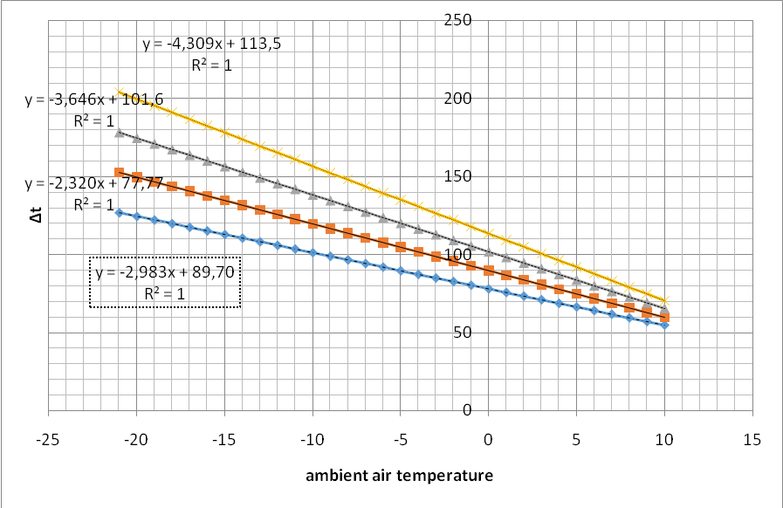
Fig. 2. Graphs of the temperature difference between the heating medium and that which is heated by the specific thermal characteristics of the building
For a particular building, accepting a constant volume V=const using the 90/70 temperature chart, we plot the change in temperature difference $Δt$ depending on the specific thermal characteristics of the building (Fig. 2).
As a specific thermal characteristic of the building we choose four values $q_{\text{V1}}=0\text{.}\text{35},$ $q_{\text{V2}}=0\text{.}\text{45},$ $q_{\text{V3}}=0\text{.}\text{55},$ $q_{\text{V4}}=0\text{.}\text{65}\text{.}$
Thus, knowing the specific thermal characteristics of the building and its volume, it is possible to obtain the value of the temperature difference between the heating medium and the heating medium. Also, by using the ratio between the water temperatures at the inlet and outlet of the heating system, it is possible to calculate the water supply temperature and the output, depending on the weather conditions.
So, for example, for it is possible to calculate the inlet and outlet temperatures of the heating system (Table 1).
As seen at ambient temperature + 8ºC, the heating can be switched off.
Table 1
Consider how the temperature difference will vary depending on the specific thermal characteristics of the building (Fig. 3).
As we can see from Fig. 3 with the increase of the specific thermal characteristics of the building, the sum of the inlet and return water temperatures in the heating system will also increase. That is, depending on the purpose of the building and its specific thermal characteristics, it is possible to calculate the supply and return temperature for the heating system serving the building.
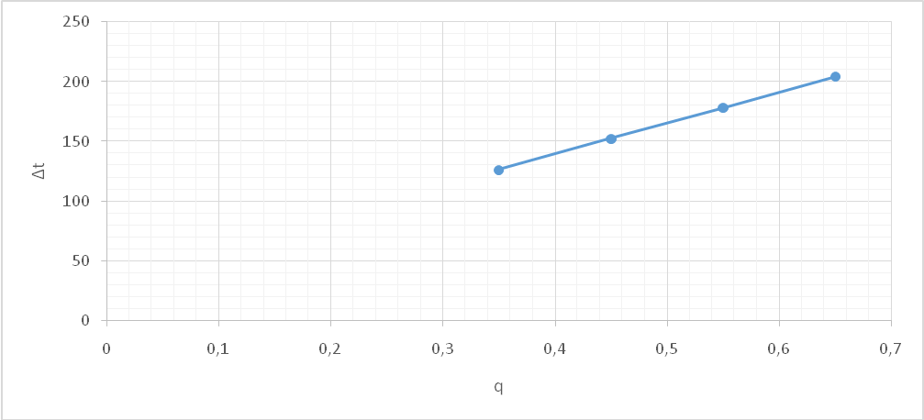
Fig. 3. Dependence of temperature difference depending on the specific thermal characteristic of the building.
V. RESULTS
The results of mathematical modeling are presented graphically and analytically for different scenarios depending on the ambient air temperature and the specific thermal characteristics of the buildings.
The simulation results indicate that the temperature head Δt of the equivalent heating appliance depends on the outside temperature and the specific heating characteristic of the buildings.
Thus, as the ambient air temperature decreases, the delta temperature Δt increases. At the same time, as the specific heating performance of buildings is reduced, the temperature pressure decreases, which leads to a decrease in thermal energy consumption and equivalent CO₂ emissions.
The results of the mathematical modeling of the temperature regime of the heat supply systems allow us to propose a number of measures to increase their energy efficiency and reduce equivalent CO₂ emissions and increase the comfort level in the premises:
1. With the involvement of energy audit, it is necessary to calculate the individual temperature charts of the heating systems of buildings.
2. In order to increase the homogeneity of thermal loads of heat consumption objects, it is necessary to cluster buildings according to their specific thermal characteristics.
3. At modernization of systems of heat supply it is necessary to carry out taking into account their individual temperature regimes.
4. Attraction of investments for modernization of heat supply systems should be made according to the criteria of their energy efficiency and environmental friendliness.
On the basis of the conducted research, it is concluded that the use of this approach saves energy by reducing useful consumption and heat losses in the range of 21-23%. Accordingly, this results in the reduction of equivalent emissions of carbon dioxide (CO₂) and other harmful substances, which is quite important for the conservation of the environment.
CONCLUSIONS
In this work, we investigated the use of an individual single-circuit heat point to regulate the temperature schedule and the mass flow rate of the coolant in the district heating system of buildings. Using the mathematical apparatus, several scenarios were simulated, depending on the external temperature and the specific heating characteristics of the buildings.
The simulation results showed that controlling the temperature schedule of the district heating system for an individual building has a significant effect on heat consumption, reducing heat loss and increasing the comfort of the building. Total thermal energy consumption of buildings can be reduced by 21-23%, which consequently reduces the cost of payment and the equivalent of carbon dioxide (СО₂).
REFERENCES
[1]. H. Kauko, K. H. Kvalsvik, D. Rohde, A. Hafner, N. Nord, Dynamic modeling of local low-temperatu reheating grids: a casestudy for Norway, Energy 139 (2017) 289–297.
[2]. N. Nord, E. K. L.Nielsen Challenges and potentials for low-temperature district heating implementation in Norway, Energy 151 (2018) 889–902.
[3]. Fialko N. M, Timchenko N. P, Sherenkovsky Yu. V. The fourth generation of district heating and district heating systems in Ukraine. International Conference Topical Issues in Civil and Environmental Construction Lviv - Kosice - Rzeszow CEE 2019: Proceedings of the CEE 2019, p. 74-86.
[4]. H. Lund, N. Duic, P. Alberg Østergaard, B. Vad Mathiesen, Future district heating systems and technologies: On the role of smart energy systems and 4th generation district heating, Energy,Vol 165, Part A, pp 614-619, 2018.
[5]. H. Lund, P. Alberg Østergaard, M. Chang, S. Werner, S. Svendsen, P. Sorknæs, J. Eric Thorsen, F. Hvelplund, B. Mortensen, B. Vad Mathiesen, C. Bojesen, N. Duic, X. Zhang, B. Möller, The status of 4th generation district heating: Research and results, Energy, Vol 164, pp 147-159, 2018.
[6]. Lazarević, S. L., et al.: District Heating Substation Elements Modeling for the Development. Thermal Science: Year 2019, Vol. 23, No. 3B, pp. 2061-2070.
[7]. Sokolov, E. Ya. District heating and heat networks: textbook. for higher education institutions [Text] / Е. Falcons. – 7th ed., P. – M .: Publishing House of MEI, 2001. – 472 p.
[8]. Panferov, V. I. Series: Computer technologies, control, radio electronics. 2016. №1. URL: https://cyberleninka.ru/article/n/ob-osobennostyah-vyvoda-uravneniy-regulirovaniya-sistem-tsentralizovannogo-teplosnabzheniya
[9]. Ermolaev, NS Problems of heat supply and heating of multi-storey buildings [Text] / N. S Ermolaev. – Moscow: publisher and type. Stroyizdata, 1949 (Vladimir: type 16 trust “Polygraph Book”). - 196 pp., 1 liter. earl. : illus., graph.

