UDC 339.54
Вірковська Анастасія Андріївна,
кандидат економічних наук, старший викладач
кафедри економіки та економічної теорії
Західноукраїнського національного університету

Вирковская Анастасия Андреевна,
кандидат экономических наук, старший преподаватель
кафедры экономики и экономической теории
Западноукраинского национального университета

Virkovska Аnastasiya Аndriivna,
PhD, senior lecturer of economics and economic theory department,
West Ukrainian National University

Карп Ірина Миколаївна,
кандидат економічних наук, доцент
кафедри економіки та економічної теорії
Західноукраїнського національного університету

Карп Ирина Николаевна,
кандидат экономических наук, доцент
кафедры экономики и экономической теории
Западноукраинского национального университета

Karp Iryna Mykolaivna,
PhD, associate professor
of economics and economic theory department
West Ukrainian National University

Divergence of foreign trade interests in international cooperation
Дивергенція зовнішньоторговельних інтересів у міжнародному співробітництві
Дивергенция внешнеторговых интересов в международном сотрудничестве

Анотація. У статті виокремлені дві взаємопов’язані моделі міжнародної економічної діяльності, які є підсистемами єдиного механізму участі країн у міжнародному співробітництві. Обгрунтовано, що майбутній розвиток сфери послуг має вирішальне значення для забезпечення життєдіяльності здорового та щасливого суспільства, а також для ефективного функціонування економіки загалом. У статті визначено, що міжнародне співробітництво між країнами й іншими учасниками міжнародних відносин сформувало систему міждержавних і недержавних організацій глобального і регіонального масштабу у сфері торгівлі. Проаналізовано, що активізація міжнародного співробітництва країн, зважаючи на відмінності в їхньому розвитку, має суперечливі наслідки. Це спричинює просторові та часові асиметрії реалізації зовнішньоторговельних інтересів, вплинути на які країни можуть через обрання тієї зовнішньоторговельної політики, яка максимально буде сприяти розвитку національної економіки.
Ключові слова: дивергенція, зовнішньоторговельні інтереси, міжнародна торговельна співпраця, міжнародна економічна діяльність, міжнародна торговельна спільнота, глобалізація.
Аннотация. В статье выделены две взаимосвязанные модели международной экономической деятельности, которые являются подсистемами единого механизма участия стран в международном сотрудничестве. Обосновано, что будущее развитие сферы услуг имеет решающее значение для обеспечения жизнедеятельности здорового и счастливого общества, а также для эффективного функционирования экономики в целом. В статье определено, что международное сотрудничество между странами и другими участниками международных отношений сформировало систему межгосударственных и негосударственных организаций глобального и регионального масштаба в сфере торговли. Проанализировано, что активизация международного сотрудничества стран, несмотря на различия в их развитии, имеет противоречивые последствия. Это вызывает пространственные и временные асимметрии реализации внешнеторговых интересов, повлиять на которые страны могут через избрание того внешнеторговой политики, которая максимально будет способствовать развитию национальной экономики.
Ключевые слова: дивергенция, внешнеторговые интересы, международное торговое сотрудничество, международная экономическая деятельность, международное торговое сообщество, глобализация.
Abstract. The article highlights two interrelated models of international economic activity, which are subsystems of a single mechanism for countries to participate in international cooperation. It is substantiated that the future development of the services sector is crucial for ensuring the viability of a healthy and happy society, as well as for the efficient functioning of the economy as a whole. The article states that international cooperation between countries and other participants in international relations has formed a system of intergovernmental and non-governmental organizations of global and regional scale in the field of trade. It is analyzed that the intensification of international cooperation of countries, given the differences in their development, has contradictory consequences. This causes spatial and temporal asymmetries in the realization of foreign trade interests, which can be influenced by countries through the choice of foreign trade policy that will best promote the development of the national economy.
Key words: divergence, foreign trade interests, international trade cooperation, international economic activity, international trade community, globalization.
Research problem. The internationalization processes of economic life and the deepening of global transformations have not only changed the world economic order, influenced the structure of international economic relations, but also modernized the format of international trade cooperation. It has acquired qualitatively new features, creating another challenge for national interests, while expanding the range of their implementation. Thus, international economic cooperation at the present stage acts as a frontal economic integration, which has become a fundamental factor in the development of individual economies.
Problem formulation. The article substantiates the importance of international trade cooperation in order to address such issues as: deepening imbalances in international trade risks due to non-compliance with agreements reached by countries and commitments made during the negotiations; violation of the integrity of the global institutional structure in the field of international trade; expanding trade of individual countries, violation of the principles of strategic partnership of countries, etc.
Research task. Based on the above, we can formulate a research task, which is an objective assessment of many geopolitical, civilizational factors, institutional conditions of export-import activities, traditional international sales channels, which serve the trade of one country with others. International cooperation is only one of the formats of combining the national interests of countries, which is a tool for resolving contradictory and conflict situations.
Presentation of research results. The international trade community can be characterized as a process of interaction between two or more participants, in which any use of armed violence is excluded, and advantages are given to the joint search for mechanisms to realize the interests of each participant on non-discrimination, respect for national sovereignty and mutual obligations and responsibilities for their violation. The principle of international cooperation is fundamental in the integration of countries into the structural and functional system of the world economic order.
Countries need to actively exchange not only goods, services and financial capital, but also technologies, knowledge, skills and abilities, provided that the international division of labor deepens and intensifies foreign economic, cultural and social cooperation, expands the scope of penetration into foreign markets. Bilateral and multilateral diplomacy, traditionally a mechanism for building cooperative relations and concluding various agreements, is aimed at mutual coordination of economic and political interests, ensuring common security and resolving conflicts, or any issues of common interest to all parties directly involved in this. International cooperation is only one of the formats of combining the national interests of countries, which is a tool for resolving contradictory and conflict situations. The multidimensional nature of global problems of international trade cooperation complicates the process of their identification in the global economic space.
International trade cooperation is of great importance for the development of the modern world. In today's economic reality, no country can feel completely self-sufficient. The growth of interdependencies and interactions only increases the importance of international trade cooperation. This is especially true in developing and least developed countries. Thus, for these countries, multilateral cooperation allows to expand trade relations with other participants in international economic relations, to ensure the supply of goods to the domestic market for which there is no import substitution, to solve, at least in part, food security, access to new technologies, increase production through attracting foreign investors, promoting their products and services in foreign markets, etc. The main reason for the intensification of international cooperation is in the economic sphere.
The globalization of almost all aspects of modern life is forced to include in the agenda the nature and content of cooperation between countries in world markets of investment, financial technology, labor, goods and services. It is necessary to prescribe clearly "game rules". The deployment of the globalization process is carried out in certain forms, which are manifested through:
• structural diversification of international trade and increase of its volumes;
• international direct and portfolio investments;
• labor migration;
• use of knowledge, technology, management and marketing generated in more developed countries and involved in economic systems.
Historically, the first form of international cooperation is considered to be international trade in goods and services in the form of their export and import. It can be carried out with the participation of both private entities and the state.
In view of this, we can distinguish two interrelated models of international economic activity, which are subsystems of a single mechanism for countries to participate in international cooperation. The first model is based on the interests of non-state entities, which is objectively an important characteristic and feature of the market system. The interests of private business structures are aimed at achieving financial results and liberalization of export-import directions of the country foreign trade policy. The second model is cooperation with the participation of state institutions. It is actively used in those areas of economic activity where, for objective reasons, public authorities have the appropriate commercial powers. In world practice, there are cases when in a directive economy established a state monopoly on foreign economic relations [1, p. 41]. In particular, such foreign trade policy was pursued in the USSR, changing only organizational forms.
The globalization of the world economy and the development of integration processes (especially on the European continent) deepen the asymmetries between countries both in terms of macroeconomic indicators and positions in global development coordinates, and also foreign trade interests. The asymmetry of countries' interests causes an asymmetry of foreign trade flows, which can be manifested in the territorial (spatial and temporal) dimension. The term "asymmetry" became widespread in scientific research after receiving in 2001 by American economists J. Stiglitz, J. Akerlof and M. Spence [2, p. 144] Nobel Prize for the development of theory and analysis of markets with asymmetric information, according to which asymmetric information creates problems of unfavorable decision choices and deepens risks.
The presence of asymmetry in processes and phenomena collectively affects the behavior of market participants, both goods and services, and financial. Asymmetry can occur at the global, national and regional levels. In the scientific literature, regional asymmetry is defined by scientists, in particular N. Bozhydarnik, as a process of differentiation of local and global territorial taxonomic units, which occurs under the influence of increasing uneven movement of factors of production, competition and implementation of complementary multilevel (local, regional, national, supranational) policy of reducing disproportion of socio-economic development and ensuring its sustainability [3, p. 12].
We can agree with the position of I. Storonyanska, who believes that the asymmetry of regional development is a measure of interregional differences in the levels of economic development (economic activity) and life (quality) [4, p. 101]. Researchers I. Vakhovych and I. Lakatosh consider the concept of asymmetry of regional development as a process of violation of harmony and balance of socio-economic development of regions, strengthening their contrast, polarization and increasing interregional differences [4, p. 35]. Regional asymmetry (it applies to both territory of country and countries within the region) is a feature of any economy, because there is always an uneven distribution of productive forces, but spatial development involves controlled integration processes and socio-economic effects of foreign trade. Regional asymmetry is considered not only in relation to regions as territorial entities of the country, but also in the geographical and spatial dimension, and in accordance with the interests of countries of a particular continent – Europe, Asia, Africa and others [3, p. 10], within integration associations and formations such as the BRICS. Thus, in the structure of the latter's interests, each country has its own interests, and combining their resources only strengthens the position of countries in the global economy. The participants of the BRICS project have certain resource advantages: Brazil – in the production of agricultural products, Russia - in the export of mineral resources, India – at the expense of cheap intellectual resources, China – at the expense of cheap labor, South Africa – in providing natural resources. The BRICS countries are becoming a kind of challenge to the emerging world trade leaders, creating not only an economic union, but also working out common political reforms. At the same time, the creation of the BRICS was a challenge to the hegemony of the United States and the European Union in international trade, a way to balance the asymmetries of foreign trade flows in the world.
Based on a syncretic analysis of the views of different scholars, we propose to define the asymmetry of foreign trade interests as the heterogeneity of the global economic space, which is manifested in the diversification of foreign interests in foreign trade and affects the differences between their economic and human development. The asymmetry of foreign trade interests is an objective feature of the world economy, because, having equal access to markets, countries build their strategies differently and choose the vectors of cooperation with other participants in international economic relations. The asymmetry of foreign trade interests of countries is manifested in their foreign trade policy, which is implemented either as a liberal or protectionist. Its modern symptoms manifest itself due to the following problems:
• deepening imbalances in international trade;
• risks of non-compliance with agreements reached by countries and commitments made in the negotiation process;
• violation of the integrity of the global institutional structure in the field of international trade;
• trade expansion of individual countries, violation of the principles of strategic partnership of countries, etc.
The world economy as a system of markets is formed under the influence of priorities for the realization of foreign trade interests of each country. For countries that are members of integration associations, such as the European Union, this task is somewhat simplified given the country's common foreign trade policy. The participation of each country, for example, in the EU's common policy, makes it possible to lobby the interests of member states in international organizations and international cooperation. At the same time, the foreign trade interests of European countries are multi-vector, each of them has or is trying to realize specific advantages in certain markets, accordingly uses tools (according to WTO requirements) to regulate foreign trade in order to: ensure competitive development of export potential, investments, efficient use of the country production potential, support of close cooperation with economically developed countries, development of cross-border cooperation, improvement of infrastructure and implementation of innovative development strategy.
Countries around the world are integrated into the global trade space to varying degrees. Thus, according to the globalization index (according to the methodology of KOF Swiss Economic Institute), which covers economic (business activity, international trade, investment, tariff policy, restrictions and taxes on international trade, etc.), social and political aspects, there are differences in the positions of countries. Thus, in terms of the level of economic globalization, the leaders are economically developed countries (Table 1).

Table 1

Top 10 countries in the Globalization Index 2019
Rank | Country | Globalization Index, overall
1 | Switzerland | 91,19
2 | Netherlands | 90,71
3 | Belgium | 90,59
4 | Sweden | 89,93
5 | United Kingdom | 89,84
6 | Austria | 88,85
7 | Germany | 88,60
8 | Denmark | 88,26
9 | Finland | 87,70
10 | France | 87,25
Source: [ 6 ]
As a component of international economic relations, international trade in recent decades has been characterized by high growth rates compared with the growth rate of world production. Given the slow pace of economic growth in the world due to the effects of the recent global financial and economic crisis, this trend may continue, but provided that the international competitiveness of countries and increasing market flexibility. The situation is exacerbated by destructive changes in the world economy and the unfavorable situation in the financial sector, in particular the slowdown in world production. In the post-crisis years, the decline in production in the world economy was halted; there was a slowdown in growth, which, however, was disrupted in 2014 due to geopolitical factors. However, the next crisis may be decisive in changing the world economic order, its epicenter may be both the United States and China, which today with its foreign trade and financial strategies promotes a new model of redistribution of spheres of influence (it should be borne in mind that the ranking of leading companies in the world are headed by Chinese corporations). It is projected that the growth of the world economy will depend on the revival of economic and foreign trade activity in European countries, including the EU.
Long-term stagnation has also affected the growth rate of world trade. Thus, in the last two years there has been an increase in world trade at 2-2.5%, while in the pre-crisis period it was 7.2%, and in the post-crisis years the world economy still had the potential to recover. In the long run, countries have the potential to increase trade. Experts see the reason for this in lower prices for raw materials and a probable increase in investment activity in these countries. At the same time, liberal fiscal policy has created threats to the economic development of countries due to excessive foreign investment, rising external debt, bank liquidity problems, which could not but affect the trends of world trade.
At the same time, the new agenda of international organizations, in particular the WTO and UNCTAD, raises the issue of contradictions in the implementation by countries of the provisions of bilateral and multilateral agreements. When signing the latter, they received liberal conditions for market access, while the practice of new preferential agreements (including issues of not only trade but also investment, standards, protection of intellectual property rights, etc.) indicates limited countries in deciding on strategic development priorities. This usually applies to developing countries, which are forced to participate in the lowest stages of global value chains.
Unified rules of international trade, in particular through the GATT / WTO agreements, equalize the conditions of participating countries in trade, goods and services, but do not take into account the country involvement in international economic relations, reasons that motivate it to accept the terms of other participants driving force of foreign trade activity of countries. The top five exporters of goods in 2019 included China ($ 195419313440), the United States ($ 140827427290), Germany ($ 128289362560), Japan ($ 62062812860), and the Netherlands ($ 60265497300). These countries (excluding the Netherlands) remain the leaders in imports of goods.
Chart 1 shows seasonally-adjusted quarterly merchandise exports and imports by level of development. Weakness was most evident in the fourth quarter of 2018, when export volumes declined by 0.1% and import volumes dropped 0.5%. On the export side, the slowdown was mostly due to reduced shipments from developed countries, which contracted year-on-year in three out of the four quarters of 2018. On the import side, developed countries recorded slow growth throughout the year, particularly in the first half. Meanwhile, developing economies saw imports fall sharply (-2.1%) in the final quarter despite stronger growth earlier in the year.
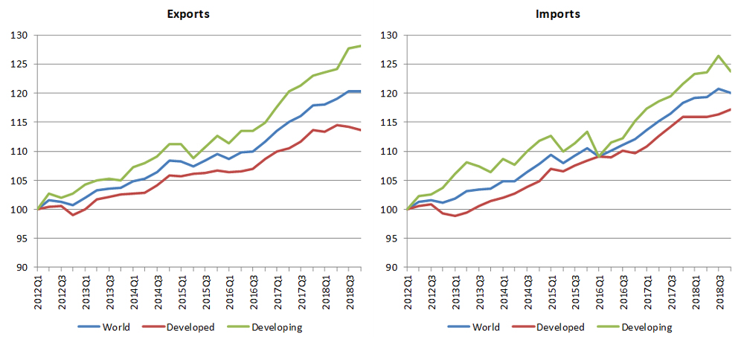

Chart 1. World merchandise exports and imports by level of development, 2012-2018

Source: [7]

Chart 2 shows merchandise export and import volumes by region. The deceleration of trade in 2018 was driven primarily by Europe and Asia due to their large share in world imports (37% and 35%, respectively). After recording strong increases in 2017, Asia saw its trade growth moderate in 2018. Meanwhile, Europe's exports stagnated throughout the year while its imports declined gradually.

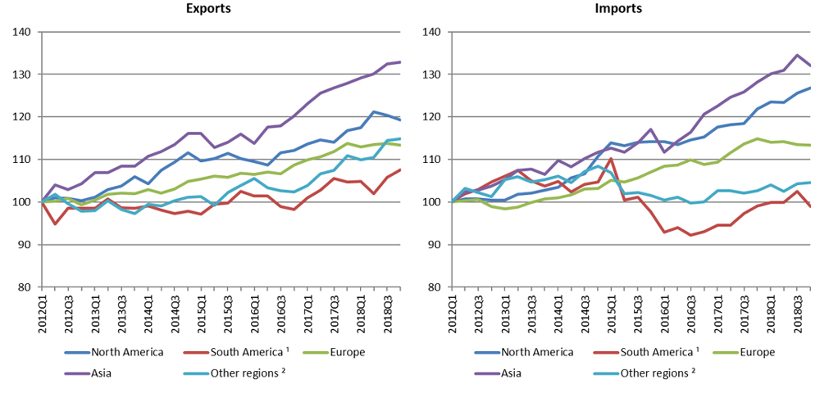

Chart 2. Merchandise exports and imports by region, 2012-2018

Source: [8]

World commercial services trade recorded strong growth in 2018 for the second consecutive year. This is illustrated by Chart 3, which shows growth in the dollar value of services exports by major categories. Goods related services registered the strongest expansion, with a 10.6% increase in current dollar terms. The weakest growth was in transport, which rose by 7.1%. Commercial services overall grew 7.7% in 2018.

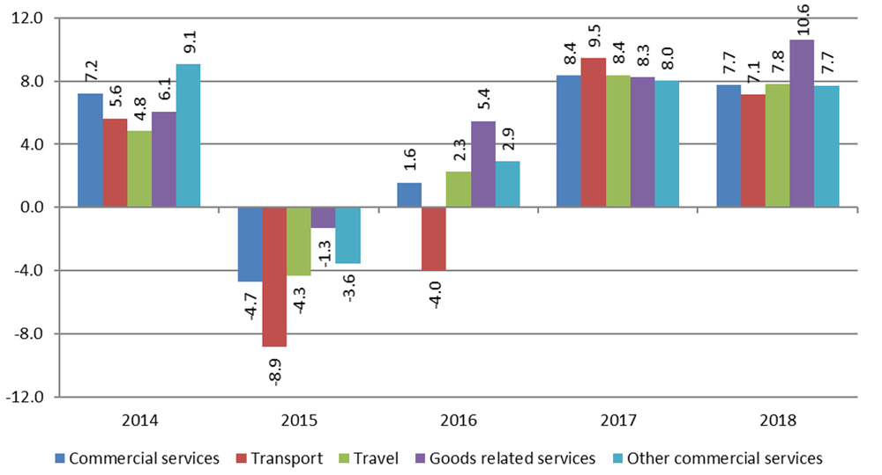

Chart 3. Growth in the value of commercial services exports by category, 2014-18 in %

Source: [8]

The future development of the service sector is crucial for ensuring a healthy and happy society, as well as for the efficient functioning of the economy as a whole, because in modern conditions new technologies are actively developing, services are changing and improving, so countries must respond to these transformations in real time. For example, European countries remain an example of a socially oriented economy, where a society with quality jobs, a competitive economy and quality services is formed. In our opinion, this should be a priority for developing countries and countries with economies in transition, including Ukraine.
The immanent feature of international trade is that its interests are interrelated with other components of international economic relations, and the asymmetry of foreign trade interests is interrelated with the asymmetry of economic, environmental, social and human development, the asymmetry of investment and information development, the determinant asymmetries of international trade. At the same time, one of the most threatening is the asymmetry of strategic partnership, when countries consciously agree to unequal terms of trade cooperation. The inertial consequence of this asymmetry is a situation in which one group of countries receives long-term status of a raw material donor, and another – an exporter of finished products. In the long run, this only exacerbates global contradictions and translates the "asymmetric disease" into a kind of chronic phase. Thus, the experience of developing countries and countries with economies in transition shows that a favorable investment climate is the basis for foreign investment in low-tech industries that are export-oriented. The adapter country retains the status of a market for cheap labor or raw materials. The main trends in the participation of economically developed countries in international trade are:
• the possibility of entire states becoming economically, politically, socially and culturally dependent on individual TNCs;
• strengthening the asymmetry of foreign trade interests through the influence of TNCs on the interests of host countries;
• monopolization of markets and ousting of national companies using unfair competition methods;
• violation of the balance of payments of these states;
• the possibility of tax evasion through the use of the internal structure of TNCs;
• use of environmentally harmful industries that have a negative impact on the environment;
• hypertrophied growth of economic sectors in which TNCs operate in the overall structure of national economic systems.
Objective needs for multilateral cooperation have contributed to the expansion of the world interdependence, the emergence and exacerbation of global problems. Accordingly, international cooperation between countries and other participants in international relations has formed a system of intergovernmental and non-governmental organizations of global and regional scale in the field of trade.
The development strategy of countries in general and their foreign economic component is connected with the policy of liberalization in the regulation of world trade, which is the result of multilateral agreements within the Uruguay Round of GATT negotiations and agreements within the established World Trade Organization (WTO). The above processes have opened not only opportunities for more effective growth, but also new threats at the global level, which can reduce the potential for national development of any country. This is evidence of the growing opposition to the current paradigm of globalization by various international governmental and non-governmental organizations, social movements of an anti-global nature [9, p. 280]. Within the WTO, there is a dispute settlement body, the function of which is performed by the WTO General Council, which has special powers to establish arbitration groups. Its functional purpose is to provide a positive solution to disputes and conflicts. At the same time, the desire of the parties to find a mutually agreed solution to the problems that arise in relations between member states is encouraged. Dispute settlement is achieved through bilateral stakeholder consultations.
Today, country policy should be aimed at liberalizing exports and imports, reducing tariffs and removing non-tariff barriers that hinder international trade between them. In practice, there is a high level of protection of some "sensitive" industries and areas of the internal market due to customs and non-tariff restrictions, which are complemented by a special sectoral competition policy. The opening of "sensitive" markets is gradual. For certain sectors of the country, it is synchronized with changes in competition policy, which allows producers from other countries to adapt to the conditions and high competition from "third" countries.
Conclusion. Thus, the peculiarity of the country's participation in international trade is the need for an objective assessment of many geopolitical, civilizational factors, institutional conditions of export-import activities, that is traditional international sales channels, which serve the trade of one country with others. The intensification of international cooperation between countries, given the differences in their development, has contradictory consequences. This causes spatial and temporal asymmetries in the realization of foreign trade interests, which can be influenced by countries through the choice of foreign trade policy that will best promote the development of the national economy. A negative feature of modern international trade is also the asymmetry of its geographical and regional structure (least developed countries account for about 1% of trade with almost all economically developed countries, only exports to Asia to 2-3% and Africa – 5-6%). Accordingly, we can speak of a disproportionate structure of world trade, which has a regional focus. In this context, the experience of European integration (within the EU and the EFTA) demonstrates the combination of national and supranational trade interests with the institutional mechanism for their implementation.
Thus, the asymmetry in the field of international trade is a concrete manifestation of the universal mechanism of competitive interaction of all stakeholders in this process. In addition, the objective factors that determine its nature and parameters include inequality in the distribution of resources, differences in the levels of manufacturability and efficiency of national economies, and so on.
References
- Вірковська А. А. Міжнародне співробітництво як основа зовнішньоторговельної діяльності країни / А. А. Вірковська // Галицький економічний вісник. – 2011. – №3 (32). – С. 41–45.
- Замулин О. Концепция реальных экономических циклов и ее роль в эволюции макроэкономической теории : Ф. Кюдланд, Э. Прескотт, М. Фридман, Р. Лукас, Дж. Стиглиц, Дж. Акерлоф, М. Спенс / О. Замулин // Вопросы экономики. – 2005. – № 1. – С. 144–153.
- Божидарнік Н. В. Регіональна асиметрія в Європейському Союзі та механізми її регулювання : автореф. дис. на здобуття наук. ступеня канд. екон. наук : cпец. 08.05.01 «Світове господарство і міжнародні економічні відносини» / Н. В. Божидарнік. – К. : КНЕУ, 2007. – 20 с.
- Сторонянська І. З. Оцінка асиметрії соціально-економічного розвитку регіонів України та обґрунтування пріоритетів державної регіональної політики / І. З. Сторонянська // Регіональна економіка. – 2006. – № 4. – С. 101 –110.
- Вахович І. М. Сутність асиметрії регіонального розвитку / І. М. Вахович, І. М. Лакатош // Економіка та менеджмент. – Л., 2008. – Вип. 5(18), ч. 1. – C. 35–41.
- Top 10 countries in the Globalization Index 2019. URL: https://www.statista.com/statistics/268168/globalization-index-by-country/
- World merchandise exports and imports by level of development. URL: https://www.wto.org/english/res_e/statis_e/merch_trade_stat_e.htm
- Total merchandise trade. URL: https://stats.unctad.org/handbook/MerchandiseTrade/Total.html
9. Cremona M. The Completion of the Internal Market and the Incomplete Commercial Policy of the European Community / M. Cremona // European Law Review. – 1990. – №9. – P. 280–292.

