МІНІСТЕРСТВО ОСВІТИ І НАУКИ УКРАЇНИ
Західноукраїнський національний університет
Навчально-науковий інститут міжнародних відносин ім. Б. Д. Гаврилишина
Кафедра міжнародної економіки

ГАНДА Майкл Киран

ВПЛИВ ТЕХНОЛОГІЧНИХ ІННОВАЦІЙ НА НАВКОЛИШНЄ СЕРЕДОВИЩЕ/THE IMPACT OF TECHNOLOGICAL INNOVATIONS
ON ENVIRONMENT
спеціальність: 051 – Економіка
освітньо-професійна програма – Міжнародна економіка (з викладанням англійською мовою)

Кваліфікаційна робота

Виконав студент групи
АМЕТм-21
М. Ганда
__________________
Науковий керівник:
д.е.н., професор, І. Я. Зварич
________________________
Кваліфікаційну роботу
допущено до захисту:
“___”________________20___р.
Завідувач кафедри
_________________І.Я. Зварич

ТЕРНОПІЛЬ - 2021
INTRODUCTION…………………………………………………………. |  | 3
CHAPTER 1. | THEORETICAL CONCEPTS OF ECO-INNOVATION………………………………………… | 7
1.1. | The Concept of Eco-Innovation ……………………….. | 7
1.2. | Role of the Technological progress in the impact of technological innovations on environment.……………. | 12
1.3. | Innovation is the driving force of change……………… | 23
 | Conclusions for 1 chapter……………………………… | 27
CHAPTER 2. | TECHNOLOGY-PUSH AND MARKET-PULL….. | 28
2.1. | Policy recommendations of technological innovations  on environment……………………………………….. | 28
2.2. | New technologies for ecodevelopment……………….. | 31
2.3. | The impact of technology on the environment……….. | 36
 | Conclusions to chapter 2………………………………. | 48
CHAPTER 3. | THE INTERNATIONAL POLICY GOAL OF GLOBAL CLIMATE CHANGE……………………. | 50
3.1. | The technical impact and challenges……………………. | 50
3.2. | The need for technological changes…………………….. | 55
 | Conclusions to the chapter 2……………………………. | 60
 |  | 62
CONCLUSIONS……………………………………………………….
REFERENCES………………………………………………………… |  | 65

INTRODUCTION
Climate change and the depletion of natural resources are the two most pressing global challenges. Waste volumes can be reduced accordingly in the transition to a circular economy. In such an economic system, waste materials and their generation are minimized. In practice, this may mean that the product must be designed in such a way that its materials are separate and recyclable. The need to address climate change and conserve natural resources has necessitated the formation of a global business model with very rapid economic growth. In a circular economy, it is not material flows or waste that are most important, but the development and implementation of much more valuable methods, such as proper maintenance, reuse of materials and recycling of equipment.
At the present stage economic development in the process of business structures there is little use of the latest technology, which causes large losses of raw materials and environmental pollution. In order to increase the efficiency of management of various industries, it is important to solve the problem of resource conservation and environmental protection. Therefore, an important area of ​​development of the subjects management is an environmentally oriented restructuring, namely introduction of ecological innovations. Factors play an important role in solving the problem of eco-innovative development of enterprises, which have endogenous and exogenous nature, which directly affect introduction of ecological innovations. Analysis of recent research on this issue. Fundamental research of theoretical-methodological and practical aspects of ecological oriented innovation activities of enterprises belongs to the following domestic scientists like V. Bozhkova, S. Ilyashenko, T. Karpishchenko, L. Melnyk, D. Panteleychuk, O. Prokopenko, L. Fedulova and others. Majority developments have an applied orientation. Scientists note that innovation, including environmental, help to strengthen competitiveness enterprises and regions. In particular, T. Karpishchenko defines ecological innovations as a result creative activities aimed at development, creation and implementation.
Research of factors of influence on eco-innovative activity of enterprises in terms of cross-border cooperation innovations in the form of new products, technology, method, form organization of production, etc., directly or indirectly helps reduce the eco-destructive impact of production and consumption on the environment and solving environmental problems. Among foreign researchers in the field of environmental implementation innovations can be distinguished such as: P. James, M. Midzinski, R. Kemp, A. Reid, K. Renings, K. Fassler, T. Foxon, T. Zwick, and others. In particular, Claude Fassler and Peter James under eco-innovation define products and processes that promote sustainable development. K. Rennings and T. Zwick explains eco-innovation as new or changed processes, equipment, products, methods and control systems that allow to avoid or reduce the harmful effects on the environment. M. Carley and P. Speypens believe that eco-innovation leads to integrated solutions aimed at saving resources and energy, while improving the quality of products and services. According to with A. Khodynsky ecological innovations cover changes in technology, organizational structure and management of the enterprise, which reduce negative impact on the environment.
Thus, the object of research is the technological innovations in environment.
Subject - development of promising directions in the impact of technological innovations on environment.
The aim of the study is to analyze the problem of the impact of technological innovations on environment.
To reveal the goal, the author sets himself the following tasks:
• to identify the Role of the Technological progress in the impact of technological innovations on environment;
• to analyze the Policy recommendations of technological innovations on environment;
• to outline the impact of technology on the environment;
• to analyze the technical impact and challenges;
•to analyze the need for technological changes.
Scientific novelty. The peculiarities of the problem of the impact of technological innovations on environment.
Research methods. The theoretical and methodological basis of the study are the fundamental provisions of modern economic theory, scientific works of domestic and foreign scientists. General and special methods of scientific research were used in solving the set tasks: formal and dialectical logic, complex, systematic, structural-functional analysis, dialectical, historical and logical methods, generalizations, statistical, economic-mathematical.
The information base of the study is the materials of domestic and foreign researchers who analyze the problems of environmental pollution and global models of environmental development. Among the information sources of the dissertation are also materials of the International Organization for Migration (IOM), the International Labor Organization (ILO), the World Bank, the International Monetary Fund (IMF), the Organization for Economic Cooperation and Development (OECD), the Council of Europe, the European Union and others.
Practical meaning. The practical significance of the results of the problem of the impact of technological innovations on environment.
Structure and scope of work.
The master's thesis consists of an introduction, three chapters, conclusions, appendices and a list of sources used. The total volume of the work is 65 pages. There are 14 figures in the text. The list of used sources includes 39 names.

CHAPTER 1
THEORETICAL CONCEPTS OF ECO-INNOVATION
  - The Concept of Eco-Innovation.

When analyzing the changes that have occurred in the global economy in the context of continuous technological progress, climate change, resource reduction, and the pursuit of a low-carbon economy, the importance of ecological innovation has become increasingly prominent [13]. The concept of ecological innovation has been proposed by researchers in various disciplines such as economics [28], sociology [29], and management [30]; even in design, governance, users, and supply chains [31]. Today, the term is used interchangeably with eco-innovation, eco-innovation, green innovation, sustainable innovation, sustainability-driven innovation, sustainability-enhancing innovation, and sustainability-oriented innovation [32,33], and includes various technologies (eg solar or wind power systems), organizational practices (e.g. pollution prevention) and services (e.g. electrified roads). The first definition of ecological innovation was proposed by Fussler and James [34]. They believed that ecological innovation is the manufacture of new products and processes, which provide customers and commercial value, but significantly reduce the impact on the environment. Other authors have put forward different definitions of ecological innovation. The OECD (2008) definition emphasizes that ecological innovation "...resulting in new or significantly improved products (goods or services), processes, organizational methods, or marketing methods that create environmental benefits, and such environmental benefits can occur in the production process. Or service, or end-user use of goods or services during after-sales"[35]. Klemmer et al. proposed a broader definition. [36] and Horbach et al. [twenty two]. They pointed out that ecological innovation should include company management processes, product and organizational changes, as well as overall changes in social and political levels, consumer behavior and lifestyles.
According to Hojnik and Ruzzier [37], ecological innovation can be viewed from three dimensions: technology, organization or system. Based on the bibliometric analysis, Türkeli and Kemp [38] studied a more comprehensive view of ecological innovation. These are (1) supply-side perspectives that focus on companies and industries (e.g., drivers and barriers to eco-innovation); (2) technology-oriented research (eg, carbon capture and storage, electric vehicles, smart outlets); (3) Academic research (eg new materials); (4) Departmental research (such as metallurgy and cast iron industry, transport, information technology, food, agriculture, tourism); (5) part of eco-innovations that support knowledge (such as skills and learning); (6) Demand side analysis (for example, the proliferation and adoption dynamics of individuals, households, and companies); (7) The policy impact perspective (the impact of policy tools, such as eco-labels, policy combinations). Türkeli and Kemp [38] believe that ecological innovation is a new or improved product, process, technology or system that can avoid or reduce environmental damage, but retain the same use value. The difference between environmental innovation and other innovations lies in the political aspect behind its emergence. Ecological innovations, especially renewable energy technologies, require political support and have global market potential based on global concerns and discussions of inevitable global warming. Ecological innovation cannot be treated in the same way as other innovations (for example, in terms of dual externalities and the effects of regulatory push/pull resources 2021, 10, 68 4 of 17), and requires specific theories and policies [28]. However, the literature lacks a comprehensive theory on ecological innovation [12,24,32]. The role of ecological innovation can be considered from two opposing theoretical perspectives: neoclassicism and evolution [10,22,36]. In the neoclassical approach, ecological innovations play a key role in achieving environmental sustainability goals, mainly through their contribution to technological progress, which can compensate for the negative consequences of depletion of natural resources. Hazarika and Zhang [39] pointed out that factors such as social and economic change, institutions and policy instruments play an important role in neoclassical theory.
They promote the development and implementation of ecological innovation. The evolutionists analyze the dynamic and multidimensional nature of ecological innovation, and recognize the important role of organizational, social and institutional innovation in environmental sustainability. In this case, the deterministic neoclassical perspective seems to be particularly useful for studying the specific characteristics of ecological innovation. On the other hand, evolutionary theory is suitable for studying radical innovation and avoiding any technological prejudice, emphasizing the need to consider social and institutional aspects. Although both methods recognize the important role of ecological innovation in supporting environmental sustainability, they differ in how ecological innovation leads the economy to sustainability [10,22]. In view of the research goals of this article, the neoclassical approach assumes that technological environmental innovation, which seems to be particularly relevant for further analysis. However, the evolutionary approach extends the analysis of ecological innovation to include social and institutional aspects as well as technology. The difference between the types of ecological innovation is not clear; in addition, different types of ecological innovation develop together. Economic, social and institutional elements influence each other. One of the most important factors to consider is not only ecological regulations. Regulations can also promote development of social innovations and institutional innovations, which is extremely important in the context of striving to achieve the model of sustainable development [28]. This requires institutional changes and the full implementation of regulations that support sustainable transformation [40]. In addition, social innovation and institutional innovation are accompanied by technological ecological innovation, which is related to its more effective adaptation. Ecological innovation is susceptible to many disturbances, including decision-making processes, technological progress, or perceptions of ecological innovation. Therefore, it is necessary to look at the issue of ecological innovation more broadly [39].
Today, the implementation of economic reforms and the direction to the European Union involves compliance with environmentally oriented economic development, which is impossible without the intensification of innovation and investment processes. The development of Ukraine's economy and the solution of existing ecological and economic problems should be based on ecologically oriented innovation activity.
Satisfying the growing needs of consumers, ensuring the competitiveness of products, development and implementation of modern methods of product quality assurance and environmental management are the priorities of policy in the field of economics and ecology. Economic development takes into account the environmental factor as a fundamental condition for environmentally balanced development. Innovative activities are aimed primarily at meeting environmental needs: production and application of environmental protection; replacement of environmentally unfavorable products and services with more environmentally friendly ones or those that contribute to the reduction of material and energy consumption of systems. Innovation and investment development of the economy requires a systemic and ecological justification, ie taking into account the requirements of environmental management. Innovative activity is directly related to the pace of development of scientific and technological progress and the economy, the standard of living of the population. Innovation is one of the main means of adaptation of enterprises and organizations to changing environmental conditions.
The quality of the environment is becoming one of the main components of the quality of life of people in different regions, countries, climatic conditions, etc. Therefore, the introduction of quality management systems and environmental management systems is gradually becoming economically viable.
The production and sale of environmentally friendly goods and competitiveness depend to a large extent on public opinion. Therefore, companies must shape their image through various promotions, sponsorships, press releases and information materials about their activities, issuing reports, holding press conferences, presentations, etc.
Private enterprises are the most sensitive and active in responding to demands and changes in demand in the market of ecological goods, as they are independently responsible for their economic condition.
A distinctive feature of the entrepreneur is that he is always looking for changes, responds to them and uses them as a chance. Entrepreneurs need to purposefully find sources of innovation, the reasons that cause them, and predict the possible consequences of their implementation.
Today ecological business develops, generally, in the following directions: manufacturing, installation and operation of nature protection (clearing) means; development and implementation of environmentally friendly technologies; production of environmentally friendly products; processing, transportation and disposal of waste; trade in environmental technologies, products and waste; energy saving, conservation of land resources; water, air control, eco-audit and eco-examination; ecotourism, ecological medicine and occupational safety; Information Technology. Working in the market is usually complicated and at the same time stimulated by competition. This is especially true of the market for environmental goods.
Thus, Ukraine has all the opportunities to form a market for eco-innovation, which will provide it with a suitable place in the world trade market.
The market of ecological innovations consists of the primary market, where the intermediate results of ecologically oriented innovation process are exchanged in information form, as well as their potential economic effect, and the secondary market, where the object of purchase and sale is the final result of ecologically oriented innovation process. market), and which mediates its further spread in the economy.

  - Role of the Technological progress in the impact of technological innovations on environment.
With the signing of the Paris Agreement on Climate Change in 2015 and the establishment of the Sustainable Development Goals (SDGs), the international community has recognized that this is a transformation of how we use natural resources and that it is a prerequisite for a prosperous, secure and sustainable society. Resource-intensive economic growth in the world has brought huge environmental costs. The supply of infrastructure and services needed to support a growing economy and population - especially in developing countries - while combating climate change and maintaining ecosystem stability requires a revolution in resource use patterns. The focus is on the potential of "circular" and sustainable development models to achieve this revolution and unlock economic, social and environmental benefits. The vision of what is called a "circular economy" (CE) is based on a systematic approach to resource efficiency, in which end-of-life products and materials are not discarded, but instead recycled, repaired or reused through circular value chains. . The circular economy also involves changes in business models with an emphasis on sharing and renting, as well as changes in consumer preferences among buyers. Most often, even in rich countries, discussing sustainability usually involves reforming specific supply chains rather than a full-fledged transformation. Over the last decade, the European Union has been active in advocacy, mainly through well-known multinational corporations such as Philips and Unilever, as well as Veolia (a leader in waste management). Partly focusing on the focus on new supply chain management business models, as well as on industrial innovation and job creation, the focus was on developed countries in the European Union and China, where CE strategies are most advanced. At the same time, the role of developing countries, except China, in the global arena of the circular economy, and the importance of promoting international cooperation and the development of global governance systems to support circular value chains are less studied. In this context, international organizations such as the United Nations (UN), the Organization for Economic Co-operation and Development (OECD) and the World Economic Forum (WEF) are increasingly calling for a new development paradigm - one that identifies priority ways to reduce poverty and improve living standards, while contributing to the efficient use of resources and their reduction of pressure on natural resources and the environment.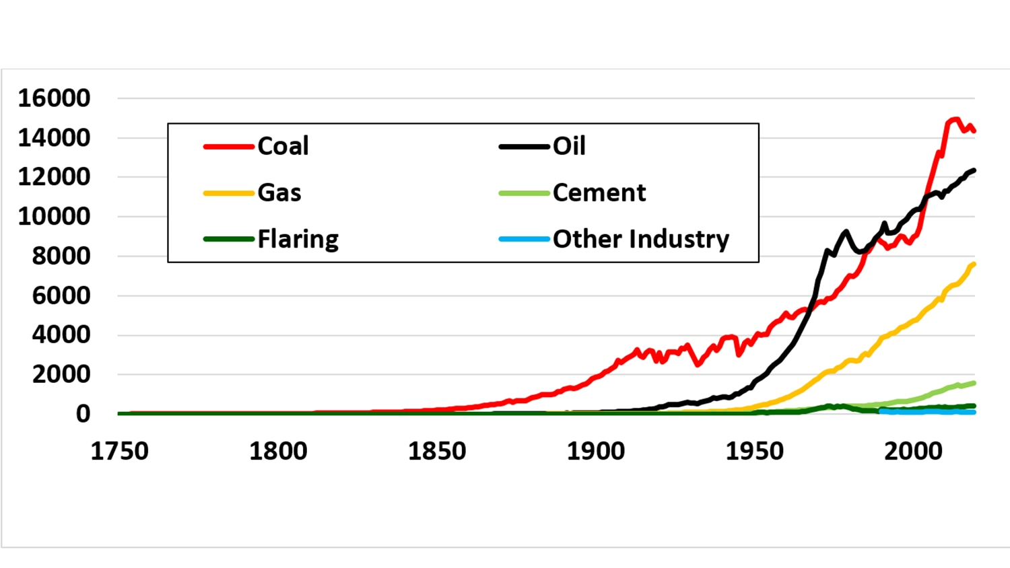
Fig.1.1. Sources of carbon emissions (million tons per year) in the world between 1750–2019. [23]
The European Union has chosen the path of a closed-cycle economy: to obtain as much raw material for the economy as possible from waste and end-of-life goods and to use as little non-renewable natural resources as possible, such as minerals or trees. Ukraine has signed an Association Agreement with the EU, which has committed itself to increasing waste recycling and reusing it in the economy. Ukraine's reforms aim to get rid of dependence on exports of natural resources and goods with a low degree of processing. Reforms of subsidies and pricing for carbon emissions by 2030 in the world are aimed at generating 2.8 trillion. dollars of government revenue per year and create 65 million clean jobs. It is the combination of these concepts that is needed to start and translate into a permanent system of decoupling (separation) of economic development processes from the processes of using resources for this development and the state of the environment. It is necessary not only not to worsen the existing situation, but also to significantly improve it. At the same time, the state will not dictate what costs a business should incur to perform this task. Moreover, the state is interested in business minimizing its costs and leaving more for investment, so that product prices rise minimally, but the norms of utilization and processing of packaging waste are met. The place of the tax package obliges businesses to pay a certain amount in the form of taxes and does not contain norms that would motivate the search for the most efficient ways to collect, dispose and recycle packaging and thus facilitate the transition to an inclusive circular economy.

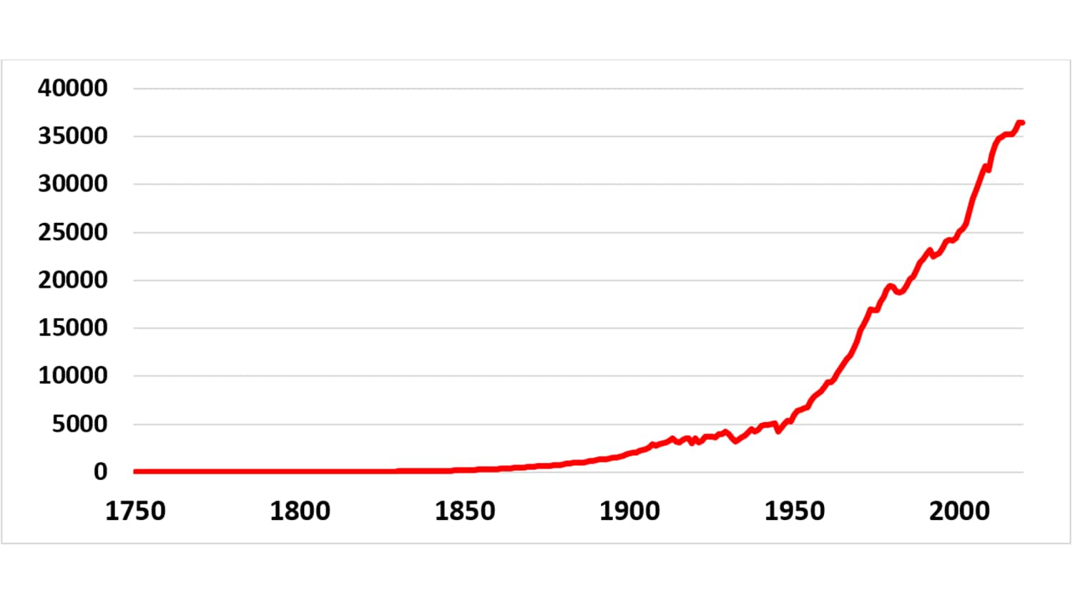
Fig. 1.2. Annual production-based carbon emissions (mi[]llion tons per year) in the world between 1750–2019. [32]
Climate change issues are central to the functioning of production in large cities such as New York, London or Paris. If they want to reach zero or even half of their carbon emissions by 2050, they will have to rethink urban mobility, as well as the food system, water supply, and so on. The implementation of a circular economy means a systematic approach with economic justification [18].
There are many cities that implement innovative development models. For example, London is an innovative environmental project. At the same time, in a small town like Peterborough, they are working to create a circular economy with the involvement of the local business community. In total, an online platform called "Share Peterborough" has been developed with more than 100 sharing resources for sharing via the Internet. Autonomy in cities is a must, but it is necessary to create an economic and infrastructural framework for policies that will contribute to their prosperity. Otherwise, the consequences can be catastrophic.
The Copenhagen Development Model combines environmental initiatives, economic growth and improving the quality of life in real time based on innovative planning. The potential of a circular economy is job creation, economic growth, and efficient resource management.
The vision of 2025 "Cooperation of Copenhagen" provides for the cooperation of the city administration in technical and environmental areas for three goals: "living city", "city with an edge" and "responsible city". The goal of a "living city" implies the need to improve the quality of life and ecology of the urban space of the best city in the world for cyclists, taking care of its environment. The goal of a "responsible city" is to achieve zero levels of carbon emissions, ensure sustainable economic development, not waste natural resources, increase resilience to climate change in the future [275].
Within the 2025 vision of "Copenhagen Development" in line with the "responsible city" goal, most Copenhagen residents use sharing, relocation and reuse schemes. The city has created places to move in 11 processing centers. Cooperation is also underway to determine the place of movement in other cities.
As part of the recently adopted UN Sustainable Development Goals Action Plan, Copenhagen will develop guidelines so that citizens, institutions and businesses can achieve their goals. The action plan contains a list of goals and measures to involve citizens in making important decisions.
The city also involves citizens in the collection and separation of their waste, which avoids littering the area, for example, public garbage containers are placed in a prominent place and painted green conditional steps on the sidewalk to landfills. Currently, the city has introduced citywide schemes for the distribution of biological waste. The decision to implement them was made in September 2016, and in the fall of 2017 it was implemented.
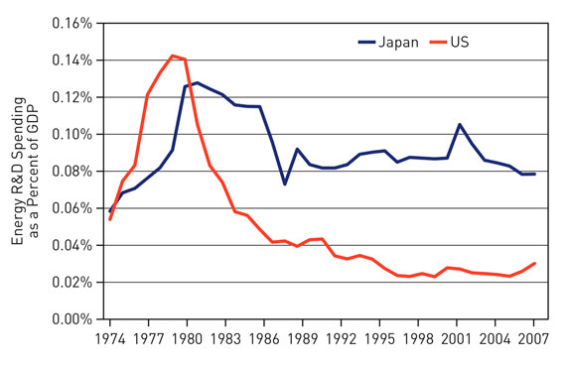
Fig. 1.3. Energy R&D Spending as % of GDP [24]
In the final analysis, in order to successfully address climate change, the private sector must play a major role in technological innovation. Reliable data on private sector funding for energy-related R&D is not easily available. Estimates by the International Energy Agency (IEA) and other institutions indicate that the current rate of R&D expenditure in the energy industry is much lower than that of industries such as pharmaceuticals, biotechnology, software, and computer services-the profitability of these industries is more dependent on the ability to create new or improve The product. In the energy sector, the power industry’s R&D expenditure as a percentage of sales tends to be the lowest. This shows that there is a need to increase private sector investment in research and development significantly to develop and commercialize new low-emission technologies to meet climate change. In turn, government policies must provide the signals and potential markets needed to stimulate private sector investment in research and development to reduce greenhouse gas emissions.
Technological innovation to reduce greenhouse gas emissions also requires more skilled workers, especially engineers and scientists in various disciplines (including social sciences). Limited data in the United States shows that the current percentage of R&D personnel in the total labor force in the energy industry is far below the average level of all industries in the United States. In the past two decades, the proportion of American engineering college graduates has also declined significantly (NRC, 2010a). Although other countries show more favorable trends, they need to intensify efforts to guide human resources and talents to focus on supporting innovations to mitigate climate change.

Of course, in an ideal world, all citizens and companies will voluntarily adopt better practices to reduce environmental damage. But let's face it - voluntary compliance is difficult to achieve, and the planet has no time to waste. On the contrary, technological developments such as automation and artificial intelligence help people to take immediate steps to achieve sustainability. There has never been such an exciting moment for environmental technology and innovation.

The following examples can have a lasting positive impact - from small projects focused on solving specific environmental problems to large-scale initiatives launched globally.

Under the sea

The ocean can play an important role in preventing global warming. Some of the last primitive, pristine wilderness areas on the planet are found on the ocean floor. Marine ecosystems, especially coral reefs, are increasingly affected by climate change, pollution, unsustainable fishing practices, growing offshore industry and human exploration. Robot experts and engineers are working hard to solve this problem, looking for new ways to create technological advances to inspect, maintain or repair aquatic organisms.

But let's face it-voluntary compliance is difficult to obtain, and the planet has no time to waste. On the contrary, technological developments such as automation and artificial intelligence are helping humans take immediate steps to achieve sustainability. For environmental technology and innovation, there has never been such an exciting moment.

The following examples show how a wide range of technological advances can have a lasting positive impact from small projects focused on solving specific environmental problems to large-scale initiatives launched globally.

Wildfire

Fire is one of the earliest technological "inventions" of mankind. However, we have always known its destructive power. Climate change has led to more frequent wildfires, which has had a devastating impact on property, wildlife, and human life on a global scale. Between 2018 and 2020, parts of Australia and the USA were ravaged by bushfires. The Australian fire killed approximately 3 billion animals and destroyed 97,000 square kilometers of land. Researchers are studying how technology can provide more early protection to help avoid these apocalyptic scenarios. Ericsson ONE in-house entrepreneurs are currently working on a new design that will allow the use of network extensions, sensors and edge computing devices to detect wildfires in remote areas early. This technological advancement will replace satellite systems that are slower and unable to detect small fires, as well as aerial systems that have limited range. Most importantly, the new setup will allow low-cost deployment of networks and sensors, which will make solutions in underserved areas affordable.

Reduce plastic waste

Walk along the plastic brick road you will soon eat or drive with an old water bottle. Most of us know that most plastics in the world are not recycled in conference factories.

To solve this problem, researchers have proposed a wide range of solutions-from melting plastic to building roads, or completely removing plastic bottles and using seaweed to make containers. We may never look at plastic water bottles in the same way again.

But what measures are being taken to remove the more than 5 trillion pieces of plastic that have been scattered in the ocean? Ocean Cleanup estimates that it will take thousands of years and billions of dollars to solve this problem only through traditional methods (ships and nets). When you realize that there are not one but five garbage dumps in the ocean, you will realize the seriousness of the problem. The largest Great Pacific garbage patch was blocked by 80,000 tons of plastic—the equivalent of 500 jumbo jets. Ocean Cleanup has brought together engineers, researchers, researchers and computer developers to develop solutions: long floating barriers act as artificial shorelines, allowing wind, waves and ocean currents to passively capture and concentrate plastic. They also converted plastic extracted from the Great Pacific Garbage Strip into sunglasses, thus fulfilling their mission. This is undoubtedly an example of how technology “turns garbage into treasure”.
Old clothes recycling
This is an amazing statistic: It takes 10,000 to 20,000 liters of water to produce a pair of jeans. In order to significantly reduce this water consumption, the Swedish sustainable technology company Renewcell has developed a new method to reprocess old clothes-in the process water consumption has been reduced by 80%. Approximately 80 billion pieces of clothing are produced worldwide each year, with huge potential for recycling.
5G is creating superheroes in pajamas
During the coronavirus pandemic, humans can directly support the environment simply by working at home in their pajamas. The "closure" of the world has had a positive impact on nature. The air quality has improved dramatically, and the degree of air pollution has been greatly reduced-this has even led to a surge in the number of bees. Water quality has improved and wild animals have begun to return to urban areas. Essentially, connectivity allows society to continue to operate during a pandemic, and the sky seen by fewer commutes is also reduced. The introduction of 5G will continue this trend, and many employees find that they can work anywhere and enjoy the best Internet connection. In fact, GWA estimates that by the end of 2021, 25% to 30% of the workforce will work from home multiple days a week.
Renewable Energy
In the past decade, renewable energy has been a buzzword - but it's not just hype. The sources of these natural supplements include sunlight, wind, rain, tides, waves, and geothermal. In recent years, some of the most recognized and important advances in environmental protection technology have been in the field of clean energy. Renewable energy sources such as solar, wind, and hydropower have become more popular and cheaper. The sector is expected to continue to grow at an alarming rate. Global renewable energy installations hit a record high in 2020-experts predict that by 2025, it will surpass coal to become the world's largest energy source.
Imagine a world, from smart cars to the Internet of Things, all kinds of environmental technology devices and sensors can communicate without human involvement. Experts predict that the future city will be a place where all cars, telephones, air conditioners, lights, etc. are connected to each other, thus bringing the concept of energy-saving smart cities. I believe that the earth is looking forward to these technological advances.
Technology is responding to some of the most pressing environmental challenges in the world. There is still much to be developed and improved, but preliminary results indicate that the future of our planet is exciting and beneficial.

In Switzerland, e-mobility is not as developed as in the Netherlands. Despite the fact that the number of electric cars in Switzerland, as well as in the Netherlands [51], it is still worth noting that the population of this country is twice smaller. Accordingly, Switzerland's electricity charging infrastructure is relatively weak. It is organized separately in each canton, but the cantonal charging systems are not connected. Accordingly, the Swiss Federal Government has prepared a public tender for the installation of a universally available platform for charging on Swiss highways [51].
The Swiss federal government sees e-mobility as one way to improve green policies. The Swiss parliamentary group Electro Mobility and the Swiss Emobility Forum are important players in the Swiss market to stimulate and improve Emobility. The Swiss Parliament published the Master Plan for e-mobility in 2015, which sets out the main measures for the development of e-mobility [24].
Sometimes there are doubts about their viability due to the excessive amount of energy required for charging. However, academic consensus has confirmed the sustainability of the effects: approximately 95% of EV studies emit lower CO2 emissions from electric cars compared to gasoline cars.
Thus, in March 2018, at the exhibition of new models at the International Motor Show in Geneva, the company "Goodyear" presented a unique concept tire "Oxygene", which is a transition towards sustainable urban mobility. This tire is lined with living moss, which acts as an effective air filter [5].
The open design of the tire and the tread design absorb and circulate moisture and water from the road surface, which allows photosynthesis, thereby releasing oxygen into the air [5]. The tire makes it possible to significantly reduce air pollution. In a city of about 2.5 million vehicles, Goodyear estimates that Oxygene tires produce about 3,000 tons of oxygen and absorb more than 4,000 tons of CO2 per year.
The concept of such a tire is designed taking into account the principles of the circular economy with an emphasis on reducing material costs, emissions and energy losses. Oxygene tires are made of rubber powder from recycled tires. They have a light, cushioning structure, are strong and resistant to punctures, which extends the shelf life and minimizes the problem of their service.
The energy consumption of the Oxygene bus during photosynthesis is used to turn on the bus's built-in electronics, including on-board sensors, an artificial intelligence unit, and a tuned light strip in its sidewall that switches colors to warn both road users and pedestrians. about future maneuvers, such as rerouting or braking.
The concept bus also uses a visible light system (LiFi) for high-performance mobile connections. LiFi equips the bus with the capabilities of the Internet of Things, which allows the exchange of data between vehicles, which is an important component of the intelligent mobility management system [5].
Thus, the company aims to direct discussions towards "smart", safe and stable mobility in the future.
For example, in China, extended manufacturer liability is the official standard in the automotive industry. Thus, manufacturers of electric vehicles (EVs) are assigned the task of creating facilities for the collection and recycling of used batteries [5].
About a decade ago, the Chinese government began advertising electric vehicles to reduce vehicle emissions and take advantage of available economic opportunities. As a result, the production of lithium batteries increased sharply in line with growing demand [37].
Under a new government decision, automakers will have to renew batteries in new vehicles to generate energy. The government also controls companies responsible for repairing or replacing old batteries, facilitating the development of this service. It is recommended that such companies assist consumers by providing subsidies and appropriate charge redemption packages.
The government is also working to ensure transparency in the sector in order to establish a system for tracking the owners of discarded batteries. Although the impact of the new rules is not fully defined, they are an important step in addressing some of the key issues that arise in the transition to the use of electric vehicles.
General Motors (GM) continues to focus on waste-free production and consumption, expanding its break-even industry to all of its manufacturing facilities in Canada, Mexico and South America. According to this program, at 27 new certified enterprises, all waste received from daily operations is recycled, ie reused [51].

  - Innovation is the driving force of change

Society is changing rapidly. Many drivers of change interact in an extremely complex interaction of human needs, desires, activities and technologies (European Economic Area, 2019a) and contribute to the "great acceleration" of human consumption and environmental degradation. As the mass introduction of innovative products and services, as well as the integration of technological culture, has shown, the pace of change and the speed of innovation are also accelerating. For example, digitalization is now part of the daily lives of most people and almost all sectors of the economy.
Technological innovations are also rapidly being integrated with new clusters and applications, integrating digital technologies (such as big data analysis, artificial intelligence and blockchain) with the fields of physics (eg. nanotechnology) and biology (eg. biotechnology). "Four industrial revolutions".
These changes are happening at an unprecedented rate and scale, creating great opportunities and serious challenges for sustainable development (EEA, 2020b). As far back as 2001, a report by the European Economic Area concluded: “Science's growing capacity for innovation seems to outweigh its ability to anticipate its effects, and the scale of human intervention in nature increases any dangerous impact that could occur.” (European Economic Area, 2001).

Innovation and novelty are the guiding principles of the New Industrial Strategy of the European Union (EC, 2020b) and one of the forces of the European Green Agreement (EC, 2019a). The same applies to the European Strategy 2020 (EC, 2010). However, we cannot know in advance the results and impact of the innovation process.
Innovation can lead to gradual change and thus develop to the expected results, but it can also lead to destructive changes and unintended consequences. When large-scale technology implementation requires infrastructure construction and affects market organization and social order, technological innovation can also lead to blockages and dependence on the path.
Obviously, innovation has great potential to change society. But so far market forces and public policy have not been able to direct this potential to sustainable development. People are increasingly realizing that too much human and financial capital is being invested in the production of wasteful or harmful products (such as sophisticated weapons or financial instruments) rather than in response to society's most important challenges. In the process of market innovation, social interests are often marginalized.
Another important lesson in the history of innovation is to prepare for uncertainty.

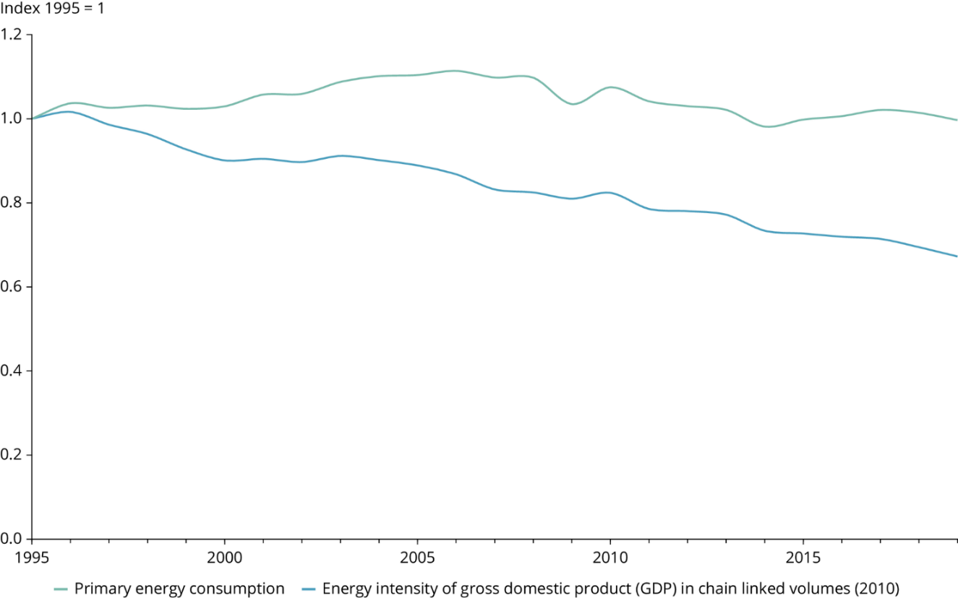
Fig.1.5. Indexes of primary energy consumption [31]

At the same time, the basic ideas of the sharing economy (sharing economy) should be outlined, which is an economic model often defined as an activity based on equal (P2P) acquisition, provision or sharing of goods and services facilitated by the on- line community based. Communities of people have shared the use of assets for thousands of years, but the advent of the Internet - and its use of big data - has made it easier for asset owners and those seeking to use these assets to find each other. Such dynamics can also be called the share of the economy, joint consumption, the economy of cooperation or the economy of peers. Sharing economies allow individuals and groups to make money on non-performing assets. Thus, physical assets are divided as services. Take, for example, car-sharing services like Lyft and Uber. According to the Brookings Institution, private vehicles are not used for 95% of their lives. The same report details Airbnb's benefits over hotel value over hotel space, as homeowners use available bedrooms. Airbnb rates are reported to be 30 to 60% cheaper than hotel prices worldwide. The sharing economy has evolved over the past few years, where it now serves as an all-encompassing term for a range of online economic transactions, which may even involve business-to-business interactions.
Other platforms that have joined the sharing economy include:
- collaboration platforms - companies that provide joint jobs for freelancers, entrepreneurs and home workers in large cities.
- Peer-to-Peer lending platforms are companies that allow individuals to lend to other individuals at rates that are cheaper than those offered through traditional lending institutions. Fashion platforms - sites that allow people to sell or rent their clothes.
- freelance platforms - sites that offer collaboration with freelancers in a wide range, from traditional freelance work to services that are traditionally reserved for handymen. Accelerated, primarily by the growth of Uber and Airbnb, the sharing economy will grow from $ 14 billion in 2014 to the projected $ 335 billion by 2025.
Modern critics of the sharing economy often draw attention to regulatory uncertainty. Businesses that offer rental services are often regulated by federal, state, or local governments. Unlicensed rental providers may not follow these rules or pay the associated costs, giving them an "unfair" advantage that allows them to offer lower prices. There are also fears that more information posted on the online platform may create racial and / or gender bias among users.
Airbnb had to face complaints of racial discrimination from African-American and Latin American tenants. In what is called shared consumption, the sharing economy, or the peer economy, homeowners rent out what they do not use, such as a car, house, or bicycle, for a stranger through these peer services. The company usually has an eBay rating system or a review system so that people on both sides of the deal can trust others. Due to the popularity of these services, many people do not have to buy when they can rent others.

Conclusions for 1 chapter
Society is changing rapidly. Many drivers of change interact in an extremely complex interaction of human needs, desires, activities and technologies and contribute to the "great acceleration" of human consumption and environmental degradation. As the mass introduction of innovative products and services, as well as the integration of technological culture, has shown, the pace of change and the speed of innovation are also accelerating. For example, digitalization is now part of the daily lives of most people and almost all sectors of the economy.
Technological innovations are also rapidly being integrated with new clusters and applications, integrating digital technologies (such as big data analysis, artificial intelligence and blockchain) with the fields of physics (e.g. nanotechnology) and biology (e.g. biotechnology).
These changes are happening at an unprecedented rate and scale, creating great opportunities and serious challenges for sustainable development. As far back as 2001, a report by the European Economic Area concluded: “Science's growing capacity for innovation seems to outweigh its ability to anticipate its effects, and the scale of human intervention in nature increases any dangerous impact that could occur.”
Modern critics of the sharing economy often draw attention to regulatory uncertainty. Businesses that offer rental services are often regulated by federal, state, or local governments. Unlicensed rental providers may not follow these rules or pay the associated costs, giving them an "unfair" advantage that allows them to offer lower prices. There are also fears that more information posted on the online platform may create racial and / or gender bias among users.

CHAPTER 2
TECHNOLOGY-PUSH AND MARKET-PULL
2.1. Policy recommendations of technological innovations
on environment.
Businesses, governments and consumers are important agents in transforming the overall economy into more stable base. Enterprises are part of the offer economy and have the function of bringing new ones market innovation. Consumers on the demand side economies signal new benefits that may cause new innovation processes. Governments on the other the hand often intervenes when either businesses or consumers face obstacles in fulfilling their market function. One an important policy tool for this type of market intervention there may be taxation, which has proved to be a powerful tool in stimulating commitment to change the behavior of both sides of the economy. This section explains the role three agents play in the process of transforming into in more detail before giving their examples in connection with cases of electric cars, soft drinks and electronic cigarettes or heated tobacco products.
Business and technology push in any process, industry transformations and technological innovation, enterprises must play an important role. They promotion of innovation by the economy how entrepreneurs enter the market with new products and challenge existing products and technology status quo. Enterprises that develop new innovative products and production processes provide the basis for the transformation process because they perform important function of linking a new innovation with a new market demand. In fact, they are promoting a new technology Market. This is, in a nutshell, a well-known concept Schumpeter's creative destruction, that is, continuous the process of product innovation in which new technologies replace obsolete. As they say, business often face difficulties in trying to fulfill their technological function. For example, businesses may fail if there is demand for a new product initially low. Or with the initial investment costs of product development and market introduction high, businesses will refrain from developing new ones innovative products, and instead continue with existing ones business lines, rather than risk capital investment in new product category.
Consumers and market attraction Consumers also play an important role and new business opportunities may arise when the consumer preferences change, new innovations actually attract on the market. Consumers can signal new areas demand through your purchases and it will stimulate or encourage firms to invest to meet these new needs.
However, consumers also face obstacles in carrying out their tasks market function. Low demand for innovative products often associated with asymmetric information about benefits these new products. Consumers are often not fully aware about the significant potential for risk reduction certain new products that offer the environment or human health, or whether it is possible to fully trust or trust the statements of manufacturers. Since markets are often unable to assess existing negative externalities products that may be more harmful may be cheaper compared to innovative and less harmful alternatives, for which innovators initially set higher prices to recoup investment costs. This can lead to demand for The more harmful product remains high, as their price does not exist reflect negative externalities.
The government has an important task to create a equal conditions and thus determines the conditions under which the transformation can take place. Beyond that, governments can actively help businesses and consumers overcome barriers that may prevent them from performing their corresponding innovative functions, ie market attraction and push technology. One example of such a policy intervention is an excise tax. If business is reluctant invest in the development of innovative products through
Concerns about low demand, governments can reduce taxes on innovative products to lower prices and increase demand. Similarly, if consumers are bad informed of the potential risk of products, possibly due to the fact that prices do not take into account the full negative external effects of products that governments can use differentiated taxation to reflect the risk profile various products. This means taxing the ordinary, more harmful products at a faster rate than new, less harmful those.
Policymakers need to consider proactive approaches to political innovations, such as differentiated taxation, to stimulate development and consumption more sustainable technologies and products. The the latest progress made in the automotive sector since development of electric vehicles and the consumer goods sector with the commercialization of low-risk products demonstrates that adequate policy-making has opportunity to promote behavior or society change. Now technological development precedes policy-making, thus hinders innovation in many areas. If innovation has potential to bring a positive society and environment influence, policy interventions must be designed to encourage the introduction of such innovative technologies.
Encourage and reward innovation for more stable Europe The desire to “encourage and reward innovation a more sustainable Europe ”should be translated into a a step-by-step policy approach that encourages and supports sustainable development efforts. The first step of policy should be identify potential innovations that are more sustainable because they reduce the negative impact on the environment and public health.
The second step of the policy should be support innovations that can limit harm environment or public health through targeted policies measures. To make this possible, it is necessary establish appropriate product-based rules quality and safety standards to determine the risk profile this product to implement a policy (such as as differentiated taxation), which are proportional to reduced risk potential of these products.
The third step is to reward such innovations through incentives their consumption. An incentive from the government can be implemented in the form of a tax on research and development loans and allowances for expenses that would reduce the cost of research and this encourages innovation. However, this was not enough to solve acceptance by consumers.
Thus, as the fourth and final step, there is a need for a different taxation scheme, which leads to changes in prices for consumers, promote innovation products. In this regard, differentiated taxation may be a powerful policy tool. Another tax is required a scheme that applies differentiated product tax rates according to their risk profile. Such a tax system will be lead to an increase in the price difference between high-risk and low-risk products. This price difference sends a powerful signal to consumers and support acceptance innovative products. Creating, for example, a new one category of excise tax on heated tobacco or electronic cigarettes allows politicians to deal with special circumstances and the cost of this new product. In the energy sector, for example, a new category of excise tax may be external costs of contaminated activities.
Usually it rewards innovation for more Sustainable Europe Policy are policy instruments which provide incentives for innovation through tax credits for R & D and allowances for expenses and incentives to adopt Art innovations under new excise tax schemes.

2.2. New technologies for ecodevelopment.
The equivalent of one textile garbage truck is thrown away or burned every second and only 1% of clothes are recycled. Excessive water consumption and the amount of pollution from textile production and dyeing should also be taken into account, which characterizes the fashion industry as one of the least sustainable. However, companies such as the women's brand Eileen Fisher are tackling this acute problem in their industry with return programs for old textiles. Since 2009, E. Fischer has been running a program whereby customers and employees can return old clothes made by the company to its stores. In 2018, the company launched Eileen Fisher Renew and opened Tiny Factory, a warehouse of 21,000 square meters north of New York.
Nike Flyknit and Everlane: Production generates 60% less waste. The company's ReNew Reverable Huffed Puffer is made from recycled plastic bottles.
Gerrard Street: The United States generated 6.4 metric tons of e-waste in 2016. And that amount continues to grow as e-waste is one of the fastest growing segments of the country's waste stream. A popular business model for the circular economy offers a product as a service, and the Dutch company Gerrard Street uses this model for one source of electronic waste - headphones. The volume of e-waste is growing rapidly due to increasing demand for electronics with the constant updating of technology and the inability to recover many of its products. This also applies to headphones. The founders of Gerrard Street, Dorus Galama and Tom Leanders, acknowledged that headphones often fail after one year of use. To solve this problem, modular headphones have been developed, the parts of which can be replaced and upgraded.
Like a subscription to Spotify or Apple Music, users pay a monthly fee for their headphones. Some headphones, which cost from $ 300, are a cheaper and more reliable option. The production of headphones is a niche market. However, the circular design of Gerrard Street for headphones confirms that the modular design of the electronics and the subscription to the product model are effective.
Lehigh Technologies: More than 1 billion tires are recycled each year. At the same time, 50% of these tires are either sent to landfills or disposed of in incinerators, which makes it possible to obtain a valuable resource. Since 2007, Lehigh Technologies has been replenishing used tires using a cryogenic turbocharger. This process makes it possible to freeze rubber raw materials (used tires) and turn it into powder. The obtained micronized rubber powder (MRP) can be used as a raw material for industrial and consumer needs, replacing materials based on fossil fuels. In 2017, Lehigh teamed up with giant tire maker Michelin to achieve its sustainable development goals, using 80% of its own materials to produce tires and ensuring 100% recycling by 2048. Today, Lehigh serves the world market, receiving a total of more than 10 billion dollars. The range of its products is quite wide: asphalt, building materials, rubber, plastics and polyurethanes, tires and more.
However, many believe that it is not necessary to owe the invented disposable plastic. This year, inspired by a coalition of activist groups, Starbucks has promised to phase out the use of disposable plastic by 2020. McDonald’s and Starbucks are also working together to develop a compost cup of coffee. Thanks to the Ellen McArthur Foundation, 250 organizations, including brands such as H&M, PepsiCo and Unilever, as well as the World Economic Forum and 40 academic institutions, will work together to develop a circular economy for plastics.
The purpose of the activity is to abandon the widespread use of plastic, and to ensure that all plastic products used are recycled.
By 2025, the following task has been set: all plastic packaging must be reusable, recyclable or composted so as not to pollute the environment.
Zazubean Chocolate: Making chocolate bars is a complex process. The practice of making them varies from company to company. We are talking about social responsibility for harmful or undesirable components used in the production of chocolate, pesticides used in the cultivation of cocoa beans, as well as working conditions. It is worth supporting companies that produce environmentally friendly products. Zazubean is a Canadian company that produces the most delicious organic and environmentally friendly chocolate.
It supports its employees and those who grow cocoa beans. The company uses organic cocoa beans in production. This is the basis of production. Although cocoa beans are one of the crops that are most intensively treated with pesticides.
Abeego Foodwraps: Abeego Foodwraps manufactures natural, reusable food film. Recently, this Canadian company offered the world community reusable food packaging made of beeswax. This is, first of all, a product
New technologies make it possible to solve the main problems of urban livelihood. There are limited resources, the need for which will only increase with population. If some budget constraints on the use of available assets are removed, governments will be able to allocate more budget funds to areas such as education, medicine, the environment, and so on. The circular economy will also increase income, which is now a topical issue. And this will help create new business opportunities in cities that are interested in business development and innovation. In general, we outline the opportunities created by the activities of many people in the field of digital technologies and information communications, which allows to implement a significant number of local business models, apply innovations that ensure innovative use of assets and storage of products and materials at the highest level. at any time. At the same time, it can also inspire the creativity of business leaders and innovators.
Climate change issues are central to the functioning of production in large cities such as New York, London or Paris. If they want to reach zero or even half of their carbon emissions by 2050, they will have to rethink urban mobility, as well as the food system, water supply, and so on. Implementing a circular economy, it is possible to develop a systematic approach with economic justification.
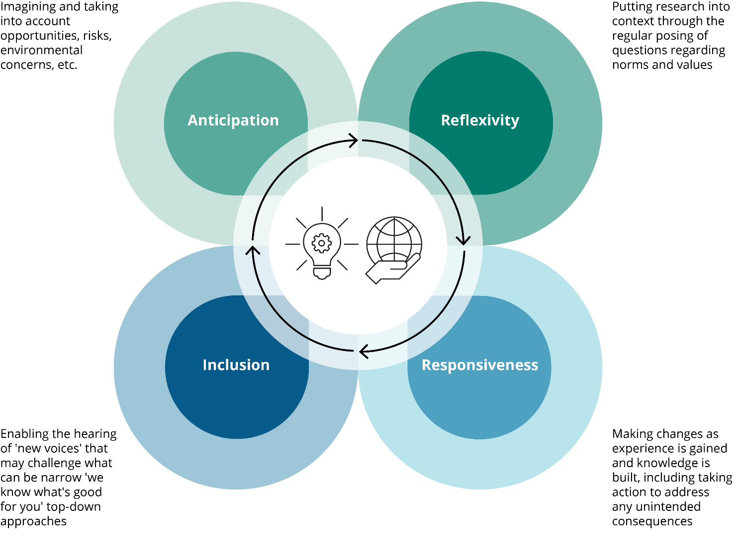
Fig.2.1. Climate change issues
There are many cities that implement innovative development models. For example, London is an innovative environmental project. At the same time, in a small town like Peterborough, they are working to create a circular economy with the involvement of the local business community. In total, an online platform called "Share Peterborough" has been developed with more than 100 sharing resources for sharing via the Internet. They are now also used. These are materials, machines, and sometimes even people who create the local ecosystem of enterprises. If you can't find out about these resources from outdoor advertising, visit the website with information about sharing platforms in cities that allow you to grow your business.
Autonomy in cities is a must, but it is necessary to create an economic and infrastructural framework for policies that will contribute to their prosperity. Otherwise, the consequences can be catastrophic.
For example, tomorrow the city will be completely circular. What will this mean? This applies to the construction of the houses in which we live, the transport we use, the type of our activity, food production, and so on.
The Copenhagen Development Model combines environmental initiatives, economic growth and improving the quality of life in real time based on innovative planning. The potential of a circular economy is job creation, economic growth, and efficient resource management.
Examples of manifestation and implementation of the basic ideas of the circular economy are the following startup companies [2; 23]:
- Thread: recycling of used bottles for shoe production;
- Looptworks: making clothes from recycled materials, balls and wallets - from airplane seats;
- LanzaTech: conversion of used carbon into fuel and chemicals;
- Method: making new bottles from plastic collected in the sea;
- Energizer: disposal of dried batteries and production of new ones;
- Dell: cleaning of computer garbage;
- Levi Strauss: updating clothes of any brand;
- H&M: production of a collection of jeans made from processed cotton in 2015;
- Unilever: recycling of waste for new packaging; the company saves more than 140 thousand tons of waste that is taken to landfill; buys more than 2 million tons of waste annually.

2.3. The impact of technology on the environment
Samsung is committed to achieving a greener future by improving our sustainability and reducing our environmental and carbon footprint. Therefore, we have invested heavily to minimize the impact of our operations on ecology, accelerate the design and development of green technologies, apply the principles of circular economy and guide consumers to make socially conscious decisions.
In the final effort to achieve the 2030 Sustainable Development Goals (SDG) or "Global Goals" of the United Nations Development Programme (UNDP), Samsung's education and donation-based app-Samsung Global Goals app-is being provided to Galaxy Users understand the meaningful ways of the 17 global goals-such as Goal 13: Climate Action and Goal 12: Responsible Consumption and Production-and take personal action. The Samsung Global Target App was created in 2019 and is currently used on more than 80 million Galaxy smartphones around the world. Thanks to the dedication and generosity of Galaxy users, we have raised more than US$1 million in donations to the United Nations Development Programme.
Galaxy Upcycling at home refreshes old phones
As part of Samsung’s commitment to creating a circular economy, we plan to expand our award-winning Galaxy Upcycling program to extend product life cycles and reduce waste. In the past, Galaxy Upcycling has transformed smartphones into medical devices that can screen for eye diseases in Vietnam. Now, by performing Galaxy Upcycling at home, consumers will be able to transform old Galaxy phones into various convenient home IoT (Internet of Things) devices through simple software updates.
For example, consumers will be able to transform Galaxy phones into childcare monitors, pet care solutions or other tools that meet their personal lifestyle and needs. For childcare services, you can use built-in sensors to monitor the sounds around your baby and sound an alarm when the baby is crying. For pet care, your Galaxy phone can become a remote remote control so that if your pet is alone at night, you can turn on the lights.
This earplug perfectly combines all-day comfort and refined style with cutting-edge audio technology, including unparalleled sound quality, intelligent active noise reduction and seamless connection. In addition, Galaxy Buds Pro-earbuds and charging case-both use 20% recycled plastic to help reduce waste.
In addition, Samsung will extend the innovative eco-packaging solutions we launched to creatively upgrade recycling bins into useful items instead of discarding or recycling. By eliminating oily ink and expanding eco-packaging in more products, Samsung now provides an interesting such as coffee tables, toy lockers or pet houses. Consumers only need to scan the QR code on the packaging box to launch the Samsung microsite, select the item they want to create, and then follow the "dot matrix" pattern instructions.
Artificial intelligence is solving sustainable housekeeping challenges. Samsung's artificial intelligence innovations continue to change the way consumers handle daily tasks. By incorporating artificial intelligence technology into our products, we are creating new home experiences, such as a revolutionary new washing machine that optimizes water, detergent and washing cycles. This optimization can reduce water and energy consumption, while providing users with a personalized laundry experience.
For example, the new 8800 series smart dial front-mounted washer and dryer have a powerful OptiWash function that detects the weight of laundry used in the cycle. It also determines the time to wash clothes to ensure that the clothes are the cleanest. In addition, the new 8800 series will become an Energy Star product, which means it meets EPA’s strict environmental standards and helps reduce greenhouse gas emissions.
At Samsung, we believe that we have a responsibility to tackle climate change and protect the planet for future generations. We are using our global influence and scale to directly solve these problems. Although we are proud of what we have achieved, such as the new and expanded plans, products, and packaging solutions we outlined above, we know that there is more work to be done, and it is us who build a sustainable future through bold innovation Top priority. We will continue to set new breakthrough goals to further reduce our impact on the planet, and will keep you informed about our journey.
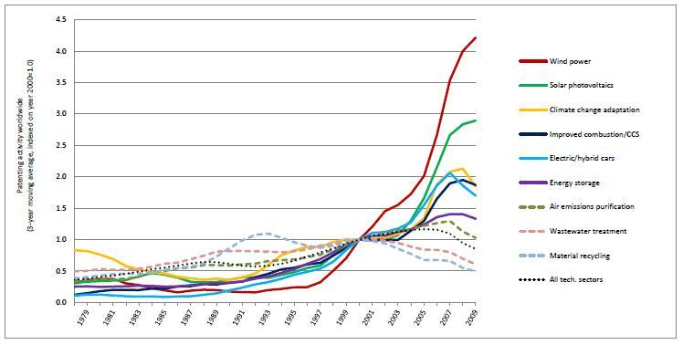
Fig. 2.2. Innovation in Environmental Technologies, Compared to All Sectors [27]

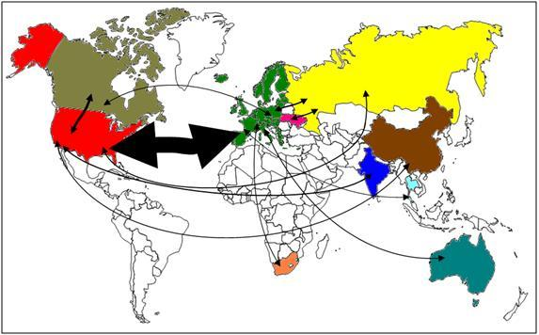
Fig.2.3. International collaboration in development of ‌wind power technologies: 1988-2007 [29]
Technological evolution has completely changed our way of life. Today, communication and numerous services are as remote as clicking a mouse or sending simple chat messages. Technology has evolved a lot, and with it comes the different resources needed to support the development of this technology. Our lives are affected by technological developments in so many different ways that it is difficult to quantify or list some of the most affected areas.
As in many other fields, technological evolution has had a huge impact on the resources we consume on the planet. Electricity also produces by-products that are harmful to our own health and the planet.
Electricity production
In the past two decades, energy production has more than doubled, which has had a huge impact on the Asian continent:

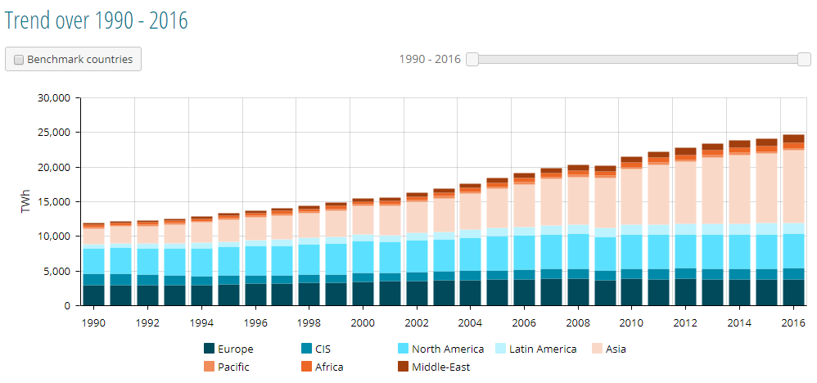
Fig. 2.4. Electricity production in world [22]

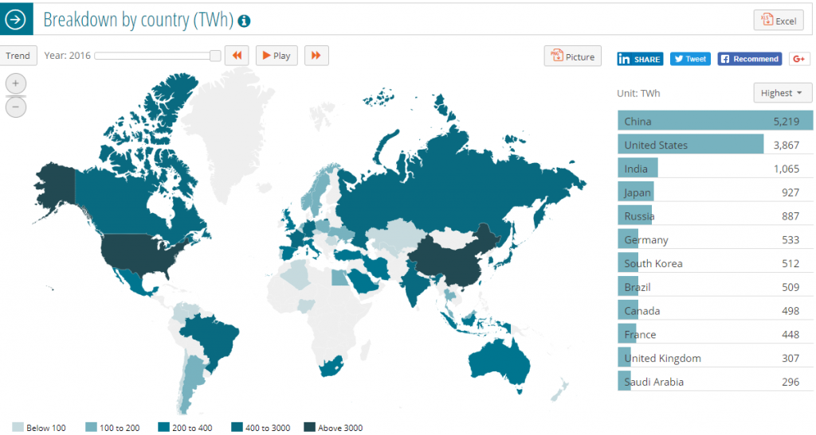
Fig. 2.4. Renewable energy sources production in world [22]

With this growth, and because more efforts have been made to introduce renewable energy sources only recently, most of the production comes from fossil fuel consumption, resulting in ozone holes and massive pollution. Until recently, a greater awareness and understanding of the interconnectedness of these facts allowed the creation of the necessary conditions to increase people’s awareness of the negative effects of using these resources in our lives, and the resulting political will to start making changes.
Global energy production
These figures can provide a reference for the growth of electronic equipment used in the past few years, and thus can estimate the energy required to maintain the normal operation of all these equipment.
In 2000, there were approximately 415 million Internet-connected devices, which are computers. In 2016, all equipment types accounted for about 3.5MM. This represents an increase of 826% in 16 years. It is expected that these numbers will increase dramatically over time with the introduction of other Internet-connected devices. It is worth mentioning that it is not clear whether these figures also include all the necessary network infrastructure equipment, such as servers and network equipment, needed to keep the Internet active.
Although most Internet services in use today are “cloud-based”, these services still require a physical computer to use. Large companies share IT resources through a data center with a large number of servers, while sharing the same building and cooling infrastructure, making it a more effective way to provide IT services. Nevertheless, data centers still require electricity to operate.
Estimation of the total electricity consumption (servers, storage, network equipment and infrastructure) of data centers in the United States from 2000 to 2020. In 2014, the electricity consumption of data centers in the United States was approximately 70 billion kilowatt-hours, accounting for approximately US total electricity consumption Current research results show that the power consumption of data centers has increased by about 4% from 2010 to 2014, which is very much from the 24% growth estimated in 2005-2010 and the nearly 90% growth estimated in 2000-2005. A major shift. Energy use is expected to continue to grow slightly in the near term, with a 4% increase from 2014 to 2020, which is the same as the past five years. According to current trends, US data centers are expected to consume about 73 billion kilowatt-hours by 2020.
This means that with the increase in the number of IT equipment used, the demand for electrical energy is expected to increase, as neither electrical energy consumption nor thermal efficiency has significantly improved in the past few years.
It is worth mentioning that in the near future, electric vehicles will become an affordable reality, thereby boosting the demand for electricity. In addition, the fast battery charging-related technology being developed in this field consumes a lot of energy to charge as quickly as possible.
Digital currency mining
As a new trend, digital currency mining has become very popular. Unfortunately, due to the complex calculations required to mine it, the power required for these operations is very high. As a direct by-product of this operation, a large amount of heat is generated, which in turn requires the use of air conditioners or other similar equipment that also consumes electricity for cooling, thereby generating additional heat as a by-product.
According to digiconomist.net, the estimated annual electricity consumption of coin mining is about 66 TWh/year, which accounts for about 0.3% of the world's energy consumption. Compared with the actual value of our daily needs, it occupies a large share. Because this is a digital commodity that is traded in the same way as any other commodity, the value comes only from speculation and what others think is worthwhile. It has no real value, nor has it brought any benefits to mankind, because it is not an acceptable form of currency. This makes digital coin mining completely waste precious resources.
Electronic equipment production and its impact
Electronic devices are manufactured using some of the most common resources on the planet, such as sand and some of the rarest resources, such as gold. In addition, extremely dangerous and harmful chemicals such as lead and mercury are used in this process.
These materials need to be extracted from the earth and do not always follow the most ecological or environmental methods, especially in the poorest countries where affordable and efficient mining and processing equipment is not available, and most importantly, knowledge on related topics is not available. And be aware of environmental protection. In these places, in order to extract certain materials, extremely dangerous chemicals, such as mercury, are used. Those are dumped underground without any treatment or attention to the environment or even the areas where people live. The poorest countries are severely affected by such industries.
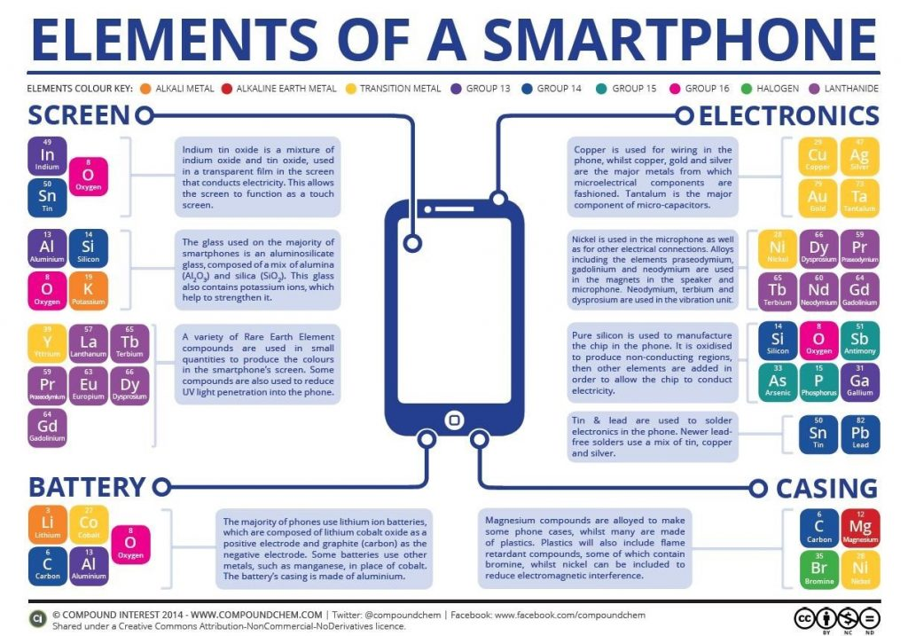
Fig.2.5. Elements of a smartphone production [17]
Building today's equipment (typically with a service life of about 2 to 3 years) requires a lot of resources. In order to build an ordinary computer, it needs:
• The weight of fossil fuel is 3 times its weight
• Use 630 grams of fossil fuel per gram of silicon wafer
• For 2 grams of microchips, 1.5 kilograms of fuel and chemicals
• A personal computer needs about 1.5 tons of water to make
• 22 kg of hazardous chemicals. Extremely dangerous and harmful, such as lead
The way we can reduce this impact is to maximize the use of our equipment. When they become obsolete, they can be reused, for example, by donating them to charities or converting them for other purposes that require lower processing power (for example, home automation equipment).
When their lives are over, it is vital to dispose and recycle equipment in a responsible manner so that they can be reborn to achieve new purposes. Never dump electronic equipment in the regular household garbage disposal.
Recycling is the only acceptable solution for our electronic equipment. Although, due to the need to separate the different materials used in the manufacturing process, there are costs associated with this process. Some countries choose to levy some taxes on the purchase of new equipment to support the recovery of part of the cost of electronic equipment.
Although the cost of recycling is high. For example, recycling aluminum can reduce energy consumption by up to 95%. The savings in other materials are small, but still large: plastic is about 70%, steel is about 60%, paper is about 40%, and glass is about 30%. Recycling is also possible Reduce the discharge of pollutants, which can cause smog, acid rain and water pollution.
Eurostat maintains an indicator of the recycling rate of electronic equipment. This ratio is calculated as the number of new equipment sold and the number of recycled equipment. As can be seen from the above chart, although this ratio has been increasing, it was still about 35% in 2015.

Finally, everyone is responsible for ensuring that every electronic device, battery, charger, etc. is properly disposed of and sent to the recycling center. It has been found that it is very common to dispose of batteries as ordinary garbage. These pose a huge threat to our health and cause serious environmental damage.
For humans, lead and cadmium can only be ingested through ingestion or inhalation. Mercury and other harmful metals can even be absorbed through the skin, although it has been reduced due to laws and regulations that have been implemented (such as the U.S. Battery Act, 1996). The content of this metal in the battery has been greatly reduced.
These harmful substances penetrate the soil, groundwater and surface water through the landfill, and release toxins into the air when burned in the municipal waste burner. In addition, cadmium is easily absorbed by plant roots and accumulates in fruits, vegetables and grasses. In turn, impure water and plants are consumed by animals and humans, and then fall prey to a series of adverse effects.
In addition, if potassium leaks, it can cause severe chemical burns, which can affect the eyes and skin. Landfills can also produce methane gas, leading to the ‘greenhouse effect’ and global climate change.
We live in a society where environmental conscience does not generally exist. This is the reality of all sectors of our society. Most governments are not determined to make major changes, because society has no clear and strong motivation to support such movements.
In addition, in most people’s lifestyles, if every material item is disposable, not many people care about using recycling centers to dispose of these items in the correct way. Usually the easiest way to dispose of these items is simple. Throw things away from the common garbage disposal. How many times have you provided a plastic straw on the bar to drink your drink, or simply dropped it into your glass? How many times have you rejected plastic straws? Well, most of these tiny plastic straws will eventually turn into ordinary garbage, or in the process, float in the ocean (for many reasons). Small actions such as rejecting plastic straws can have a significant impact on the environment. This applies to many other situations. Simply think about what you throw away and you will get it in a few minutes. Refuse to use these things.
Companies are also interested in profit, and environmental issues are completely inconsistent with profit. Respect for the environment requires a price. Even if there is no cost, usually the simplest method is chosen, the residue (by-product of the production process) is dumped directly in nature without proper treatment.​​​​ This usually pollutes the soil or water on which we depend. People often find areas where people's health is affected by such behaviors. In some cases, because it is cheaper to do so, companies will hire laboratories to "create" results that are beneficial to the company. In the 1960s, a company in the United States did this.
The company is also interested in selling new equipment, rather than extending their lifespan. Evidence is usually found that the equipment was built for a certain number of uses and then thrown away. Generally, the cost of repairing equipment (such as mobile phones) can be very close to the cost of new equipment. In some cases, the manufacturer will install parts that will be damaged during disassembly to deliberately avoid repairs.
In addition, the company is driven by profits, and it is a common strategy in the industry to design products with a lifespan that is much shorter than technically achievable. In many cases, especially on electronic devices, manufacturers usually include a “suicide” function, which will be automatically activated after a period of use or the number of times of use, even if there is no problem with the device.
Everyone is responsible for running their lives in a sustainable way. This can be achieved by minimizing the resources used, such as packing, driving, shopping. Some things that have a positive impact on the environment include maximizing the use of material products, refusing to use plastic products, and saving water and energy. Using public transportation during commuting every day is also a good way to save the planet.

Fi.2.6. The 3R policy
Source: made by author

For example, making a new car and then letting an old car continue to run (even if it is a car that emits more pollution) is much more harmful to the environment. Specific to IT companies, there are also things that can be done. It is conceivable that most companies in this field have a large amount of e-waste. The company needs to ensure that these items are properly disposed of to the recycling center. In addition, in terms of energy consumption, even if you are using "standby", it is common to let your computer or screen run at night for no reason. Even if you only use the remaining battery, why not turn off these devices at night? Smart lighting or air conditioning, garbage sorting are also on the list. How about a plastic cup for water or coffee? How much do you use every day and why can't it be made of reusable glass?
Renewable Energy
Investing in renewable energy is also an excellent way to help transform to a greener economy, while at the same time restoring economic benefits without causing significant damage to the environment. Buying solar panels has never been so cheap, and solar panels can be used to generate electricity for most needs. There are small solar panels that can be used to charge mobile phones, and there are also large solar panels that can power the entire building, not to mention drastically reducing energy-related costs.
Many companies and governments are investing in this area, not only for ecological benefits, but also to reduce neighboring countries’ dependence on electricity and help reduce the trade deficit.
There are many ways to invest in this area. Those who cannot afford or do not have the necessary space to purchase solar panels may be able to obtain positions in investment funds in the field and may gain some monetary gains in the process. There are great concessions in this area, and you can usually buy them at regular banks. These products usually provide low but regular profit distribution or investment appreciation. By investing in all available renewable energy, these investments are cross-sectoral. In addition, these funds usually also invest in research and development in this area. The interesting fact is that oil companies are also investing in this area, which indicates that even these companies are aware of the impending mentality shift.
Conclusions to chapter 2.
These harmful substances penetrate the soil, groundwater and surface water through the landfill, and release toxins into the air when burned in the municipal waste burner. In addition, cadmium is easily absorbed by plant roots and accumulates in fruits, vegetables and grasses. In turn, impure water and plants are consumed by animals and humans, and then fall prey to a series of adverse effects.
In addition, if potassium leaks, it can cause severe chemical burns, which can affect the eyes and skin. Landfills can also produce methane gas, leading to the ‘greenhouse effect’ and global climate change.
We live in a society where environmental conscience does not generally exist. This is the reality of all sectors of our society. Most governments are not determined to make major changes, because society has no clear and strong motivation to support such movements.
In addition, in most people’s lifestyles, if every material item is disposable, not many people care about using recycling centers to dispose of these items in the correct way. Usually the easiest way to dispose of these items is simple. Throw things away from the common garbage disposal. How many times have you provided a plastic straw on the bar to drink your drink, or simply dropped it into your glass? How many times have you rejected plastic straws? Well, most of these tiny plastic straws will eventually turn into ordinary garbage, or in the process, float in the ocean (for many reasons). Small actions such as rejecting plastic straws can have a significant impact on the environment. This applies to many other situations. Simply think about what you throw away and you will get it in a few minutes. Refuse to use these things.
Companies are also interested in profit, and environmental issues are completely inconsistent with profit. Respect for the environment requires a price. Even if there is no cost, usually the simplest method is chosen, the residue (by-product of the production process) is dumped directly in nature without proper treatment.​​​​ This usually pollutes the soil or water on which we depend. People often find areas where people's health is affected by such behaviors. In some cases, because it is cheaper to do so, companies will hire laboratories to "create" results that are beneficial to the company. In the 1960s, a company in the United States did this.

3 CHAPTER
THE INTERNATIONAL POLICY GOAL OF GLOBAL CLIMATE CHANGE
3.1. The technical impact and challenges

The international policy goal of global climate change was established in 1992 under (UNFCCC). So far, 192 countries have passed the UNFCCC goal. Scientific research attempts to better understand and quantify the links between human activities, greenhouse gas emissions, the resulting increase in atmospheric concentration, the consequent changes in global temperature, and the effects of these changes (Figure 4). The biggest uncertainty lies in the link between global temperature increases and the resulting effects. However, based on current science, many policymakers around the world advocate a long-term global temperature rise of no more than 2°C as a climate policy goal needed to prevent dangerous effects. Achieving this goal requires action to stabilize atmospheric greenhouse gas concentrations at levels only slightly higher than current levels. According to a recent study (IPCC, 2007b), this in turn requires that by 2050 annual global greenhouse gas emissions be reduced by 50% to 80% from 1990 levels.
The technical impact and challenges to achieve this goal are daunting. These results show that there is no single solution or way to achieve a substantial reduction in greenhouse gas emissions-different models provide different solutions based on different assumptions about the future availability and cost of alternative technologies and other factors. However, all models emphasize that the energy system needs to undergo dramatic changes because this is the main factor in climate change.

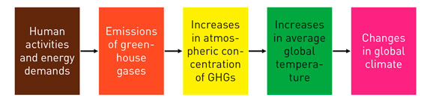
Fig. 3.1. Key linkages between human activities and global climate change [31]

Today, approximately 85% of the world's energy is provided by fossil fuels. About half of this is oil (mainly used for transportation), followed by roughly equal amounts of coal (mainly used for power generation) and natural gas (used for various household and industrial heating applications, and increasingly for electricity generation). The CO2 released when these fuels (mainly from power plants and automobiles) are burned is the main source of greenhouse gas emissions. Achieving the transition to a sustainable low-carbon (ideally zero-carbon) energy system is our main challenge in avoiding potentially dangerous climate change.
Large-scale technological changes are needed to achieve a substantial reduction in global greenhouse gas emissions. The results in Figure 5 illustrate four overall strategies that can be used to change the energy system of a country or region: 1. Reduce the demand for energy from all major economic sectors (buildings, transportation, and industry), thereby reducing the need for fossil fuels; 2. Improve energy efficiency, and meet the "end-use" energy demand with fewer fossil fuels, thereby reducing carbon dioxide emissions; 3. Use low-carbon or zero-carbon alternative energy sources such as natural gas and nuclear energy, as well as biomass, wind energy, solar energy, etc. Renewable energy replaces high-carbon fossil fuels such as coal and oil; 4. Capture and sequester CO2 emitted from fossil fuel combustion to prevent it from being released into the atmosphere.
As shown in the scenario (80% reduction in emissions by 2050 compared to 1990), all four methods are required to reduce emissions at the lowest cost. The reduction in energy demand, including the effect of improving efficiency, plays the most prominent role in all but one of the five models shown. In all cases, the uncontrolled burning of coal has been eliminated or greatly reduced, and the direct use of oil and natural gas has also been reduced compared to the 2000 reference case. In contrast, the use of nuclear power, biomass energy, and non-biomass renewable energy (mainly wind energy) in these studies has increased significantly. The same is true for the use of carbon capture and storage (CCS). This technology can capture carbon dioxide from power plants and other large industrial sources, and then isolate it in deep geological formations or depleted oil and gas reservoirs. In recent years, this choice has attracted widespread attention worldwide, and efforts are currently being made to develop and prove the applicability of CCS in mitigating climate change.
In short, the development and adoption of new technologies is an essential element of any comprehensive response to global climate change. But technological change of the required scale cannot happen overnight. For example, in order to achieve the substantial reduction in carbon dioxide emissions based on Figure 5, the United States alone must retrofit or replace hundreds of power plants, tens of millions of cars,.
Many of the required technologies for power plants, have not yet gained widespread social and political acceptance. Since the development and adoption speed of new technologies will respond to government policies and market forces such as energy prices, we will then pay more attention to affect them.
The process of technological change
As discussed elsewhere the four commonly used descriptive words are (fig.3.2.):

Fig. 3.2. The technological change’ stages
Source: made by author

However, as used here, it only refers to the creation of a commercially available product or process; it does not mean that the product will be adopted or widely used. This happens only when the product is successful in the last two stages-adoption and dissemination, which reflects the commercial success of technological innovation. These two stages are inevitably vital to reducing greenhouse gas emissions through technological change.
The study also shows that the four stages of technological change are not a simple linear process of stage after stage, but are highly interactive, as shown in Figure 6. Therefore, innovation is not only stimulated by R&D, but also stimulated by R&D experience. Early adopters and additional knowledge gained as the technology enters the market more widely. Therefore, "learning by doing" (economy in product manufacturing) and "learning by using" (economy in product operation) are usually (but not always) key elements in the adoption and dissemination of new technologies. With ongoing research and development (sometimes called "learning through search"), these stages often help improve performance and/or reduce the cost of new technologies-these trends are often characterized and modeled as "learning curves" or "experiences" The curve "" (IEA, 2000; McDonald and Schrattenholzer, 2002).
We must also look at and consider large-scale changes from a "systems" perspective, because the success of any new technology often depends on other technical and non-technical factors. For example, the popularization of energy-saving technologies such as air conditioners and water heaters that can automatically adjust home appliances may depend on the development and popularization of "smart grid" technology in the power grid. Similarly, the spread of energy-efficient appliances may be inhibited by institutional arrangements, such as the relationship between landlords and tenants, in which neither party has the incentive to buy more expensive but more energy-efficient appliances.
Significantly reduce greenhouse gas emissions requires action, not only to deploy the low-emission technologies available today, but also to promote innovation in the new technologies needed. Therefore, in recent years people have become more and more interested in ways to promote such innovations, especially the role that the government can and should play in this process.
Although research and development are a major element of the innovation process, people are increasingly aware that technological innovation is a complex process that usually involves interaction with other stages of technological changeIn this article, a key question is: Which strategies and policies can most effectively promote technological innovations that help reduce greenhouse gas emissions? As mentioned earlier, greenhouse gas emissions mainly depend on the type of energy and technology used to provide the goods and services that society seeks. Therefore, technological innovation can help reduce greenhouse gas emissions in many ways (NRC, 2010). E.g:

• New or improved technologies can make vehicles, machinery and electrical appliances use energy more efficiently, thereby reducing energy use per unit of useful products or services (such as driving one mile or first-class lighting) and greenhouse gas emissions for lighting) .

• New technologies can create or use alternative energy carriers and chemicals, and each unit of useful products or services (such as renewable energy or new low-nitrogen fertilizers) emits fewer greenhouse gases.

• New technologies can create alternative ways to provide goods and services that are less greenhouse gas intensive (for example, through the use of alternative products or materials with lower greenhouse gas emissions, or promote larger system-wide changes, such as teleconferences) Replace car and air travel and telecommuting).

3.2. The need for technological changes.

Technological innovation can promote this full range of possibilities. Broader innovations will include social and institutional systems and designs. For example, innovations in urban planning and development can help reduce future transportation and energy requirements (and related greenhouse gas emissions) for residential and commercial buildings. Institutional innovation can encourage power companies and others to invest in measures to reduce energy demand, rather than policies that are conducive to increasing energy sales.

In this modeling study, the "business as usual" case (including the historical speed of technological improvement) was compared with the case of faster technological change. When "advanced technology" becomes available, the cost of meeting strict emission reduction programs will be greatly reduced. This reduction in unit emission reduction costs translates into substantial national and global cost savings, especially as emission reduction requirements become more stringent over time.
Greenhouse gas emissions is that there is almost no market for many of the more efficient and low-emission technologies needed. For example, if there are no requirements or incentives to significantly reduce carbon dioxide emissions, which power company would be willing to spend a lot of money on carbon capture and storage technology? How many people are willing to buy advanced electric vehicles that cost much more than traditional cars, just to reduce their carbon footprint? Costly actions taken by a company or individual to reduce greenhouse gas emissions provide little or no tangible value to the company or individual. Only through government actions that require or make it economically worthwhile to reduce greenhouse gas emissions can a substantial market be created for products and services that achieve such emissions reductions. Therefore, the government's action to create or strengthen the market for greenhouse gas emission reduction technologies is a key element of the technological innovation process.
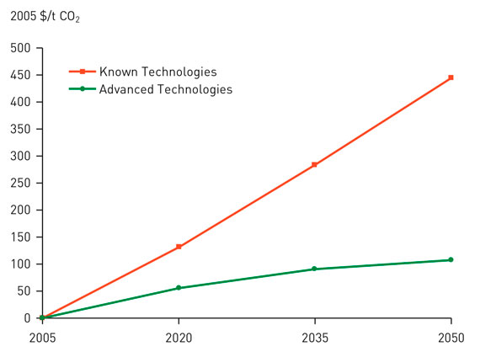

Fig. 3.3. Global carbon (CO2-equiv) prices needed to reduce emissions [31]

Different policy measures affect technological innovation in different ways.
At present, more than 150,000 Groupe Renault electric vehicles are used in various countries around the world. Their goal is the large-scale deployment of 100% electric mobility. The electric vehicle is part of today's real ecosystem at the intersection of mobility and energy, where digital technologies play a major role.
Source: compiled by the author.
Ways to overcome the gap of circularity on the basis of business smart models and circular cities are identified:
- increasing the scale of circular activities;
- creation of an economic and infrastructural basis for conducting a circular policy;
- environmental initiatives, economic growth and improving the quality of life in real time based on innovative planning;
- cooperation of local administrations in technical and environmental areas in three areas: "living city", "city on the outskirts" and "responsible city";
- involvement of citizens in making important circular decisions;
- avoidance of clogging of territories (public garbage containers in a visible place and colorization of conditional steps on the sidewalk to landfills);
- involvement of large (multinational) companies in the circular economy, to stimulate the creation of products and services in accordance with circular principles;
- "electronic libraries" of clothing and design items;
- mobile platforms for renting clothes and fashion accessories from the Reuse Center without any payment.
- cooperation between three educational institutions and public waste management companies;
- use of plants for processing into paper;
- production of durable hygienic paper (paper towels and toilet paper) from recycled packaging for milk and juice;
According to J. Sternberg, CEO of the Swedish company Box of Energy AB, which cooperates with Porsche and Volvo Cars, car manufacturers face the problem of disposing of a huge amount of batteries, which in the near future will form a new market for second-life applications ”for energy storage, ie the so-called circular market for e-media batteries with inclusive orientation [5].
Bloomberg NEF has released data that by 2040, more than half of new car sales and a third of the total, 559 million cars, will be electric. By 2050, companies will invest about $ 550 billion. in home, industrial and network batteries. The basis of this process is the circular economy, as the battery coming from the electric car becomes part of the new energy world [5].
Although the issue of climate change seems to guarantee a rapid transition to electric mobility, it may be just a transitional technology. Electric cars will do little for urban mobility and viability in the coming years. Established automakers such as Porsche are working on new modes of transportation, especially for congested and growing markets such as China. Instead of fewer cars, as transport experts have called for, automakers continue to promote individualized transport, albeit a greener version.
As the population grows, it may be necessary to change the paradigm in transport, which is aimed at solving transport problems. In Copenhagen, for example, bicycles now exceed the number of cars in the city center, which has not had a car for the next ten years. Many other cities, including Oslo in Norway and Chengdu in China, are also on the way to a free car.
Experts are already developing new ways to develop cities. They combine efficient public transport, as can be found in Curitiba, Brazil, with the principles of passability, as can be seen in Woben, Germany. They are characterized by mixed use, mixed income, and transit orientation, as observed in places such as Fruitvale Village in Auckland, California.
These events are not just about environmental issues related to transport. They increase viability by returning urban space to green development. They reduce the cost of living by reducing costs and travel time. They provide health benefits by reducing pollution and a more active lifestyle. They improve social cohesion by facilitating interaction with people on city streets and helping to reduce crime. And, of course, they improve economic performance by reducing productivity losses due to congestion. That is, all this works towards the development of an inclusive transport paradigm [14].
Electric cars are the rapid deployment of technology that helps address climate change and improve air quality - at least until a certain point. But the endgame of evolution should eliminate many daily needs for travel [14].
The conversion of minerals to batteries takes up the supply chain, and each stage can be a bottleneck and a problem. Such electric vehicle manufacturers should be concerned that the supply of one of the key mineral components, or processing infrastructure, may become too centralized in one country. Without a variety of sources, the possibility of supply constraints becomes more likely.
Currently, graphite is quite centralized because it is produced by fewer countries, but reserves are more diversified. As almost half of the world's cobalt ore reserves are concentrated in the Democratic Republic of the Congo in the foreseeable future, and with a large share of processing capacity in China, the supply chain may be more vulnerable.
Eventually, governments may restrict supplies again. In this scenario, the Democratic Republic of the Congo is not on the list of the best suppliers. She misjudges most of the World Bank's indicators caused. unstable political situation, and China - better. But, as China has shown in the case of rare earth elements, there is uncertainty about the reliability of the supplier.
The supply of basic materials for lithium batteries is not threatened soon, but demand is likely to open up new mining areas, leading to new risks. The political situation of countries with large reserves and large shares in the processing of these metals can quickly become uncertain. Will countries such as Bolivia allow the free export of lithium and will the Democratic Republic of the Congo and China restrict cobalt supplies [12].
Environmentally, the future of the lithium-ion battery is also a matter of concern. Ultimately, lithium recycling should play a role in mitigating political, environmental and economic risks in the future, but high and the rate of recycling of lithium batteries has not yet emerged [12].
From a marketing standpoint, most potential buyers want an EV because it is more environmentally friendly than a regular car. These customers will thus be more interested in other stable characteristics of the car. Manufacturers hope that the use of recycled materials can help buyers choose one brand over another. In particular, we can single out companies that are leaders in the use of recycled material [12].
Nissan Leaf. Nissan's green program aims to eliminate all waste throughout the life of the vehicle, from design to disposal. Almost 25% of Nissan Leaf is made from recycled materials. Old PET soda bottles are recycled to make seats, recycled fabrics are used in sound insulators under the hood, and parts from old electrical appliances are used in the center. Recycled plastic resin is even used to make larger plastic components for sheets, such as accessories and door parts [13].

Conclusions to the chapter 2.
We must also look at and consider large-scale changes from a "systems" perspective, because the success of any new technology often depends on other technical and non-technical factors. For example, the popularization of energy-saving technologies such as air conditioners and water heaters that can automatically adjust home appliances may depend on the development and popularization of "smart grid" technology in the power grid. Similarly, the spread of energy-efficient appliances may be inhibited by institutional arrangements, such as the relationship between landlords and tenants, in which neither party has the incentive to buy more expensive but more energy-efficient appliances.
Significantly reduce greenhouse gas emissions requires action, not only to deploy the low-emission technologies available today, but also to promote innovation in the new technologies needed. Therefore, in recent years people have become more and more interested in ways to promote such innovations, especially the role that the government can and should play in this process.
Although research and development are a major element of the innovation process, people are increasingly aware that technological innovation is a complex process that usually involves interaction with other stages of technological changeIn this article, a key question is: Which strategies and policies can most effectively promote technological innovations that help reduce greenhouse gas emissions? As mentioned earlier, greenhouse gas emissions mainly depend on the type of energy and technology used to provide the goods and services that society seeks.

CONCLUSIONS
Society is changing rapidly. Many drivers of change interact in an extremely complex interaction of human needs, desires, activities and technologies and contribute to the "great acceleration" of human consumption and environmental degradation. As the mass introduction of innovative products and services, as well as the integration of technological culture, has shown, the pace of change and the speed of innovation are also accelerating. For example, digitalization is now part of the daily lives of most people and almost all sectors of the economy.
Technological innovations are also rapidly being integrated with new clusters and applications, integrating digital technologies (such as big data analysis, artificial intelligence and blockchain) with the fields of physics (e.g. nanotechnology) and biology (e.g. biotechnology).
These changes are happening at an unprecedented rate and scale, creating great opportunities and serious challenges for sustainable development. As far back as 2001, a report by the European Economic Area concluded: “Science's growing capacity for innovation seems to outweigh its ability to anticipate its effects, and the scale of human intervention in nature increases any dangerous impact that could occur.”
Modern critics of the sharing economy often draw attention to regulatory uncertainty. Businesses that offer rental services are often regulated by federal, state, or local governments. Unlicensed rental providers may not follow these rules or pay the associated costs, giving them an "unfair" advantage that allows them to offer lower prices. There are also fears that more information posted on the online platform may create racial and / or gender bias among users.
These harmful substances penetrate the soil, groundwater and surface water through the landfill, and release toxins into the air when burned in the municipal waste burner. In addition, cadmium is easily absorbed by plant roots and accumulates in fruits, vegetables and grasses. In turn, impure water and plants are consumed by animals and humans, and then fall prey to a series of adverse effects.
In addition, if potassium leaks, it can cause severe chemical burns, which can affect the eyes and skin. Landfills can also produce methane gas, leading to the ‘greenhouse effect’ and global climate change.
We live in a society where environmental conscience does not generally exist. This is the reality of all sectors of our society. Most governments are not determined to make major changes, because society has no clear and strong motivation to support such movements.
In addition, in most people’s lifestyles, if every material item is disposable, not many people care about using recycling centers to dispose of these items in the correct way. Usually the easiest way to dispose of these items is simple. Throw things away from the common garbage disposal. How many times have you provided a plastic straw on the bar to drink your drink, or simply dropped it into your glass? How many times have you rejected plastic straws? Well, most of these tiny plastic straws will eventually turn into ordinary garbage, or in the process, float in the ocean (for many reasons). Small actions such as rejecting plastic straws can have a significant impact on the environment. This applies to many other situations. Simply think about what you throw away and you will get it in a few minutes. Refuse to use these things.
Companies are also interested in profit, and environmental issues are completely inconsistent with profit. Respect for the environment requires a price. Even if there is no cost, usually the simplest method is chosen, the residue (by-product of the production process) is dumped directly in nature without proper treatment.​​​​ This usually pollutes the soil or water on which we depend. People often find areas where people's health is affected by such behaviors. In some cases, because it is cheaper to do so, companies will hire laboratories to "create" results that are beneficial to the company. In the 1960s, a company in the United States did this.
We must also look at and consider large-scale changes from a "systems" perspective, because the success of any new technology often depends on other technical and non-technical factors. For example, the popularization of energy-saving technologies such as air conditioners and water heaters that can automatically adjust home appliances may depend on the development and popularization of "smart grid" technology in the power grid. Similarly, the spread of energy-efficient appliances may be inhibited by institutional arrangements, such as the relationship between landlords and tenants, in which neither party has the incentive to buy more expensive but more energy-efficient appliances.
Significantly reduce greenhouse gas emissions requires action, not only to deploy the low-emission technologies available today, but also to promote innovation in the new technologies needed. Therefore, in recent years people have become more and more interested in ways to promote such innovations, especially the role that the government can and should play in this process.
Although research and development are a major element of the innovation process, people are increasingly aware that technological innovation is a complex process that usually involves interaction with other stages of technological changeIn this article, a key question is: Which strategies and policies can most effectively promote technological innovations that help reduce greenhouse gas emissions? As mentioned earlier, greenhouse gas emissions mainly depend on the type of energy and technology used to provide the goods and services that society seeks.

- Berrone, P.; Fosfuri, A.; Gelabert, L.; Gomez-Mejia, L.R. Necessity as the mother of ‘green’ inventions: Institutional pressures and environmental innovations. Strateg. Manag. J. 2013, 34, 891–909.
- Hargroves, K.; Smith, M.H. (Eds.) The Natural Advantage of Nations: Business Opportunities, Innovation and Governance in the 21st Century; Earthscan: London, UK, 2005.
- Urbaniec, M. Towards Sustainable Development through Eco-innovations: Drivers and Barriers in Poland. Econ. Sociol. 2015, 8,179–190. Resources 2021, 10, 68 16 of 17
- Kobarg, S.; Stumpf-Wollersheim, J.; Schlägel, C.; Welpe, I.M. Green together? The effects of companies’ innovation collaboration with different partner types on ecological process and product innovation. Ind. Innov. 2020, 27, 953–990.
- Albino, V.; Ardito, L.; Dangelico, R.M.; Petruzzelli, A.M. Understanding the development trends of low-carbon energy technologies: A patent analysis. Appl. Energy 2014, 135, 836–854.
- Wu, Y.; Gu, F.; Ji, Y.; Guo, J.; Fan, Y. Technological capability, eco-innovation performance, and cooperative R&D strategy in new energy vehicle industry: Evidence from listed companies in China. J. Clean Prod. 2020, 261, 121157.
- Colombo, L.; Pansera, M.; Owen, R. The discourse of eco-innovation in the European Union: An analysis of the Eco-Innovation Action Plan and Horizon 2020. J. Clean Prod. 2019, 214, 653–665.
- Scarpellini, S.; Aranda-Uson, J.; Marco-Fondevila, M.; Aranda-Uson, A.; Llera-Sastresa, E. Eco-innovation indicators for sustainable development: The role of the technology institutes. Int. J. Innov. Sustain. Dev. 2016, 10, 40–56.
- Vence, X.; Pereira, Á. Eco-innovation and Circular Business Models as drivers for a circular economy. Contaduría Adm. 2019, 64, 1–19.
- Sica, E. Economic theories of eco-innovations: A comparison between the neoclassical and evolutionary approaches. Int. J. Innov. Sustain. Dev. 2016, 10, 87–102.
- Dangelico, R.M.; Pujari, D.; Pontrandolfo, P. Green Product Innovation in Manufacturing Firms: A Sustainability-Oriented Dynamic Capability Perspective. Bus. Strategy Environ. 2017, 26, 490–506.
- Kiefer, C.P.; Del Río González, P.; Carrillo-Hermosilla, J. Drivers and barriers of eco-innovation types for sustainable transitions: A quantitative perspective. Bus. Strategy Environ. 2019, 28, 155–172.
- Costa, J. Carrots or Sticks: Which Policies Matter the Most in Sustainable Resource Management? Resources 2021, 10, 12.
- Fogarassy, C.; Finger, D. Theoretical and Practical Approaches of Circular Economy for Business Models and Technological Solutions. Resources 2020, 9, 76.
- Prieto-Sandoval, V.; Jaca, C.; Ormazabal, M. Towards a consensus on the circular economy. J. Clean Prod. 2018, 179, 605–615.
- Smol, M.; Marcinek, P.; Duda, J.; Szołdrowska, D. Importance of sustainable mineral resource management in implementing the circular economy (CE) model and the European Green Deal Strategy. Resources 2020, 9, 55.
- De Jesus, A.; Antunes, P.; Santos, R.; Mendonca, S. Eco-innovation in the transition to a circular economy: An analytical literature review. J. Clean. Prod. 2018, 172, 2999–3018. 18. O’Brien, M.; Bleischwitz, R.; Bringezu, S.; Fischer, S.; Ritsche, D.; Steger, S.; Samus, T.; Geibler, J.v.; Giljum, S.; Polzin, C. The Eco-innovation Challenge: Pathways to a Resource-Efficient Europe. Annual Report 2010; European Commission: Brussels, Belgium, 2012.
- Eurobarometer, F. Attitudes of European Entrepreneurs towards Eco-Innovation; European Commission: Brussels, Belgium, 2011.
- Ehrenfeld, J.R. Sustainability by Design. A Subversive Strategy for Transforming Our Consumer Culture; Yale University Press: New Haven, CT, USA, 2009.
- Langinier, C.; Chaudhuri, A.R. Green Technology and Patents in the Presence of Green Consumers. J. Assoc. Environ. Resour. Econ. 2019, 7, 73–101.
- Horbach, J.; Rammer, C.; Rennings, K. Determinants of eco-innovations by type of environmental impact—The role of regulatory push/pull, technology push and market pull. Ecol. Econ. 2012, 78, 112–122.
- Sun, Y.; Lu, Y.; Wang, T.; Ma, H.; He, G. Pattern of patent-based environmental technology innovation in China. Technol. Forecast. Soc. Chang. 2008, 75, 1032–1042.
- OECD. Green Growth and Eco-Innovation; OECD: Paris, France, 2012; Available online: http://www.oecd.org/sti/ind/greengrowthandeco-innovation.htm
- Migotto, M. Measuring Environmental Innovation Using Patent Data; OECD: Paris, France, 2015.
- Wydra, S. Measuring innovation in the bioeconomy–Conceptual discussion and empirical experiences. Technol. Soc. 2020, 61,101242.
- Imai, K. International market competitiveness of Japanese green innovation technologies: An analysis using patent data. World Rev. Sci. Technol. Sustain. Dev. 2015, 12, 77–94.
- Rennings, K. Redefining innovation—eco-innovation research and the contribution from ecological economics. Ecol. Econ. 2000, 32, 319–332.
- Spaargaren, G. Sustainable consumption: A theoretical and environmental policy perspective. Soc. Nat. Resour. 2003, 16, 687–701.
- Pujari, D. Eco-innovation and new product development: Understanding the influences on market performance. Technovation 2006, 26, 76–85.
- Carrillo-Hermosilla, J.; Del Río, P.; Könnölä, T. Diversity of eco-innovations: Reflections from selected case studies. J. Clean Prod. 2010, 18, 1073–1083.
- Schiederig, T.; Tietze, F.; Herstatt, C. Green innovation in technology and innovation management—An exploratory literature review. Rd Manag. 2012, 42, 180–192.
- Varadarajan, R. Innovating for sustainability: A framework for sustainable innovations and a model of sustainable innovations orientation. J. Acad. Mark. Sci. 2017, 45, 14–36.
- https://yearbook.enerdata.net/electricity/world-electricity-production-statistics.html
- http://www.internetlivestats.com/internet-users/
- http://gs.statcounter.com/platform-market-share/desktop-mobile-tablet
- https://digiconomist.net/bitcoin-energy-consumption
- http://www.it-green.co.uk/uk_business_recycling/the-life-cycle-impact-of-electronic-equipment/
- https://www.economist.com/node/9249262
- http://ec.europa.eu/eurostat/tgm/graph.do?tab=graph&plugin=1&pcode=t2020_rt130&language=en&toolbox=type

Global Workplace Analytics
the United Nations Framework Convention on Climate Change

