Ministry of Education and Science of Ukraine
West Ukrainian National University
Bohdan Havrylyshyn Education and Research
Institution of International Relations
International Economics Department
Master’s Thesis

“The Challenges of Unregulated International Migration Flows”

Student of Master’s Course, Group AMETm21
Désirée Eugénie Kpukumu
Supervisor: Mariia Lyzun

National Scale_______
Total Grade Point____ ECTS GRADE______
Member of the Commission
__________________________________
__________________________________
__________________________________

Ternopil-2021

Table of Content
Introduction
Chapter 1. Theoretical Aspects of Unregulated International Migration
  - Challenges of Unregulated International Migration
  - Barriers of International Migration
  - Opportunities of International Migration on the Receiving Countries
Conclusion of Chapter 1

CHAPTER 2. MIGRATION IN THE FRAMEWORK OF GLOBAL AND REGIONAL INTERGOVERNMENTAL PROCESS
2.1 Government Perceptions of and Policies of Migration
2.2 Unregulated Migration and Labor Migration
2.3 Integration of Migrants
2.4 COVID 19 Effects of Migration
Conclusion of Chapter 2

Chapter 3. STRATEGY OF COORDINATION OF UNREGULATED INTERNATIONAL MIGRATION FLOWS
3.1 Impacts of Migration on Economic and Social Development
3.2 Underemployment and Occupational Identity
Conclusion of Chapter 3

Conclusion
Reference

Introduction
Migration is a human phenomenon which involves global movements within national and international borders. Even with the Covid-19 pandemic disrupting all forms of human mobility with the closing of borders and the great halt which was put on worldwide travels, international migration for 2020 was 281 million people living outside of their country of origin, with international migrants representing 3.6 percent of the world’s population.
Migration is a controversial subject, this being based on it touching on so many distinct areas of public life, starting with the economic aspect, demographics, national security, culture and even religion.
The challenges of unregulated international migration have resulted into many push-pull factors that led to insecurity and instability both population wise and economically. Unregulated migration has led to many challenges for governments and policy makers some of these challenges consist of political and economic instability, food and water shortages and scarcity, organized crimes, civil conflicts and much more.
There are a number of potential drivers of unregulated international migration, some of which may include: political and economic instability, pandemic, environmental changes (natural disasters) food and water scarcity, civil conflicts and crimes and much more.
When two or more of these factors coincide, it causes a multiplier effect which will in turn lead to instability among nations. The significant increase in unregulated migration consists of a series of consequential implications on national and regional security and ability.
Unregulated migration tends to be considered as a potential challenge which at a minuscule level does not raise immediate attention of policy makers only until it becomes out of control and a problem of national security.
The UN Fund for Population Activities noted that the two least desirable features of this mass movement are (a) migration of ill-equipped persons to countries ill equipped to receive them and (b) the drain of qualified personnel from countries that can ill afford to lose them.
Some migrants tend to carry with them the health problems of their place of origin, and often times are factors to the high risk of new problems at their country of destination. Social tensions tend to be created between the migrants and the citizens of the destination countries. Valuable resources are lost, the migration from poor countries to wealthier ones can increase patterns of inequality (brain drain, remittances and capital flight).
Migrants are seen as key additions to the workforce, even if their presence is resented by the citizens and general public of the receiving country and they are not always able to make the best use of their skills and advantages.
Governmental policies will evolve if migrants, the societies they leave and those they join are to continue benefiting from migration. The developed countries and its populations tend to see the problem of the gap between the rich countries and poor countries only in terms of the migrants arriving at their borders in thousands and millions each day.
This analysis is meant to examine unregulated international migration, it drives and its effects on governments and countries as a whole.

CHAPTER 1. THEORETICAL ASPECTS OF UNREGULATED INTERNATIONAL MIGRATION
  - Challenges of Unregulated International Migration

The UN Migration Agency defines a migrant as any person who is moving or has moved Across an international border or within a state away from his slash her habitual place of residence, regardless of their legal status Call mom voluntary or involuntary movement, the cause of the movement and the length of their stay.
Migration or human migration can be defined as the permanent change in residence by an individual or a group. It involves the movement from one place to another with the intention to settle either temporarily or permanently in a new location.
People who migrate are referred to slash categorized into several categories which are:
- Immigrants- an individual who settles into a country that is not their country of original/ country of my birth.
- Emigrants- an individual who leaves their country of residence or birth to settle permanently in another country.
- Refugee- an individual who has moved to a new country in order to escape persecution, war or natural disaster.
There categories of migration are:
- Internal migration is the migration which takes place within national boundaries. This is when people move within a country but to another location (city or region).
- External migration (international migration) this refers to migration across borders from one country to another country.
Out of the many components related to population change, migration is a prominent key holder at both an internal and international level.
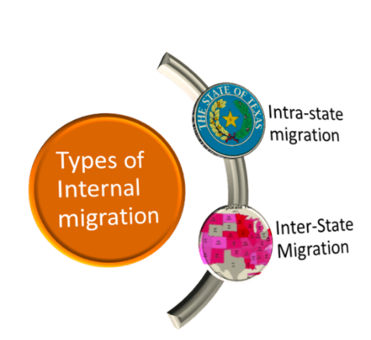
Fig. 1. Types of Internal Migration
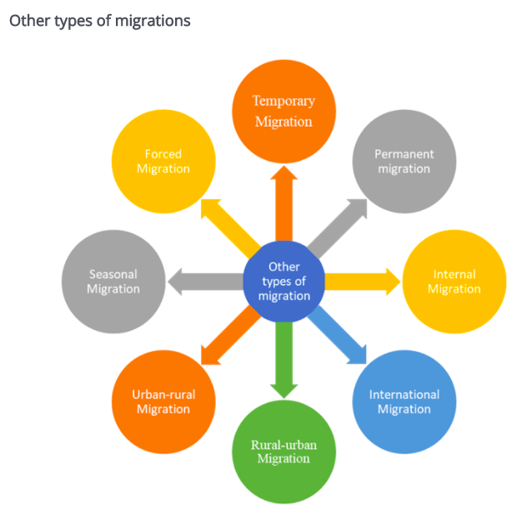
Fig. 2. Other Types of Migration
Migration and internal displacement find themselves as some of the most pressing topics on the international agenda. While there are many aspects of migration and displacement that are not controversial, there are also the aspects of uncontrolled, poorly managed irregular migration and population displacement that has led to policy controversy. migration flows have created vulnerabilities of great concern for many international communities and NGOs.
Challenges of Unregulated Migration
- Language barriers- when migrants move, they are faced with the challenges of learning a new language. This is a challenge for many as they are expected to possibly pay for classes as to be able to properly learn the language of the host country so that they will be able to easily communicate with the members of the society in both the formal and informal sectors of their day to day activities.
- Obtaining jobs- many clients may be unskilled or have not had the proper education qualifications to obtain the high paying jobs. For those who are educated, their qualifications are sometimes deemed as not being up to standards in the countries that’s they find themselves. So with these in mind, many migrants must obtain low paying, unskilled, manual labor jobs until they are able to acquire the proper qualifications so that they may gain proper employment opportunities.
- Brain Drain- this is the process in which the skilled and highly educated individuals disadvantage their home countries by taking their skills and educational qualities to other countries. With the influx level of highly educated individuals leaving their countries of origin to seek greener pastures, there is a drastic fall in the countries developmental level, as professionals leave, they take along their innovative ideas, inventive potentials and their potential contributions to the various fields of the country (health sector, educational sector, agricultural sector etc.).
- Fiscal burden arises when there is a drop in the level of taxpayers in the country. This leads to a fall in government involvement as taxes are used for by the government of development of the country. With the influx of unskilled migrants, it leads to a reduction in the taxes being paid in the country and also fewer investment opportunities for the government and country.
- Aged Population-in many LEDCs, due to migration the population consists more of older citizens and younger citizens who are not of the working age or to work effectively. When younger migrants move to the host countries, the sending countries lose their youngest and most productive workers, whiles they host countries gains more able-bodied workers and additional tax benefits for legal migrants. In the case of unregulated migration, there is no direct increase in additional taxpayers.
The diagram below shows the effect that migration made have on the US population by the year 2034 there's an expected growth and the level of adults projecting to outnumber children.
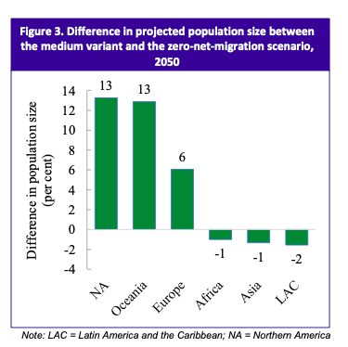
Outmigration
has a marginal effect on the median age in developing countries, according to the UN being only 0.1 years lower by 2050 than with migration continuing at current levels (figure 4)
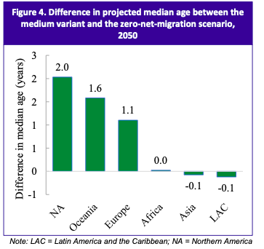
According to the UN, without migration, the population of the developed regions will decrease by 2050, while the population of the developing regions experiences an increase. The emigration of children may lead parents “left behind” to face higher poverty risk and a greater need for care.
- Gender Imbalances- Since men are considered as the breadwinners of their families, they are the ones that tend to forge outside at their homes or their countries to seek a better life for their families. through migration or work migration, men leave their families and move to other countries where they think they can find better jobs so that they can support their loved ones.
- The host country will experience an increase in population which in turn can lead to overcrowding/overpopulation, causing price surge of services such as health care and education. there would also be an increase in the demand for goods and services.
- Prejudice and Racism- Migrants are highly discriminated against be it for religion, their skin color, the way they talk or even just the way they appear.
- Remittance- This is when money is sent by foreign worker to their home country. This is bad for the receiving country as it means there's an outflow of money from then to another country which can also be known as capital flight.
- Migrants are exploited in the receiving country; Due to their availability and readiness to work for the low paying jobs as a means of getting their foot in the door and earning some form of a place in the community. Illegal migrants on the other hand experience this exploitation on a different level as many of them would sometimes like to fight for their rights but are in unable to do so and will end up being threatened by their employees with deportation or calling immigration authorities on them.
- Due to the diverseness of migrants, this can lead to cultural clash i.e. religion and cultural background. The migrants bring with them their language, religion, and cultural values. They also try to preserve their religion, culture, language, and customs.

  - Barriers of International Migration

For unregulated migrants, there are several immigration laws and policies within countries such as the United States, UK, Canada etc. that continuously hinder their access to adequate services such as health care and jobs. Governmental policies evolve with the massive influx of migrants each year, this is because both societies they leave and those they join want to protect the rights and benefits of their own citizens without keeping into consideration the migrants and immigrants regardless of the benefits obtained from migration. The governments of the developed countries introduce policies which will place new mechanisms in order to better address their labor market needs.
- Barriers to healthcare- National policies exclude undocumented immigrants from receiving health care, insurance is required for affordable care or required to receive services at all, there are laws in place which effectively barred access to care for those without the correct and necessary documentation. Health system barriers included external resource constraints, costs to the individual, discrimination, and high bureaucratic requirements. Undocumented migrants avoid healthcare and only tend to seek health care when issues have become critical due to concern of being reported to authorities
- Personal Barriers which may include fear of deportation, inability to communicate with other members of the community because of language barriers and lack of financial resources.
- Legal changes- border laws and restrictions, immigration quotas and the lack of rights and accesses to all necessary services. As Mentioned in the beginning government policies are always likely to evolve so as to keep illegal migrant out of the system.
- The low pay: Migrants are the largest number of employees working in sectors and institutions which are drivers of low pay. Sectors and institutions like this work the employees to the bone without any chance or possibility of climbing up the work ladder into higher and more important positions these are all elements which hinder progress in the lives of the migrants.
- Rigorous Labour Migration Policy: the developed countries implement policies. The governments of the developed countries inclined to develop policies which placed new mechanisms in order to better address their labor market needs. The employment systems in developed countries makes it hard for unregulated migrants to obtain proper jobs; even the international student who are regulated migrants work a specific amount of time per week based on the regulations in the varying countries (in America they can work up to 40hours, whiles countries like Turkey and Ukraine they are unable to work)
- Insufficient recognition of skills and qualifications for migrants: foreign credentials overlooked in the developed countries which the migrants move to. Their credentials are then negated and they are then forced to gain the credentials of the said country, this is a disadvantage as the migrant is forced to work odd jobs or spend money to gain the “proper” qualifications needed.
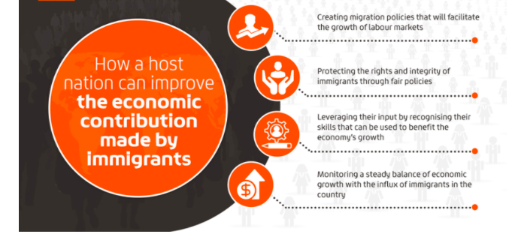
Fig. 5

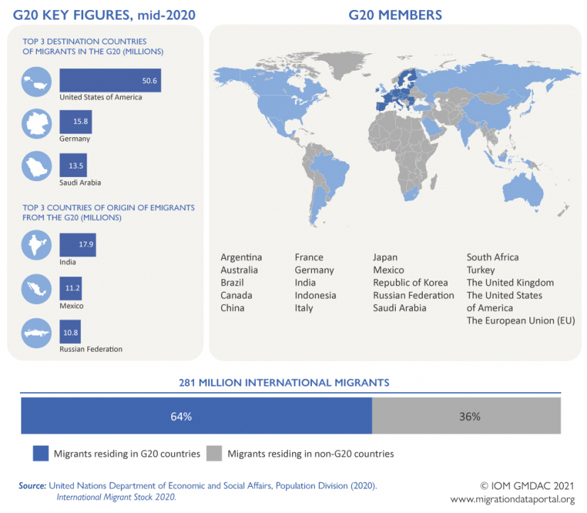
Fig. 6. Represents the destination countries of migrants.

  - Opportunities of international migration on the receiving countries

Migrant workers are important contributors to the labour market in both high- and low-skilled occupations.
- Migrants contribute more in taxes and social contributions in comparison to what they receive in individual benefits- migrants contribute more in taxes and social contributions than they receive in individual benefits. This means that they contribute to the financing of public infrastructure, although admittedly to a lesser extent than the native-born.
- Migration contributes to innovation and economic growth international migration has both direct and indirect effects on economic growth. Some of which are
- Population increase
- Increase in the demands for good and services- the labor markets will also need to be adapted to meet the demands of the rapidly growing economy
- Growth in the informal sector as there is where many migrants tend to find jobs easily and illegal migrants don’t need documentation to work.
- Expanding the labour market- Many people move overseas to improve their financial situations and look for a better life with more advantages for themselves and their family. Immigration surplus can boost the host country’s economy. Immigrants that can easily fall into the life of the host country are great contributors to the economy and growth of the country.
- With a boost in labor supply, immigrants increase the level of economic output. As unregulated migrants are not bound to any specific part of the host country, they move around to where they are highly needed to work.
- Introduction of new skill- many migrants bring along skills which are sometimes referred to as being “new” to the receiving countries. 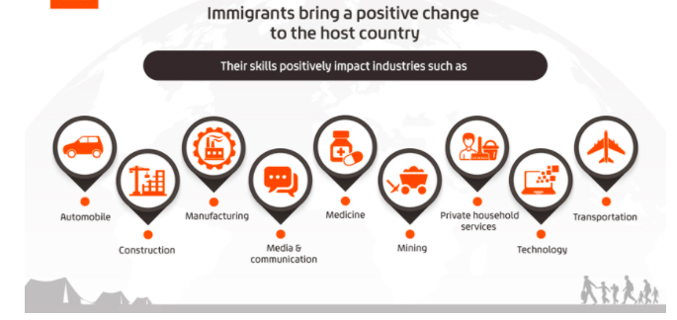
Fig. 7

Migrant workers provide opportunities not only for themselves but also for many sectors of the host countries’ economies which sadly many native citizens would not like to acknowledge. I believe that with time, they would then see the benefits which migrants provide to not only their hard and manual labor economy but also the tax benefits they come with.
Conclusion of Chapter 1
Refugees and migrants experience a life of extreme difficulties and hardships when settling into a new country with hopes and dreams of leading a better life.
Even though they are highly unappreciated and underrepresented in their host countries, they still find ways in which they can integrate themselves into the day to day activities of their communities and become valued citizens in some way.
The challenges which they encounter along the way play an enormous roll in ruining the dreams and aspirations of a better life. If governments systemically recognize and ameliorate these challenges this will ensure that legal migrants are able to transition smoothly and face fewer challenges. Illegal migrants on the other hand I believe they should find the correct means in obtaining legal residency within the country so ask to make life a bit simpler and less tedious for them.

CHAPTER 2: MIGRATION IN THE FRAMEWORK OF GLOBAL AND REGIONAL INTERGOVERNMENTAL PROCESS
2.1 Government Perceptions of and Policies of Migration

Migration policies shelter and protect various sectors which include but are not limited to labor markets. Good governance is the process when public institutions are conducting and creating systems which protect human rights and bring about the rule of law for the country. Several components exist to make up good governance alongside migration these components include policy coherence, gender issues, internationals standards, transparency and social dialogue.
Policy Coherence – as old a phenomenon that migration is, it is still one of the most complex and ceaseless challenges for governments, with these challenges they often-times find themselves trying to balance and maintain multiple benefits and problems which can be economic, social or political. Policy coherence is when there are correlations between government policies and regulations in different communities and constituencies. The importance of policy coherence on governments are prominent as lack of coherence leads to failure in achieving goals, misuse and waste of resources especially in the carse of resource scarcity and the greatest and most impactful effect being governmental policies and laws losing their credibility thus making them ineffective. When there is lack of coherence, it has a negative effect of political leaders as they become afraid of losing their supporters.
When policy coherence is lacking, there is no regulation of working conditions and standards of working especially for those employers who exploit their employees and have then working irregular hours, poor conditions and in the case of illegal migrants they work for below- minimum wage with the threat of deportation in comparison to other employees who are legally employed.
Gender Sensitivity- the female gender is highly discriminated against not only in LEDCs but everywhere in the world. Since women make up a vast majority of migrants, they are always underrepresented and unprotected in the work communities that they find themselves in.
Migrant women acquire jobs where they are left unprotected by not only the employers but also by laws which normally protect male workers. Vulnerability plays a big role in migrants women working in some of the jobs that they have some examples of these include:
- Sexual abuse
- Sex trafficking
- Gender abuse
Lack of gender differentiation policies leave women to struggle in silence with dilapidated and depraved working conditions in many companies and organizations.
International Standards- migration policies are viable when they are stable and are operated on the rule of law. Organizations such as the International Labor Organization and the United Nation’s International Organization for Migration help with instilling international regulations of labor migrants and protect migrant workers through labor laws and employment regulations. These organizations assist governments and states towards achieving international standard consistency.
Transparency and Flexibility- when there is transparency in the government and policies, it means that there are no hidden agendas, and everything is made clear for the citizens of the country. It allows for a better understanding of important issues such as those concerned with employment, laws and working conditions.
Flexibility on the other hand does not mean that there should be a change in policies but that the migration policies should be flexible enough to associate with important developmental policies and policy evolutions.

Social Dialogue- this is the act of governments negotiating and exchanging information among themselves and government representatives, this in turn will establish the type of support that the country needs for controlling migration and migration policies.
The host country put in place policies which are beneficial to the employer and his concerns which contribute to their business and employment regulations that seemingly only benefit them and the country and not the migrants.
Social dialogue provides a great critique to the achievement of migration policies in the country of origin for the migrants.
Employer and worker organizations are advocates for establishing the appropriate and necessary policies and structures which are needed for immigration regulation.
Ukraine
Ukraine gained independence from the Soviet Union in 1991 and became a presidential republic. It is one of the European countries that is greatly affected by migration, with approximately 2.5 million labor migrants (with a remittance of $11 billion) out of a population total of 43 million people, with this increase in migrants their population consist more of younger people between the ages of 15-64 years old.
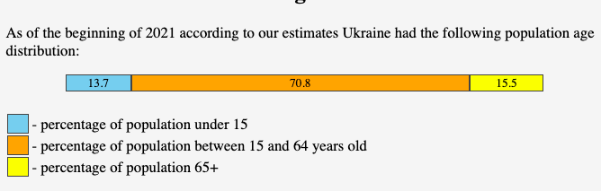
Fig. 8: Population by age in Ukraine

Even though there are many migrants there are also many Internally Displaced People (IDP) in the country and approximately 20 million Ukrainian diasporas.
The current net migration rate for Ukraine in 2021 is 0.146 per 1000 population, a 15.61% decline from 2020. Ukraine refugee statistics for 2020 was 2,274.00, a 4.99% increase from 2019.

Fig.9. Ethnicity in Ukraine

The State Migration Service of Ukraine and the immigration service manages the data on the migrants in Ukraine to which they provide the services on:

- The information for foreigners who participate in the Anti-Terrorist Operation-
- Citizenship of Ukraine
- The Freedom of Movement and Free Choice of Place of Residence in Ukraine
- The procedure of exit from Ukraine and Entry into Ukraine of the Citizens of Ukraine
- Border Control
- External Labour Migration
- Legal Status of Foreigners and Stateless Persons”
- “On Immigration
- Refugees and Persons Seeking Subsidiary or Temporary Protection
- Ukrainians Abroad
- Countering Human Trafficking
- Securing Rights and Freedoms of Internally Displaced Persons.
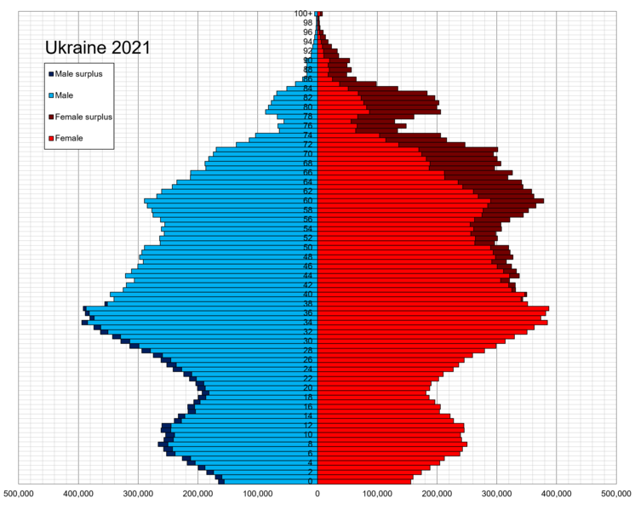
Fig. 10. Gender population in Ukraine

Currently, the Ukrainian immigration process is highly influenced by a vast amount of factors with the most important ones being:
- The seizure of Crimea and the recession which was due to the effect of conflict which is taking place in not only Crimea but eastern Ukraine.
- Introducing credible reforms this defines the credibility of government policies, taking credibility into account helps governments not deviate from future policy measures.
- Migration leads to diversification of networks which has allowed Ukrainians in becoming active in labor migration at home and abroad.
- Introducing European and Euro-Atlantic integration, including introduction of the visa-free regime with the EU in 2017.
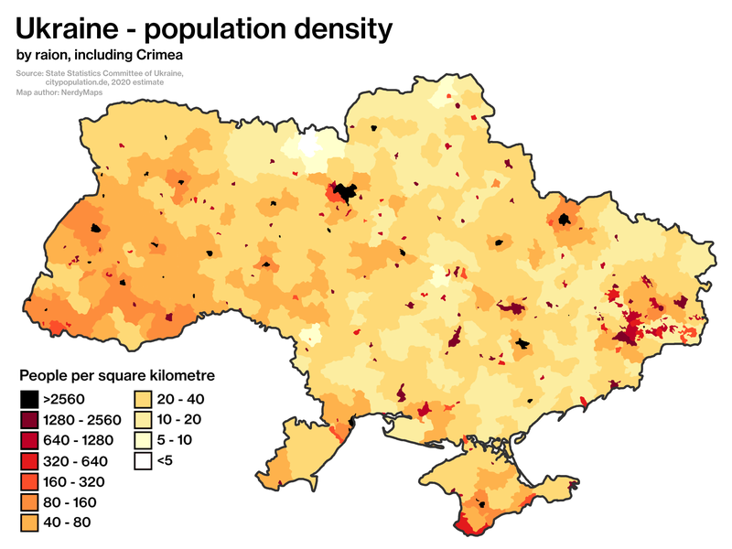Fig. 11. Population density by region

The Ukrainian government has put into place measures that will assist and cover the IDPs in the country, this included the promulgation of laws towards displacement.
In 2017, a 3-year strategy was implemented towards the restoration and reintegration of the displaced people and finding long term solutions in ways in which they can help them to become proper citizens who pay taxes and work. With this strategy, many IDPs have benefited from it.
The Ukrainian government has put into place measures that will assist and cover the IDPs in the country, this included the promulgation of laws towards displacement.
In 2017, a 3-year strategy was implemented towards the restoration and reintegration of the displaced people and finding long term solutions in ways in which they can help them to become proper citizens who pay taxes and work. With this strategy, many IDPs have benefited from it.
The government of Ukraine like many other countries still has a long way to go with regards to managing illegal immigration, but I believe as time goes on all the countries in the world would find a valid solution for this global issue.
United States
There are multiple laws which govern migration and immigration in the United States, but it’s the Immigration and Nationality Act (INA) that immensely impacts the country and its immigration policies. Under INA, 675,000 immigrants are given visa in the vast visa categories (Work visa, student visa, domestic employee visa etc.) which the United States visa processes have.
Legally obtaining a visa for the right purpose and situation makes an immigrant of this stature what is known as a Lawful Permanent Resident (LPR). There are also processes in which illegal immigrants can obtain LPR status whiles inside the US through what is called “adjustment of status”.
The adjustment status process is a 9-step process which consists of:
- Checking the eligibility of the applicant for the Green Card- the category in which the immigrant is applying for determines their eligibility for the green card.
- An immigration petition must be filed wherever it is required.
- Visa availability
- Filing the I-485 this is the application which an individual applies for to gain lawful residency status
- Attend the Application Support Center appointment where your photograph, fingerprints and signature are taken.
- Go for your interview
- Check case status
- Receive a decision
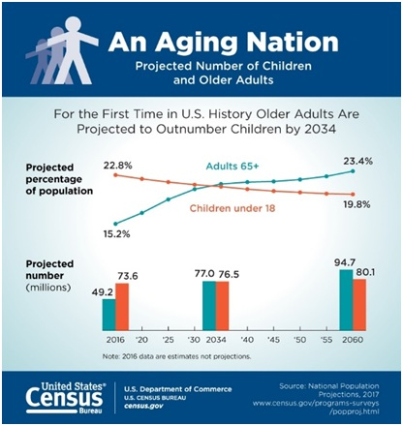
Fig. 12
Family-Based Immigration- this type of immigration system allows citizens of the U.S and LPRs to bring immediate family members (spouse, parents, children/ unmarried children under 21years old) to the U.S. Like the LPR process, there is a limit to the number of family-based visas given out each year and the potential immigrants have an eligibility standard which they should meet alongside age and financial requirements.
This is one of the most important policies of American immigration laws.
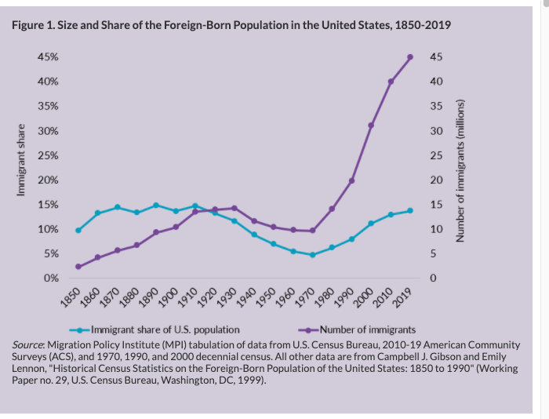
Fig. 13
Employment-Based Immigration- as a country which is always receiving a high number of immigrants every year, they provide legal and valid ways for valuable and skilled workers to enter the country be it on a permanent or temporary
The United States provides various ways for immigrants with valuable skills to come to the country on either a permanent or a temporary premise. The process for this requires that a job be offered, and the employer is to file an Immigration Petition for Alien worker (I-140 form). There are also Employment-Based Green cards which are categorized by the level of skills which the individual has for example;
EB-1 is given to extraordinarily talented individuals in fields such as art, business, science etc.
EB-2 is given to professionals with advanced degree levels
EB-3 is given to professionals, skilled and unskilled workers
EB-4 is given to “special migrants” such as religious workers.
EB-5 is for investors who plan on investing $500,000 to 1 million dollars in a new commercial enterprise and employing 10 or more full-time US citizen workers.
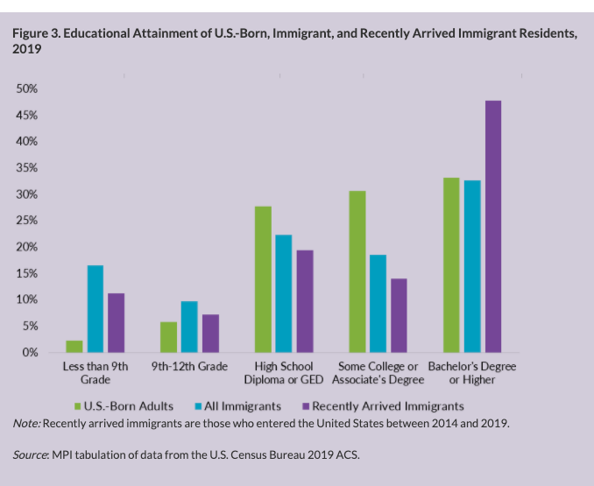
Fig. 14. The level of educational level attainment for immigrants varies according to their country of origin.

Fig. 15 shows the services in which both US citizens and Foreigners work in.

Temporary employment-based visa - like the employment-based immigration mentioned above, an employer is to petition towards hiring a foreign employee for a specific job and a limited amount of time (no longer than 1 year). The disadvantage of this type of employment visa for the immigrant is that they are limited to only working for the employer who petitioned for them which gives them no chance of acquiring another job legally.
Per-Country Ceilings- The INA places a limit on how many immigrants go to the United States from any one country
Refugees and Asylees-
Every year the president will consult with the members of Congress in deciding the ceiling for refugees, to which it is then further broken down into all the regions of the world. After the September 11,2001 tragedy, there was a drastic reduction in refugee admissions.
Presidential Determination on Refugee Admissions, FY 2021
Africa | 22,000
East Asia | 6,000
Europe and Central Asia | 4,000
Latin America/Caribbean | 5,000
Near East/ South Asia | 13,000
Unallocated Reserve | 12,500
Total | 62,500

Canada
Canada has 4 immigration categories when it comes to admitting new permanent residents, these categories are
Economic- like America, Canada also has what they consider to be the employee-based immigration. They call it their Economic Immigration process, unlike the American system, there is a ceiling with the number of workers entering Canada. The immigration system looks for younger candidates who have obtained higher educational levels and are highly skilled employees who would bring about economic growth for the country.
Family- like the American system, Canadian citizens and permanent residents are able to apply for their immediate family members (legal spouse and children) to join them in Canada through the family immigration process. Having a family member in Canada does not always mean that the applicant is susceptible to getting the visa especially if they do not meet the requirements or their family member doesn’t meet the necessary requirements of a sponsor them through the process. Situations like this where a migrant wants to be close to family I s what leads migrants to entering the country illegally
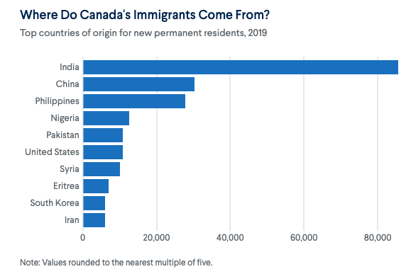
Fig.16- we can see in the graph that the largest origin of migrants in Canada come from India with more than 80,000 residents and the smallest being from Iran with approximately 5,000 residents.

Protected Persons and Refugees- Canada receive approximately 28,000 displaced people annually who acquire resettlement permanent residency through 2 programs which are:
Government assisted- the Government- Assisted Refugee (GAR) Program is a UNHCR operated body which chooses and restless individual in Canada (individuals can not apply for such program). It’s a 3-step program which consists of:
- Checking of processing time- the processing time for each individual may vary. But with the effects of COVID 19, some processing of status would take time.
- Once the case has been referred to the Canadian government, a Canadian immigration officer would review the files of the individual; this includes their medical record, previous criminal records and biometric data.
- Lastly after the whole process is completed and the individual is accepted, they can then start preparing themselves for their departure to Canada

Privately sponsored resettlement- the Canadian Refugee and Humanitarian (CRH) program allows Canadian citizens to assist in resettling their families or specific individuals who the CRH deem as qualified to be called a refugee and to gain the residency.
Illegal Immigrants in Canada
It is a highly regulated system, which includes some of the world’s strictest visitor-visa requirements
Like many Americans, nearly half of the Canadian population favor increasing the level of deportations of people in Canada illegally, there are several Canadian cities that have what is known as sanctuary city and “access without fear” policies that limit police cooperation with immigration authorities and guarantee undocumented people public services. Officials also rarely enforce a law banning Canadian companies from hiring undocumented workers.
The United States and Canada collaborated to control the movement of people and goods across their shared, mostly unguarded border.
In 2011, the governments announced a “Beyond the Border” strategy to enhance security cooperation and promote lawful travel and trade. Under the plan, the two countries share information about visa applicants and border crossers. The bilateral framework has fostered a healthy working relationship between Canada and the United States
Some of Trump’s immigration actions have been a boon for Canada’s economy. For example, in June 2020, his administration suspended the issuing of visas for highly skilled workers until at least the end of the year. Meanwhile, Canada has made it easier for foreign workers to acquire jobs there, giving qualified professionals, many applying from the United States, work permits within two weeks. Some U.S. companies are also expanding their presence in Canada.

2.2 Unregulated Migration and Labor Migration
A great and ongoing security issue in developing countries is the largest-scale, unregulated movement of migrants across international borders. Over the last two decades there has been a drastic increase in the number of refugees, illegal labor workers and migrants and displaced persons world-wide.
Migrants and labor workers are smuggled into countries all over the world at an alarmingly high rate, because of this there has been a huge amount of media coverage and world-wide attention on the situation alongside policy regulations being amended.
As big and important of an issue migrant smuggling is to governments it is also an issue for migrants, the smugglers and agents who are in charge of these illegal movements and NGOs who are keenly invested in giving support to legal migrants.
Since there are no accurate data on the exact scale of migrant smuggling globally, there has been a gap in the comparative analysis of legal and illegal migrants worldwide.
There are many other areas of international migration
and irregular migration especially with there being no available and accurate data on the extent at which the scale of global migrant smuggling takes place. The lack of global data on migrant smuggling hinders comparative analysis, as well as the ability to inform the development of effective responses.
Media coverage on the topic of irregular migration has put the necessary focus which is needed to formulate methods of how migrant smuggling can be stopped and how and data can be found on the number of migrants being smuggled into countries be it through human trafficking, labor workers or sex trafficking.
Human trafficking is the most illegal and dangerous form of migration/migrant smuggling with fatalities and deaths always being a prominent outcome.
Every year it becomes clear and important why there should be an analysis on the irregular migrants which extends and covers the issue of migrants smuggling in recent years. The governmental officials alongside their policy makers and analysts are the one who should be put in charge of conducting a research of this scale alongside academic officials.
Worldwide, the 2019 survey for the international migrant workers reached 169 million people which makes up for 69% of the global workforce.
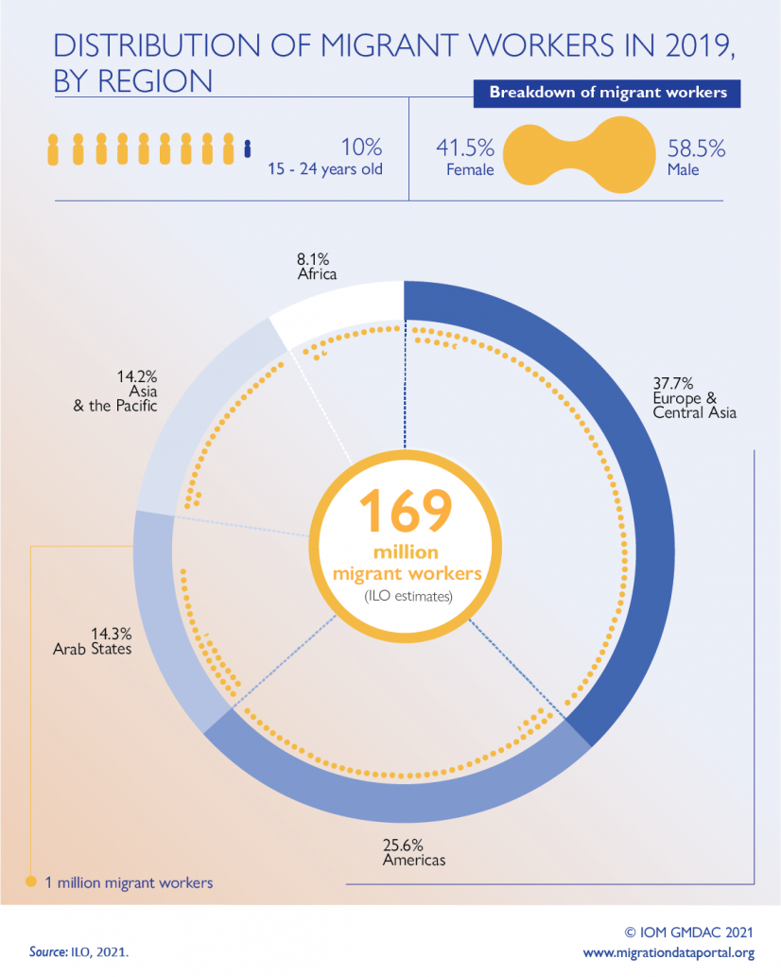
Fig. 15. As represented in the chart, there are 169 million migrant workers for the year 2019, which consist of
- 37.7% Europe and Central Asia
- 25.6% Americas
- 14.3% Arab states
- 14.2% Asia and the Pacific
- 8.1% Africa
With their being a 58.5% migration of men workers and 41.5% migration of women workers, where 10% are within the ages of 15-24 years old.
The world’s international migrants are in every nook and cranny of the world, but they are evidentially more pronounced in certain regions where the 3 main ones are: Northern America, Arab Nations, Western Europe and Southern Europe. Due to the vast availability of benefits and chances of improving your life being present in these countries, it is an eye candy for many immigrants as the goal is to live somewhere that can provide opportunities that’s their countries cannot.
International migrant workers make up two-thirds of the population in high income countries where of the 169 million, 113.9 million or 67.4% are in HICSs and 33 million or 19.5% are in MICs. The remaining of the migrants find themselves living to lower middle-income countries 9.5% and low-income countries 3.6%.
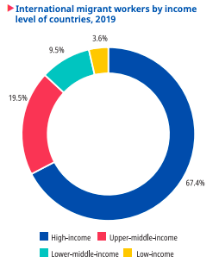
Fig. 16

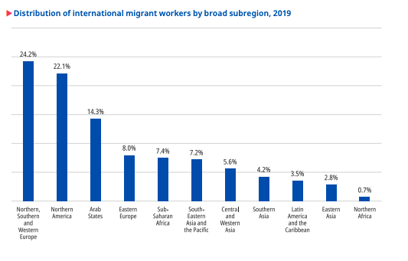Fig. 17. As portrayed in the graph above, we can see that there are more migrant workers who reside in Northern, Southern and Western Europe (24.2%) and Northern America (22.1%).
With a smaller number of migrants in Easter Asia (2.8%) and Northern Africa (0.7%).
What Makes a Migrants Worker
Types of Migrants | Is a Foreign Migrant worker | Is an international Migrant worker
Citizen of the country of residence who is working and was born in another country | No, as did not move in search of work | Yes, as the country of birth is different from the country of residence
Person born in, and working in the country in question, but who does not have citizenship | Yes | No
Citizen returning to work in the country in question after working abroad | No, as holding the citizenship of the country of origin | Yes, due to change in country of residence
Border workers (who reside in one country but work in another) * | Yes | No
Consular official* | Yes | No
Military personnel | Yes | No

Unregulated migration is an issue which I believe cannot be handled well especially when there is no proper information and statistics of those illegally entering into many of these high incomes, developed countries.

2.3 Integration of Migrants

Migrant integration is described as the procedure in which the host country and society migrants find themselves in accept them for who they are, their religion, race, gender and all else that come with them. Migrants can be accepted as an individual or as a group.
Integration is a two-way street; the migrant adapting to their new surroundings, learning and adapting to their new atmosphere and respecting their values. The host society must accept the migrants by allowing them access to the many services provided for legal migrant workers and respecting the values in which the migrants strongly believe. Respect and integration are the core values which bind migrants and their host communities.
Alongside migration integration, we must also look into social inclusion if migrants are being integration, they should also be integrated into the social aspects such as economic sector, political participation and the cultural and social aspects of the country. This would mean that they are fully immersed and accepted into the society and reach a mutual understanding. With a case of them not being accepted, they would be experiencing social cohesion which falls in line with combating the situations of discrimination and xenophobia.
When collecting migrant integration data there are main sources which are to be delved into which are censuses and labor force census. They contain the necessary data which can be used to improve the migrant integration in many areas of the country. The key areas which governments and political leaders should pay close attention to which include:
- The labor market consisting and not limited to wages, employment rate and occupation availability.
- Educational levels of the migrants this focuses on the attainment level of migrants whether they are high school dropouts, college graduates or individual who have advanced educational levels e.g. master’s or PhD. level.
- Health this focuses on whether the migrants who are coming in are healthy individual and the life expectancy of the country in which the migrants come from and whether the receiving country’s health services are responsive to their needs.
- Cultural and social inclusion
- Financial inclusiveness which means that the migrants can own bank account which will allow them to save, obtain and improve their credits and credit score.
- The ability of the migrants to integrate into the public and accept their communities becoming diverse.


Fig. 18

The increasing level of diversification due to migration in Northern America and Europe this influx is a result of vast immigration and asylum crisis and the settlements of people into new places. Integration policies influence the way in which immigrants integrate into their host countries.
Governments have policies and initiatives which help in determining the opportunities available for immigrants and that they are guaranteed the same rights as the native citizens of the said country. The Migration Integration Policy Index (MIPEX) is an indicator which focuses in 8 policy factors for every country. These policies include
- The mobility to labor markets
- Permanent residency
- Nationalization policies
- Anti- Discriminatory factors
- Political participations such as voting rights
- Family reunion and the accessibility of immigrating being reunited with family at home.
- Educational opportunities
- Health benefits and availability
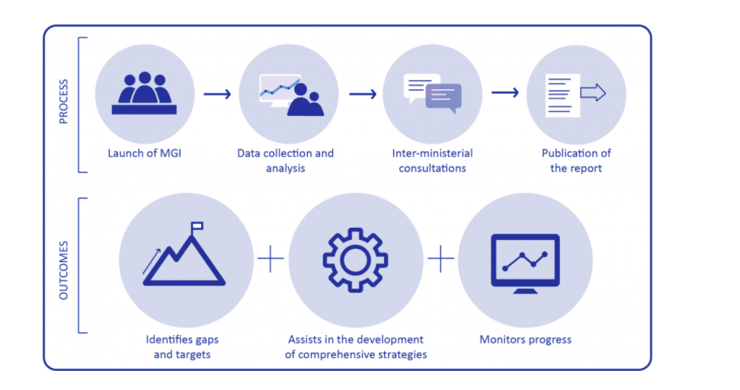
Fig. 19

Like the MIPEX, IOM was able to develop a framework which is meant to assist in properly managing integration policies at a national level this development is known as the Migration Governance Framework (MiGOF). It allows for government to have an insight on policies which can assist them in developing and improving migration laws. MiGOF does not rank countries based on their immigration policies but assess and helps with amendments of their own policies and goals as a nation.
MiGOF focuses on
- Migrant rights - this focuses on the rights of migrants are the same as those of native citizens with regards to access to social necessities such as health services, educational opportunities and gaining their social security details which will allow to work and obtain proper jobs.
- Governmental Approach - it investigates the way governments collect and make use of the migration information and surveys.
- Partnership levels and opportunities- it focuses on the efforts of a country to cooperate with NGOs and other states and governments, private companies and organizations. These type of partnerships and opportunities can assist governments in improving their governments and their policies and standards.
- Migrants and their well-being-this focuses on the policies which government have put in place for the socioeconomic benefits of migrants.
- Safe migration- MiGOF allows countries to analyze their approach to migration with regards to border control, migration policies and migration flows. It also assists in focusing on human trafficking and migrants smuggling.
The Migration Governance Indicator (MGI) was developed to perfect the MiGOF and the framework of country policies. The MGI process consists of 4 phases which are;
- Organizing governmental briefings which allows them to know the importance and the full effects and benefits of the MGI.
- Data collection- MGI is used to process and analyze data based in the MiGOF policies and goals.
- Inter-ministerial consultation- this is the cooperation of policy actors and policy makers. Ministers and stakeholders come together and discuss what they consider as beneficial policy improvements.
- Publication of the Global Migration Data Migration - this is the IOMs publication.
The MGI has great effects on how countries manage their migration stance and policies to not only benefit them but the migrants as well.

2.4 COVID 19 Effects on Migration
The COVID-19 pandemic has drastically transformed the way in which we go about our day to day activities and interact with other people. With the large number of fatalities which were caused by the virus, many precautionary measures were first implemented and when governments realized that they were just that precautionary measures that did not have any great effects on reducing the cases which occur it was unanimously decided that a worldwide lockdown will take place with multiple travel bans and restrictions to protect the citizens of each country.

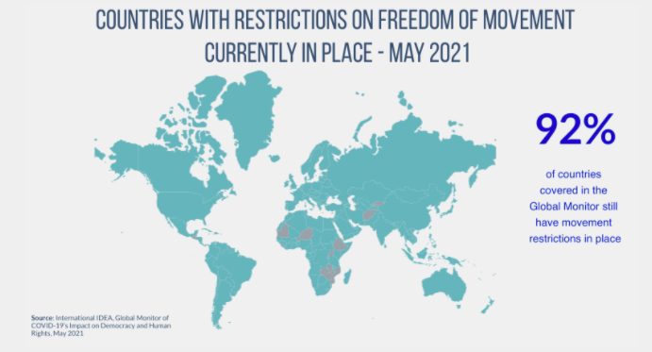
Fig. 20. All the countries in blue represent those which had country restrictions.

The COVID-19 measures which were introduced to stop the spread of the virus greatly impacted worldwide mobility along with all forms of migration. With migration, the individuals are unable to follow along with COVID-19 preventive guidelines in their onerous journeys to greener pastures.
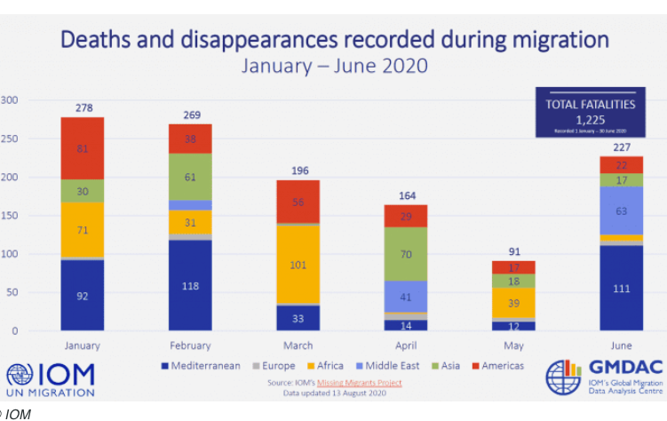
Fig.21.
As we can see above, the graph represents the total fatalities of migrants which took place during the first 6 months of the COVID-19 pandemic, as we can see, the month of January experienced the most fatalities with 278 in total with the least number of fatalities in the month of May with 91. With a total of 1,225 fatalities, 269 occurred among people from the Mediterranean region, 242 people from the African region, 196 from the Asia, 104 from the Middle East and 245 from the America. With close observation we can see that there were minimal fatalities which occurred to the European population.
There was a worldwide effect on asylum seekers, refugees and migrants- as a result of the pandemic they were also some of the people hit hardest by the aftermath of the economic and social collapse and the worldwide closure of all borders and the policies implemented as a response to trying to control the spread of the virus. For those migrant workers who were lucky enough to escape their home countries and make it to their host countries, they too were unlucky as the continued to face risks which affected them and their health immensely. Some of these include
- Poor hygienic living conditions- due to the fact that many migrants find themselves in places with deplorable living conditions that are overcrowded, this is a disadvantage to their health as COVID-19 is an airborne virus and can be spread easily among large crowds. Asylum seekers and refugees also live in highly congested camps which are never clean with extremely poor health services
- Due to the status of migrants especially those who arrive into their destination countries illegally, many cannot attain the proper health services and if they can receive health services there is almost always some kind of language barrier.
- With the pandemic bring everyone to their knees and everything to a stop with lockdowns and economic downfall which left no country unharmed, all social groups affected and the brunt of the impact affecting the vulnerable immensely. Many migrants especially labor migrants were unable to work which lead to many of them being unemployed with little to no saving to prepare them for such a traumatic and unexpected problem all over the world.
- Since all businesses, organizations and government run offices were closed due to the pandemic, many migrants, asylum seekers and refugees who were ok their way to receiving their residency permit and documentation to be legal citizens of the host country; their processes were put to a halt and processes back dated thus making many of them illegally residing in the country.
- Migrants who thought that they were on their way to seeking a better life for themselves and their families were sadly left with a completely different outcome with everything being on standstill. This standstill put many people into a state of depression or a state of overwhelming anxiety and poor mental state.
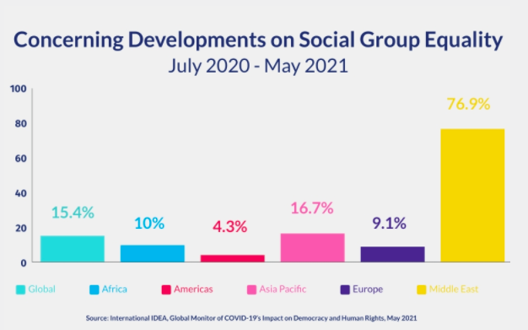
Fig. 22.
Represents the effect of development on each social group during the second half the COVID-19 pandemic, when restrictions were being reeled in a bit. We can see that the Middle East experienced the most and fastest growth with 76.9% whiles the Americas experienced the least and slowest growth with 4.3%.
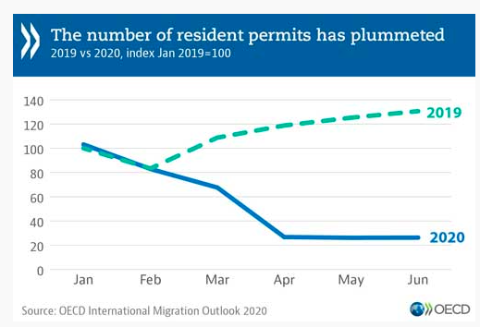
Fig 23.
In the aforementioned paragraph, I spoke on the impacts of the lockdown and the pandemic on al offices and the rate of residency permits which were processed during the time frame. In the graph we see that there was a plummet from March to June 2020 in comparison to the rise which took place in 2019.
The effects of the pandemic were heart wrenching for everyone around the world, but I believe it really provided a time of hardship, confusion and doubt for many migrants, refugees and asylum seekers as they were all stuck in a state of limbo not know what would befall them next.
Conclusions to Chapter 2
This chapter has made us come to realize that migration can be beneficial on a global and regional scale and many of these policies and restrictions put in place towards migrants as a whole is unfair too legal migrants as they have obtained all the rights and necessary documents to be in the country in comparison to the illegal migrants who the policies were mainly implemented for.
For there to be a positive impact and change in the realities of migrants , migration policies will have to Surpass and overlook its boundaries: with this statement I am not saying that migration policies are not important but I believe they should be narrowed so as to not have such a great impact on migration of migrant workers, asylum seekers and refugees respectively.
COVID-19 has left and adverse and tentative change in the way that migrants move around in the search of jobs and better life for themselves.
CHAPTER 3. STRATEGY OF COORDINATION OF UNREGULATED INTERNATIONAL MIGRATION FLOWS
  - Impacts of Migration on Economic and Social Development
Migration affects not only one country but both the receiving and sending countries economically and socially in many different ways, with the sending country receiving the brunt of the negative impact in comparison to the receiving or host country. International migration affects every aspect of a countries economy both positively and negatively from the employment aspect all the way to the taxation system of the country.
The aggregate income of a country is the total income earned in a country without inflation and taxation deductions. International migration helps to increase the aggregate income of the host/high income country, this is achieved through the expansion of the labor force and wage increase (which means there is an increase in the minimum wage in the country).
Migrants sometimes bring along with them skill which may not be present in the current work force of the host countries that they find themselves becoming a part of; but there are also situations in which migrants have the same skill set as the members of the host country’s workforce leading to competition (this is what causes many Americans to say that the immigrants are “stealing their jobs”).
International migration indirectly has an adverse effect on the employment sector some of which are:
- Since there are many female migrants who move to other countries as well as male migrants, they have caused an increase in the number of women working in the labour market. But in countries (eg. Ukraine, Germany, Netherlands and Sweden) where the labor market consists of skilled women, the migrant workers increase the availability of unskilled or lower-skilled workers who work for lower wages and longer hours.
- With the influx of labor migrants there is an increase in the demand for unskilled, lower skilled or manual laborers in the workforces especially with companies which are experiencing labor shortage.
- The migrant workers get employed and do the harder jobs which will then lead to the natives of that company sometimes receiving a promotion and being moved to more skilled and complex jobs.
- In the employment sector of the migrant’s departing countries, they experience a loss in the able body workers making the labor force consist mainly of older workers who are close to retiring age. This is bad as it reduces the productivity levels of the country.
The greatest economic impact of migration would be remittance. This is money which is sent from the migrants back to their home countries, with the influx of migrants worldwide there has been a boom in the remittance level. For the migrant’s home country, remittance has a great advantage as it is a means of poverty reduction and income growth, these in turn lead to economic growth and development. With the flow of money and increase in taxes the government can also use this excess income to improve the educational and health sectors. Due to the frequency of remittance in developing countries, it is now more of less and external financing source. In times of economic recession or hardship, natural disasters and epidemics there is a spike in remittance as the families back home become full dependent on the money received from, the family member abroad.
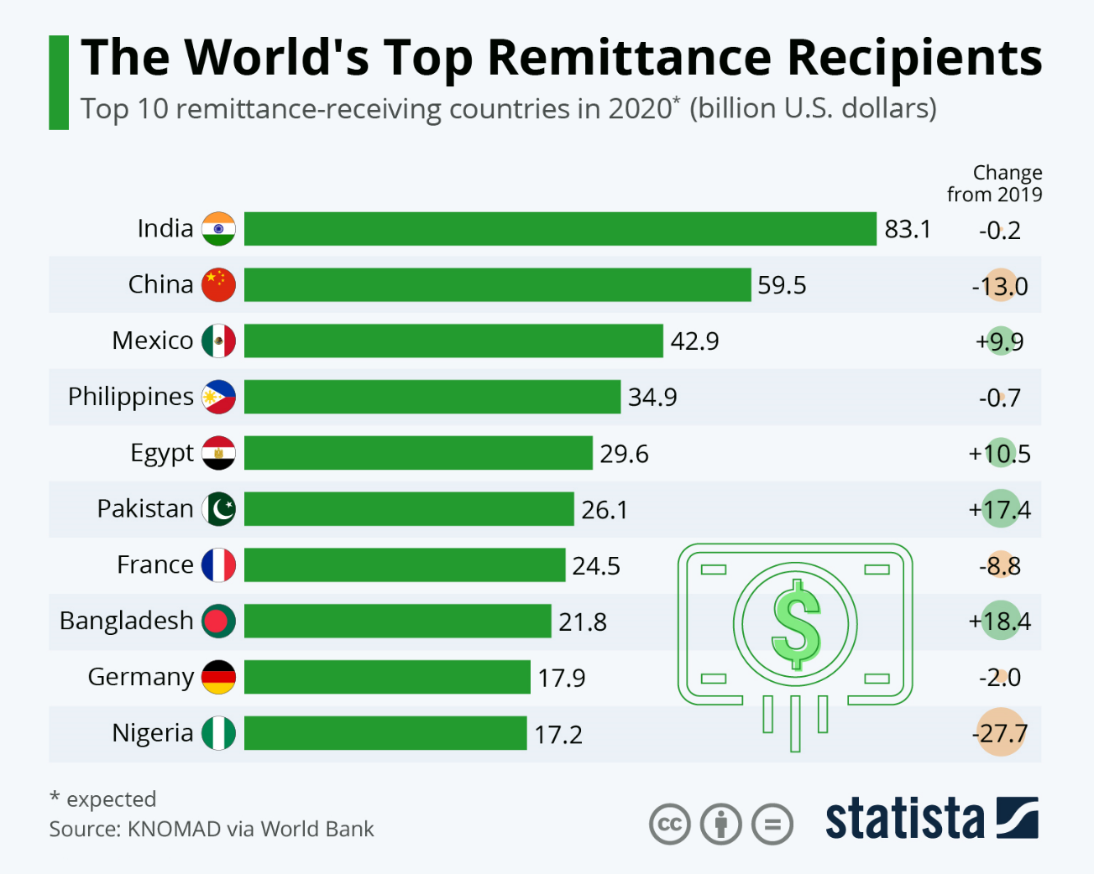
Fig. 3.1
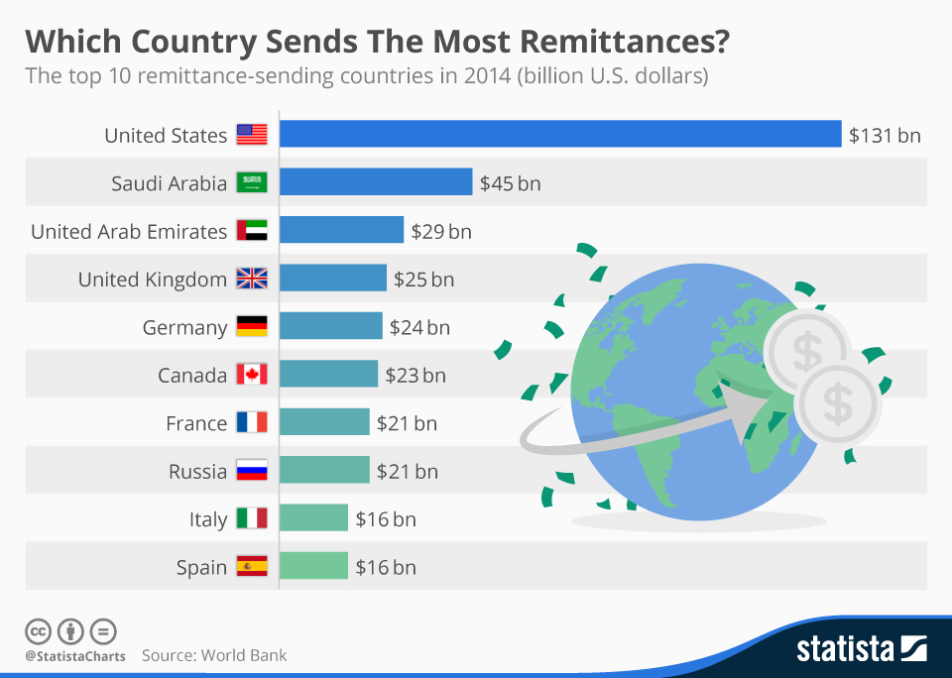
Fig. 3.2
Migration is a human capital investment because of the costs and return which are involved int the whole process (from getting a passport and necessary documents to moving and settling into the host countries), many migrants bear these cost because they expect to have a return of their expenditures once they get their foot on the ground and find a job.
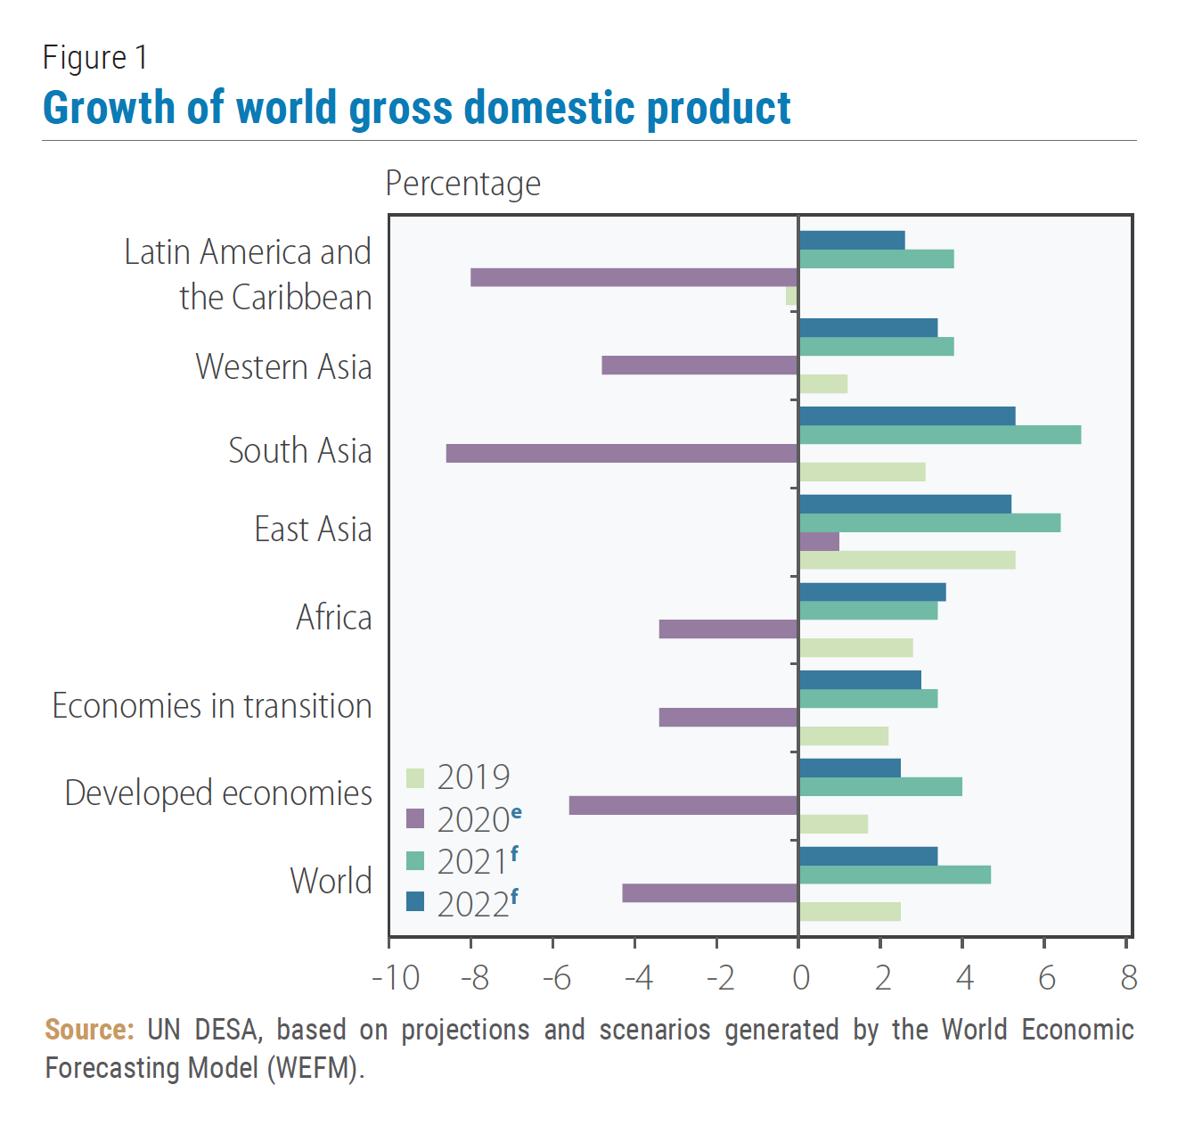
Fig. 3.3
With the diversity of migrants, the international migration can lead to new demands for goods and services ( for example in Ukraine there have been shops opened by foreign students which cater to the needs of some foreign students, me on the other hand I would buy all the things that I need from Sierra Leone during my Christmas break and bring back with me to Ukraine since there wasn’t much provision available for Sierra Leoneans).
Also, with the population growth experienced by the country, producers would need to increase their availability of goods used by everyone, this also leads to an increase in job demands which can be occupied by the migrants.
Migration can be seen as an advantage to many and a disadvantage to other like many prominent issues in the world but overtime the host countries tend to appreciate the positive effects which migration has n their economic infrastructural development.
Migration is oftentimes do to not only economic and political factors but social factors also play a great role some of these are
- Poverty
- Transfer of cultural values
- Housing
- Education
The link between migration and the rate in which social development takes place even though overlooked most times, they really go hand in hand. It is important for us to understand the effects which the social stance of migrants effects the economic outcome of the country as well.
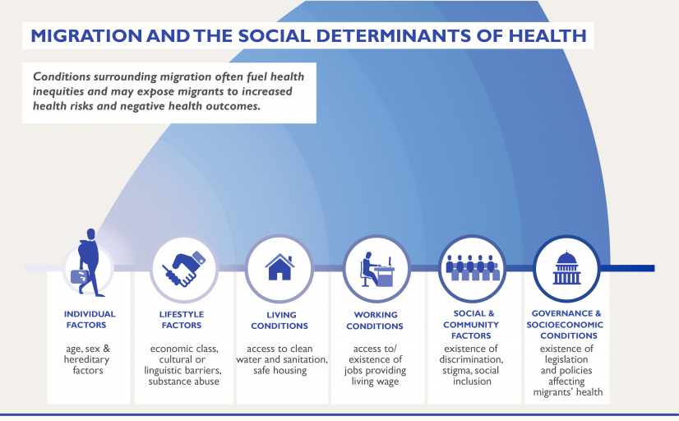
Fig.3.4

When we speak on social development and migration, we would first delve into the expected changes that would occur in the family dynamics of the migrants, refugees and asylum seekers; when it comes to looking for a better life for oneself and family, there is oftentimes the one individual that would leave the rest of the family behind and in most of the household of migrants, they are often too poor to have every member emigrate together. This is what we would refer to as separation of the family - when this occurs with all the younger individuals leaving the older family members behind. Children experience the brunt effect of the separation from parents: for the children who are left behind some will sometimes feel as if they have been abandoned by their parents especially if the parent were to go and have more kids or start a new family in their destination. Even though they can receive gifts and money they never really make up for the physical bond between a parent and their child.
Technological advancements have made communication with family members abroad much easier especially with the development of video call, it allows you to not only hear the person’s voice but to also know the persons face.
In the host/ destination country, many individuals are faced with unexpected challenges and outcomes.
For women and children, it maybe sex trafficking or kidnapping. In general, many are faced with abuse from the jobs which they work for this comes in the form of over working, below minimum wage pays, lack of amenities from the job such as health insurance coverage/lack of proper health care facilities and derelict working conditions.
Alongside these issues, they further experience discrimination in their newfound communities and lack of integration with which they find themselves among.
The adverse effects of migration if spoken about might dishearten people but due to the fact that many are good to look for better situations for themselves and loved ones, they have no other choice but to face the consequences of their actions.

3.2 Underemployment and Occupational Identity
Underemployment and deskilling of migrants go hand in hand. Underemployment can be defined as having an individual work way less than what they are potentially capable of and working under their skills. Deskilling is when they eliminate the importance and need for workers this is often time done to increase the companies profit and reduce expenditure.
Companies and organizations play a very important role of shaping the system of underemployment.
For one they are the ones who assess and determine the necessary criteria Required to make an individual employable. Employers put migrants through rigorous exams and evaluations which normally they do no put native citizens through.
Migrants experience what is known as brain waste this is because they are not using their brain, skills and talents to their full potential this is because many employers hire migrants so as to not have to pay them much wages.
Types of underemployment
There are two types of underemployment
- Visible underemployment is when employees work fewer hours then what is necessary even though they have the necessary skills which are needed for them to work full time, this can also be referred to as part time employment.
- Invisible underemployment is when people work in jobs and positions that do not make use of their skills and knowledge this is the type of underemployment that skilled migrants experience.
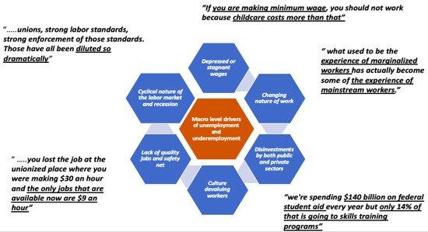
Fig. 3.5
Occupational identity is when and individual has some sense of direction toward obtaining their hopes and dreams in their occupation.
Underemployment and occupational identity go hand in hand. When an individual is underworld and not used to their full potential, they become lazy and Are not goal driven to obtain the goals which they had sets for themselves before leaving their country.

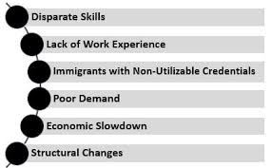
Fig. 3.6: potential causes of underemployment

How to calculate underemployment:
$$Underemployment=\frac{Number of underemployed }{Total Labor Force }$$

Disadvantages of underemployment
- Lack of employee rights
- Increase in machinery and robots reduces the need for people to physically work in the positions that are not controlled by robots and machinery.
- Reduction in mental health quality-when underemployed, it is hard to make ends meet Many families are just scraping by, this can cause anxiety do you to not being able to provide for your family and depression from not being able to use your skills and knowledge to the best of your ability.
- Workers never experience growth in their workplace as they are stuck doing the same mediocre underpaid jobs for an extensive period of time.
Underemployment and deskilling are normally a phenomenon faced by youthful migrants due to the result of them not having the full requirements needed in the new countries that they find themselves. Employment is a huge source of income for everybody and also a source of economic development for the country to which underemployment can play a role in reducing the country's GDP and lowering the labor demands.

Conclusions of Chapter 3
This chapter has made us come to the realization that the disadvantages that migrants possess are sometimes far greater than the advantages that they come with although it is a situation of underemployment that is not the case.
Underskilling and underemploying skilled and able body migrants is a form of discrimination which should be rectified and looked over as many of these migrants are capable of working in positions that native born citizens can work in.

With the necessary support firm employers, the migrants can be shaped in suit being used to their full potential And becoming an asset to not only the company but to the country at large.

CONCLUSIONS
Migration has always been a very important phenomenon which is greatly motivated through the search for standard of living in first world and developed countries due to their strong economy and availability of labor.
As we can see, migration has both its challenges and its advantages for the host country and the country of departure of the migrants.
Policy makers should make use of the advantages that migration comes with especially in the host country where immigrants provide many economic and developmental possibilities.
Migrants sometimes bring along with them skill which may not be present in the current work force of the host countries that they find themselves becoming a part of; but there are also situations in which migrants have the same skill set as the members of the host country’s workforce leading to competition (this is what causes many Americans to say that the immigrants are “stealing their jobs”). Smiling should not be looked upon as competition but they should be looked upon as partners towards achieving the goal of economic growth in the country

