DIRECTIONS OF CLUSTER SYSTEMS ADAPTATION
DEVELOPED COUNTRIES PRODUCTION ORGANIZATION TO NEW CHALLENGES OF UKRAINIAN ECONOMIC EVOLVEMENT

Olena Sokhatska, Yevheniy Kurylyak
Abstract
In the article are reviewed the directions of successful global experience adaptation of clustered forms of production organization in implementing the economic reforms in Ukraine in conditions of severe economic and financial crisis, which has significantly worsened during the "hybrid war” with Russia. In particular it is emphasized, that we cannot talk about using this experience by individual businessmen or representatives of the regional authorities, it is important for cluster policy to become an integral part of economic policy. Therefore, the article offers the basic elements of a clustering policy in the formative period in the whole of new approaches to the functioning of small and medium businesses, with particular emphasis given to the development of this form of production organization in the priority sectors: IT, agricultural sector, defence industry, processing (refining) industry and so on.
Keywords: Cluster, economic reform, economic policy, knowledge economy, networks of competence.
INTRODUCTION
Given the accumulation of a significant amount of new scientific knowledge and practical nature in the field of clustering for Ukraine is particularly important a need to adapt this resource for the national economy. We are not talking about using it as initiatives of individual businessmen or regional leaders, but about the transformation of clusters in an important strategic element of economic policy. The creation of clusters needs to be an integral part of socio-economic goals and ideas of development in the system of economic reforms which taking place in 2015.
Cluster policy is focused mainly on the development of small and medium-sized enterprises, because they provide an opportunity to address issues of employment, to engage in innovative activity large amounts of workers. In advanced economies, the share of employment in these enterprises is 50-70%, and the share in GDP - 50-60% . On the base of small and medium businesses the production systems of the cluster type are established, which provides the opportunity to expand the boundaries of economic freedom, create jobs and build up the middle class. The association of small and medium enterprises in clusters gives a benefits, that are traditionally characterized by a large production. Among them stands out - increased financial opportunities for the use of scientific-technical progress and economy on scale.
As evidenced by international experience, the successful implementation of the cluster approach requires the development of special national program, which will determine the promotion and support of clusters in various sectors of the economy. This can be considered as traditional approaches to the creation of local production systems that are drawing near their wider interpretation as agglomerations, and identified ways of creating clusters of world-class, focused on innovative development.
1. THE FORMATION OF ECONOMIC POLICY ON THE CLUSTER FORMS OF PRODUCTION ORGANIZATION
1.1. Elaboration of the national cluster programme and it’s actors
The analysis of the programmes of economic reforms in Ukraine, which are covering the current period and the future, suggests that in terms of small businesses and clustering a relevantly small role is payed to them. Clustering is a new economic phenomenon, which has become a mechanism for resisting the pressure of global competition and the formation of internal, national and business competitive advantages. Elaboration of the national cluster program should clearly identify the level at which it is designed. Since the cluster approach is primarily a managerial technology association of small and medium enterprises, to the extent it should focus on improving the competitiveness of the region that hosts the cluster members. Through the prism of the region we should consider the impact of clustering on the development of the industry and the state as a whole.
The national Ministry, as a rule, formulate an overall strategic guidance. They also determine fiscal goals and solve the problems of new authorities creation. Other state agencies and regional authorities play a leading role in programme development and management. Programs include initiatives of specific nature, which are implemented with the use of tools, which is within the competence of a particular region or sector. In this process an important role is given to institutions that promote the initiative. So, the design and implementation of cluster policy involves many actors that requires effective coordination mechanisms of their interaction.

1.2. Qualitative indicators and information in the system cluster policy
Cluster policy is advisable to differentiate in terms of stardom. This system was developed by experts from the European cluster observatory by analogy with the hotel classification. It has a four-tiered grading – 0*; 1*; 2*; 3*, which is set a number of stars for each cluster on the basis of indicators of size, specialisation and focus. The method of assigning a star level to european clusters is analyzed by ukrainian researchers O. S. Burmich, O. D. Lukianenko, Y. G. Panchenko and V. I. Chuzhikov . Size indicator associated with the impact of cluster employment. It’s highest level should exceed 10% of standardized measure among the leading regions of the EU, which is calculated as the ratio of employment in the cluster and in the EU. Specialization in the cluster of stars is determined if the region in framework of the European division of labour is allocated by specific cluster category among the 10% of successful EU regions with the highest employment in the relevant industry. The third indicator, which is called "focus", accepted for evaluation stardom, if the cluster has a large share in the employment structure of the region, in particular, cluster is in the TOP 10% of similar categorie of clusters, with the highest share of employment in the region.
Development of cluster policy requires appropriate systems of information support for this task. It can be created by institutions which are specializing in information functions. In particular, in the European Union source data considering clusters is formed by INNO-Policy TrendChart in cooperation with ERAWATCH . Currently, more than 130 national events registered in terms of cluster support . At the same time developing a new scheme of gathering information about cluster policy. Special attention is paid to providing information about the horizontal and vertical cluster strategy, as well as programs of financial assistance to clusters.
The formation of economic policy in the field of clustering of the Ukrainian economy now relies on experience of countries in the Euro-Atlantic space which is gained in the last decade. However, it has not acquired a systemic character. Ukrainian publications mainly analyzing some attempts to create a network of associations in European countries. Given this approach it is impossible to count on a fairly high level of implementation of the best world achievements. A different approach has emerged in the countries of Central and Eastern Europe. For example in Poland since 2002 is systematically investigated the development of clusters with regard to the achievements of affluent countries. Special attention is paid to small and medium businesses, its innovation potential,realization of phenomenon of the "Third Italy" .
For Ukraine it is relevant in the framework of clustering a development of such programs: information and brokerage services; technical and advisory assistance; direct funding; formal and educational events; organisation of network activities; lobbying; marketing; monitoring and reporting. On the basis of these programs can be fulfilled the system to achieve such purposes, as professional development, cluster expansion, business development, deepening and expansion of business cooperation; R&P innovations, the use and improvement of the business environment.
It should be noted that informational reflect of the development processes and implementation of cluster policy is a very complicated task and its improvement requires the rehearsal of new advanced methods. This activity is based in the EU.
Also, it should be taking into account that the policy of a specific cluster can cover a wide range of different tasks and measures that receive support. Sources can be the events of "soft policy" to support the self-organization through various networks and information dissemination. Not excluded the use of "hard" horizontal channels which implement regarding clusters regional bodies (often it is legitimate to associate with the tightening of financial policy).

1.3. Organizational-economic conditions of the cluster policy
The structural component of the cluster policy should reflect the advantages of such a union, for implementation of which the participants established production network. The experience of firms in the Euro-Atlantic space suggests that the strengthening of the competitiveness of the cluster as a whole and its members, in particular, is due to the receipt of synergies in the areas of resource use, increase in market activity, productivity growth and the ability creation future potential.
Economic policy in the field of clustering should proceed from the fact that the clusters as a form, which has a predominantly regional and innovative institutional framework, should receive appropriate financial and infrastructural resources. The latter must be formed outside the traditional resources of enterprises. As a rule, these internal and external funds or investments allocated for the financing of joint projects. In the infrastructure aspect at the disposal of the cluster are office space, meeting rooms, internal network and the laboratory. It is important that the resource potential were not a one-time basis, and were in long joint participants in the cluster.
The participants of the production network cluster formation as businesses and organizations should support due to competition level performance, objectively try at least to prevent its decline. However, the fact that the establishment of the cluster determines the feasibility and the need to improve network performance. For this there should be planned a activities which are aimed to the development of human resources, competitiveness, enhance the innovation cluster development and internationalization, They should not duplicate internal activities of the cluster participants. This is the set of activities that are defined and implemented on sahlinisternas level.
In general it is lawful to say that the growth potential of clusters, is in the model that gives the ability to best use of the resources of the region, its scientific-technical, human, financial, informational and managerial capacity. At the same time the last should be integrated into the system of macroeconomic policy and strengthen it’s positions on the world market.

1.4. The terms of the clustering processes extension in Ukraine
Great hopes are placed in Ukraine by many economists and scientists on the use of cluster systems of production organization, can come true at least under three conditions. First, the processes of clustering should correspond to the real state of the economy of Ukraine. Secondly, the existing clusters and those that will arise in the future, should naturally be logged on economic reforms, which will be developed during the implementation of the Association Agreement between Ukraine and European Union. Third, clustering in ukrainian economy should adapt to the national context a rich experience of network systems cluster type that was stored in the global economy.
In terms of inclusion in the Association with the EU and its member States, Ukraine has a unique chance to guide its development to adopt a new European strategy "Europe 2020". We are talking about both goals and means to achieve them. Main purpose for the European Union in the twentieth decades of the twentieth century is return of lost positions because of the crisis. "Europe needs to get back in line and stay there," , - J.M. Barroso in his Preface to the messages of the European Commission on the European strategy for 2010-2020 years. Last, receiving the name "European strategy for smart, sustainable and inclusive growth", has identified five areas of activity of the European countries: employment; research and innovation; climate change and energy; education; poverty alleviation.
As shown in Fig. 1, only under the condition of sustainable growth Europe can surpass the pre-crisis growth path. Slow recovery will have a lower base of economic growth, from which to form the lower growth trajectory compared to the pre-crisis period. In the end, a possible scenario in which Europe will have a permanent loss of wealth and potential for future growth. So, the strategy of sustainable recovery is the ideology that needs to be based in the basis of the economic policies of countries emerging from crisis. It should be taken as the basis of Ukraine in the development of a new strategy for socio-economic development.
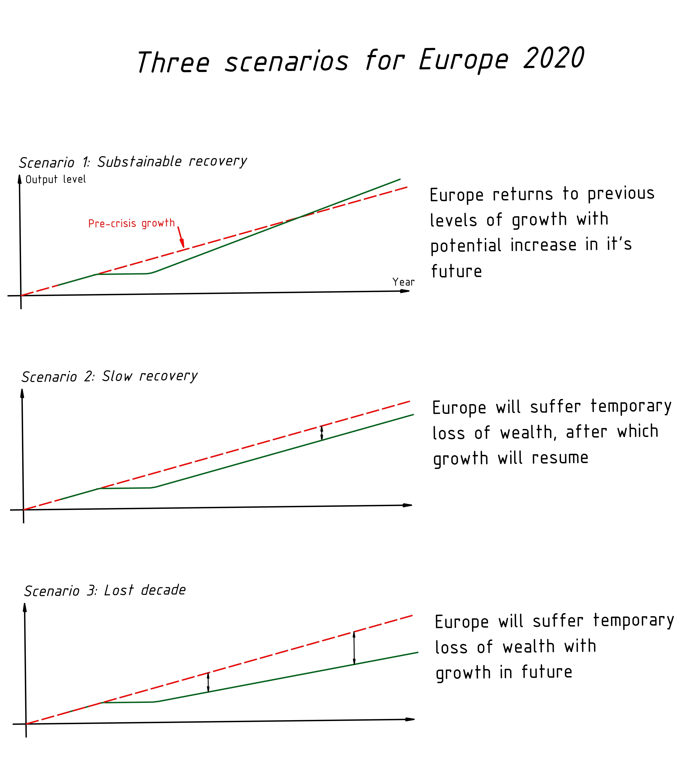
Fig. 1. Scenarios for successful implementation of the European strategy

By given the geopolitical and geo-economic position of Ukraine the use of network forms of organization of production for the purposes of smart, sustainable and inclusive growth must begin with a revival of the military-industrial complex. In general approach the objective is to give a "second wind" for research, educational, testing and production companies that develop, manufacture and registration of weapons, military and special equipment, ammunition. At the same time we should set up new enterprises, so that the country had a relatively autonomous production cycle of competitive weapons.
Priority of MIC in the processes of clustering stipulated by the security needs of the country in conditions of "hybrid war", which began in 2014 and prioritizes the needs of the armed forces in current and future aspects. However, this is not the main argument, as can be armed with the most modern weapons and imports. No less important is the fact that the economy armament stimulates intensification of scientific and technical research and focuses their use in the production primarily for the army, and then to the civil sphere.
2. DIRECTIONS TO ENHANCE THE ROLE OF CLUSTERS IN TRANSITION OF UKRAINE TO THE KNOWLEDGE ECONOMY
2.1. Prerequisites of cluster policy orientation in to the knowledge economy
The answer to the question on how to achieve leadership positions in the global economic space is situated near the plane of development the ideas of knowledge economy. In the political-economic debate, it is also defined as classes of "decent" places in a competitive global environment. In conditions, when Ukraine is forced on its territory to wage undeclared war and the disruption of traditional trade flows with the Russian Federation, primarily should be considered a problem of reorientation of business and markets of the Customs Union countries, especially Russia, to the markets of other countries. Having in regard the provisions of the Association Agreement between Ukraine and the European Union, favourable institutional conditions for this are opening on the European markets. There is no doubt that for european consumers will become very popular the ukrainian agricultural products, food industry, and with time also an energy. Today it is the most successful Ukrainian products on the world market.
However, in long term conditions should be produced a strategy for promotion of Ukraine on the innovative products markets. For foreign markets “are particularly interesting the new industries, because they are the future. IT, education, health protection, which can go into medical tourism in Ukraine. We may already have such a complex product of Ukrainian land: not only of fertile lands, but also of the people" .
The orientation of the cluster component of Ukrainian reforms on the ideas of the knowledge economy is a top priority to achieving real european identity of Ukraine in scoping the future, if we understand it as the implementation of modern values of world civilization. Focusing on the production of knowledge and the formation of new technological processes and production, though the most difficult, however, but least risky, at the same time, way into the circle of leaders. After all, economic growth based on the production of traditional and commonly used products does not give global recognition. This is illustrated by the African and especially Asian countries. Thus, when the average world export growth in 2005-2012 years around 3.5%, North America had a rate of 3.5%, Central and South America 1.5%, Europe - 2,0%, CIS - 3%, Asia 7% (China 11%, India 10,5%, Japan 2.5%) and Australia - 3,0% .
Ukraine as a country that integrates into the European economic space, should take as a main strategic guideline - European Union. It is quite clear that public authorities and business environment should first carefully study the processes of knowledge economy development, typical for Europe.

2.2. The output base of R&D in the development of cluster processes in Ukraine
The reformers of Ukraine should take into account the fact that from the five key objectives of the EU strategy 2020 identified the achievement of the share of expenditure on research and development in GDP at the level of 3% (EU-27) while the rate was 2,03% in 2011 and a 2.01 in 2010. These figures (presumably, they are average for the EU-27 as a whole) below the cost of R&D in many developed countries. Thus, according to the latest statistics published by the state statistics Committee of Ukraine in 2013, the share of expenditure on R&D in Japan was 2.01%, South Korea - 4.0% and the United States - 2.87% (2009), but higher than in China (1.7% in 2009). Among the EU-27 only in Finland (3,78%), Sweden (3,37%) and Denmark (3,09%) the intensity of R&D exceeded the goal of the Strategy and the indicator of the United States. In other countries such as Germany, Austria, Slovenia, Estonia, France, the Netherlands and Belgium, the intensity of R&D was higher than the average in the EU-27, although still below its target value, 3%, (respectively 2,84%, 2,75%, 2,47%, 2,38%, 2,25% and 2,04%).
The intensity of R&D in Ukraine is much lower than in developed countries and most countries of the EU. It was 0.75% of GDP in 2012, despite the fact that in 1990 this indicator in Ukraine was 2.3% . Despite the fact that in 2011, this level has been established in some post-socialist countries (Slovakia, Latvia, Bulgaria and Romania), as well as Malta and Cyprus , the existing state of scientific research development and elaboration does not create a basis for drafting, which would be adequate to geo-economic and geo-strategic location of Ukraine in Europe. However, comparing to the countries of EU with small population, Ukraine has advantages in terms of absolute expenditures on R&D - they are 2.4 billion american dollars. However, the range of EU countries, which expenditure on R&D exceeds Ukraine, limited only by Latvia, Bulgaria, Estonia, Lithuania, Slovakia and Romania.
In general, in terms of expenditure on R&D Ukraine lags behind other European countries big time. Countries which are closes to Ukraine according to the rating are: Czech Republic (excess expenditure on R&D compared to Ukraine in 2.2 times), Poland (2.4 times), Denmark (2.6 times), Finland (3 times), Belgium (3.5 times), Austria (4 times), the Netherlands (5.9 times). At the same time, France spends on R&D 20.1 times more than Ukraine, Germany - 37.2 times.
The cost analysis for the development of R&D in Ukraine allows to draw at least two conclusions. First, the destruction of the economy through the creation of oligarchic model in conditions of weak governance and operation of the inherited Soviet assets by private entrepreneurs that were in power or in the management of state-owned enterprises, has brought the country to a state of a backward country. Secondly, despite the presence of a large number of problems in the economy, the government must adopt a program for the accelerated development of R&D. it is necessary to put the European benchmark of 3% of GDP. If every year the existing level of cost will increase by 0.25 points, till 2020 Ukraine may reach the level of the strategy "Europe 2020".
Achieving the 3% intensity level of R&D will increase the amount of the cost of research and development in the gross domestic product of $ 10 billion. It will put Ukraine on a par with such developed countries as Austria, Belgium, Denmark, Netherlands, Finland, Sweden, given the overall amount of funding, and the size of the cost attributable to the citizen. In the end, this strategy can rapidly turn Ukraine in the state of the knowledge economy and get rid of the burden of oligarchic economic model. In fact, for the oligarchs will not be left with no other option, how to get involved in the processes of the national economy transformation to the knowledge economy or gradually go off the stage. The original accumulation of capital through rent-a corruption of origin must find the transitions to new sectors and products. Otherwise the energy of oligarchic capital and businessmen of the post-Soviet sample will be lost and will transfomr to use by new entrepreneurs. We are talking about a new generation of business leaders, which has already formed and is likely to evolve in the near future on the principle of a chain reaction.
2.3. Implementation of the german experience in the creation of networks of competence in to ukrainian conditions
The idea of the ukrainian transformation in to the knowledge economy can succeed only in terms of big investments in R&D, which, firstly, have industrial interest, and, secondly, will form the modern innovation of the national economic complex. For this purpose it is expedient to perceive the german experience coherent innovation strategy of the government and private sector companies through a network of “competence" (Kompetenznetze). These are the regional associations which produce new knowledge on the basis of the concentration of specific competencies. The creation of networks of competence is carried out for the search for new scientific and technological solutions involving public funding target. The procedure for obtaining financing, based on open competitive selection of projects of regional consortia, which are formed from academic institutions and private companies.
German experts consider the current stage of development of innovation policy, as a transition. It is characterized by a strengthening of the requirements for complexity of scientific and technical developments, which finds its expression in taking into account the aspects of environment, health, transport and so on . In the new conditions we are not rejecting the idea of using cluster forms of innovation capacity of enterprises growth, which has proven itself in practice in the global economy. However, formed by M. Porter approach as a geographical concentration of companies and research institutions in the same industry or technological field is expanding. New approaches are preferred to the creation of a network of industrial and scientific structures without necessarily binding to a specific site in the organization and management of which are clustered principles. They are characterized by universality, which means territorial and departmental limitless and coverage of breakthrough development challenges . In Europe such networks was named cluster initiatives and they are a subject for the financing of programmes to promote clusters. The mechanism for the creation of competence networks in the general construction can be illustrated by the example, of First Federal initiative, which had the name of BioRegio program (www.bioregio-stern.de). It was aimed at new clusters that are not yet "set" by long term "seticlient on traditional approaches. For participation in the program was submitted 17 proposals, from which selected only three. The winners received 90 million euros, and later, after the high results of the program, the amount of support increased by EUR 1 billion.

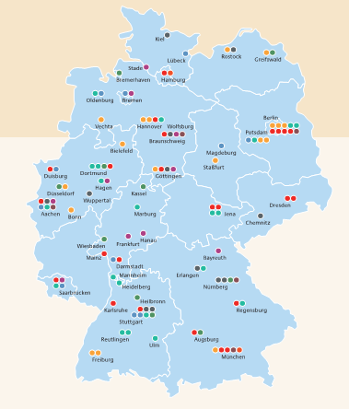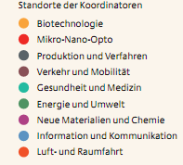
Fig. 2. The location of the focal points of the competence networks in Germany
Equally important in the initiative networks of competence is the system of submitted bids evaluation, because the winners receive significant amounts on research and development. Poland, for example, in five years can attract 100 million euros to support clusters from pan-european fund: “Operational programme innovative economy”. (Program Operacyjnego Innowacyjna Gospodarka). Also well deserves a attention the providing an important role to small and medium enterprises in the structure of cooperation relations. The mechanism of it’s inclusion in the national projects should be flexible and provide support, both at the bottom and the top. The authorities will need to focus on the adoption of a package of legal norms that provide real opportunities and encourage the establishment and functioning of clusters in the network of system competence.

Using the experience of competence networks of Germany in ukrainian conditions requires setting priorities for scientific and technological policy. After all, if such a developed country like Germany can't afford the provision of financial support, so to speak, "on demand", - Ukraine with a very high accuracy should approach it’s own funds concentrating on the areas that have the potential to reduce the formation of knowledge economy. It would be logical to build this process along the line of "priorities - human and material support - funding". However, under current conditions, this process must be reversed. The most scarce resource for Ukraine is financial. So first of all you will need to determine the necessary and possible investments for network competence, and respectively to justify priorities.

2.4. Sectoral priorities in justification of the cluster policy of Ukraine
Priorities in scientific and technical sphere of Ukraine must first be identified as alternatives for consideration. They are recently indirectly discussed in connection with forced reorientation of export flows from Russian market to Europe. They can be arranged in the following sequence:

- Agriculture and food industry ;
- Medicine and medical tourism;
- Engineering and shipbuilding;
- Aviation and space.

It should be noted that basic research on agriculture, food industry, medicine and medical tourism can have a joint interdisciplinary program. At the junction of these sciences we should always expect the most promising areas of application development, which will be adapted in the know-how for the production and practical medicine. The corresponding methodology may be used in the strategy of creation the networks of competence, which would cover the engineering and shipbuilding, aviation and space. Such approaches will allow at minimum cost - maximize the results.
It is reasonable to assume that with the establishment of the initiative networks of competence, might occur the temptation to monopolize access to sources of financing due to the current position in the industry. So, in engineering and shipbuilding on the exclusive right to determine the branch of scientific-technical policy can claim Dnipropetrovsk, Kharkiv, Mykolaiv, Odessa, Kyiv. To avoid this from happening, it would be worthwhile to elect a new geographical location of the coordinating center of competence network. It is advisable to choose in the area of country center. Under this condition it will be easier to attract new personnel that will be difficult (if not impossible) in the traditional placement of the largest industrial enterprises and institutions.

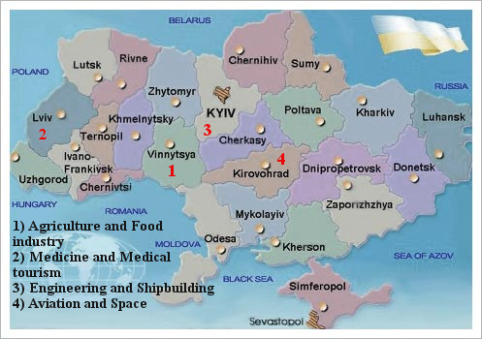

Figure 3. The location of the coordination centres of competence networks in Ukraine (project)

As shown in Fig. 3, the location of the coordination centre of competence network on the issues of agriculture and food industry, it is advisable to choose the Central Ukraine. It may be South of the Vinnytsia region, climatic conditions of which are close to almost all regions of the country. Western Ukraine could become a center for medicine and medical tourism, where there are complex conditions for scientific research in the field of medicine, and for the establishment of medical institutions of a new type based on the use of natural-climatic factors. For coordination of new approaches in the fields of engineering and shipbuilding it is useful to consider Kyiv region (not Kyiv), or the angle South of Kyiv region - North Khmelnitsky region - South-West of Cherkassy region. They are close to the leading scientific and technical institutions (Kyiv, Zhytomyr, Poltava, Kharkiv, Dnipropetrovsk, Chernihiv). The location of the coordination centre of competence for the sphere of aviation and space exploration in the region is reasonable, given the economic and political factors. This region is relatively far away from the borders and not densely populated, which contributes to a better provision of trade secrets. Moreover, on the territory of Kirovograd region there is a flight academy of National aviation university.
The creation of competence networks centres will ensure the formation of their human and physical asset, which will take a hub of scientific problems and get the best clusters to achieve the ultimate goal. With time on their basis should be developed a national scientific-production corporations with global strategic objectives. Some distance of the centre from regional cities will avoid corruption in the recruitment process and will facilitate the solution of everyday problems. For this purpose it will be necessary to provide the allocation of the site for construction and development of scientific-industrial and residential complexes.
The prototype of this approach can be borrowed from the policy support of clusters in UK, where one of the most successful in the North East of England in 2005 was created the cluster of processing industry (North East Process Industry Cluster - NEPIC) in Teesside in the chemical industry. The cluster has been quite successful, especially in attracting new investment. Human potential formed mainly from local youth. For this purpose, they organized a number of meetings in universities and schools, during which the visitors were convinced that the chemical industry is a place for a successful career.
NEPIC has arisen as a result of two regional cluster initiatives: Pharmaceutical & Speciality (P&S) Cluster and the Teesside Chemical Initiative (TCI). Their members came to the conclusion that the pharmaceutical and chemical industry is so interconnected that can bring mutual benefit on the basis of association. The subject of the cluster activity includes pharmaceuticals; biotechnology; chemical, polymer, rubber, petrochemical and other products. In these areas company has become the engine of development not only for regional, but also for national economies. Cluster companies provide annually about a billion pounds to regional GDP (25%) and 20% working in the region. Petrochemical industry in Teesside production ranks first in the UK and second in Europe.
The formation of new competence networks in the framework of the national economy transformation policy, in the knowledge-based economy, requires a systematic approach to participants recruitment. It should be based on socio-economic trends that are inherent to the country in the corresponding period of development. Especially important is the evaluation of legal support for the development of long-term complementary cooperation, with which termination of network will be unacceptable, i.e. the emergence of important links, that may delay or frustrate the achievement of the goal, will be impermissible. Thus the horizon of the activities of all participants of the project must be global in order to ensure a high level of competitiveness of the final products.
There is no need to prove that the production of new knowledge requires the inclusion to the network competence of institutions, which carrying out research and provide educational services. However, in Ukraine, the mechanism of their functioning have "preserve" in the first half of the twentieth century. The new law on higher education, adopted by the Verkhovna Rada of Ukraine in June 2014, brings it closer to european standards. However, the search for a new model of organization of educational and scientific activity cannot be completed on this stage.
In the contrast, the new law creates a breeding ground for new searches. Thus, it is necessary to take into account the experience of providing new features to academic centers that have developed after the Second world war in the United States, in particular the pioneering experiments on the organization of the Massachusetts Institute of Technology (MIT) and Stanford University in the area of contacts with businesses. For new approaches commercialization of scientific research is becoming no less important than the education and research activities. As noted by K. B. Matusiak, the task of higher education institutions in the era of globalization, while ensuring a high level of education and scientific research, is turning them into international centres of entrepreneurship and technology transfer. Academic transformation is a specific combination of ideas of Humboldt (unity of education and research) and Schumpeter (creative destruction)" .
Commercialization of scientific activity cannot be considered only as a subject of provision subsidies through various grants. Equally effective may be the cooperation with the mediation of institutions specializing in the organization of direct contacts between business and science. This practice developed in the UK, where the regional development Agency has developed 9 programs for creation of collaborating Centres with industry (Centres for Industrial Collaboration - CISs). They contribute to the transformation of the regional scientific and technical resource to the needs of entrepreneurs, facilitating their access to the latest scientific and technical achievements. The program helped to expand the role of the local universities in the direction of marketing, market research, pricing policy development, negotiation, obtaining lucrative contracts. The direction of the universities to the needs of the business, highlights by CISs will, to have their offices in immediate proximity to the producing departments.
The fact that enterprises that cooperate with CISs, do not receive any grants, contributed to the awareness of companies of the studies value in which they have invested their own funds. In addition, the inclusion to the network CISs provided access to world class scientists and retrofits involving equipment of the highest quality. Importantly, customer research managed to ensure their implementation within the agreed time and within a certain budget . Thus, in the region Yorkshire & Humber thanks to CISs initiatives, recorded sales growth, expanding to new markets and business development for hundreds of companies. CISs collaborated in carrying 1,700 projects with enterprises, estimated at 40 million pounds, that made it possible to save more than 1,300 jobs in the region .
CONCLUSION
Elaboration of the national cluster program should clearly identify the level at which it is designed. Since the cluster approach is primarily a managerial technology association of small and medium enterprises, to the extent it should focus on improving the competitiveness of the region that hosts the cluster members. Through the prism of the region, should be considered the impact of clustering on the industry development and the state as a whole.
Development of cluster economic policy has a rich structure and depends on the profile of the cluster management subjects activity. In this cluster, it is advisable to differentiate in terms of stardom. This system was developed by experts from the European cluster observatory, by analogy with the hotel classification. It has a four-tiered grading - 0; 1*; 2*; 3*, which is set to star cluster on the basis of indicators of size, specialization and the share of workers in the employment structure of the region.
Given the characteristics of the cluster organization's priority activities in the system of cluster policy, we should highlight the orientation on market challenges and leadership in technology and product aspects of entrepreneurial activity; marketing and PR, internal communications; use of scientific achievements, the formation of new knowledge, innovation and unique value.
The orientation of the cluster component of Ukrainian reforms on the ideas of the knowledge economy is a top priority to achieving real European identity of Ukraine in scoping the future, if we understand it as the implementation of modern values of world civilization. Ukraine must provide 3 % of the intensity of R&D, which will bring the total cost to perform research and development in the gross domestic product of 10 billion $. In terms of this policy clusters will be able to play a decisive role in the transformation of Ukraine in a relatively short period of time in state with the knowledge economy and to deprive the burden of oligarchic economic model. This task can be successfully resolved using the german experience of coherent innovation strategy of the government and private sector companies through a network of “competence".
Priorities in scientific and technical sphere of Ukraine in the system of financial policy cluster support should be placed in the following order: Agriculture and food industry; Medicine and medical tourism, Engineering and shipbuilding; Aviation and space.

Bazilevich V.D. Economic theory: Political Economy [Electronic resource] / Access Mode: http://pidruchniki.ws/1299101039956/politekonomiya/klasifikatsiya_pidpriyemstv_rozmirom_maliy_biznes_novi_vidi_pidpriyemnitskoyi_diyalnosti
Technological modernization in the European economy : Monography / [Burmich O. S., Lukyanenko O. D., Panchenko Y.G., Chuzhikov V.I.]; scien. ed. by V.I. Chuzhikov. - K.: KNEU. - 2013. - P. 174-175.
Innovation Cooperation (PRO INNO Europe ®) [Electronic resource] / Access Mode: http://ec.europa.eu/enterprise/policies/innovation/support/pro-inno/index_en.htm?fuseaction=page.display&topicID=52&parentID=52
CORDIS. Community Research and Development Information Service [Electronic resource] / Access Mode: http://cordis.europa.eu/guidance/welcome_en.html
DG Enterprise and industry report. Innovation Clusters in Europe: A statistical analysis and overview of current policy support – P. 17 [Electronic resource] / Access Mode: http://www.central2013.eu/fileadmin/user_upload/Downloads/Tools_Resources/Cluster.pdf
PARP. Benchmarking klastrów w Polsce – 2010. Raport z badania Warscawa, 2010. – S. 13 [Electronic resource] / Access Mode: http://www.pi.gov.pl/PARPFiles/file/klastry/Benchmarking_klastrow/Benchmarking_klastrow_w_Polsce_2010.pdf
Europe 2020: European strategy for smart, sustainable and inclusive growth. – P. 3 [Electronic resource] / Access Mode: http://ec.europa.eu/research/era/docs/en/investing-in-research-european-commission-europe-2020-2010.pdf.
In original: “Europe needs to get back on track. Then it must stay on track.”
Europe 2020: European strategy for smart, sustainable and inclusive growth. – P. 7 [Electronic resource] / Access Mode: http://ec.europa.eu/research/era/docs/en/investing-in-research-european-commission-europe-2020-2010.pdf.
Pavlo Sheremeta held a meeting with representatives of the economic services of local authorities / Press service of the Ministry of economic development 14.04.2014 // [Electronic resource] / Access Mode: http://www.me.gov.ua/News/Detail?title=PavloSheremetaProvivNaraduZPredstavnikamiEkonomichnikhSluzhbMistsevikhOrganivVladi
WTO: International trade statistics 2013 / [Electronic resource] / Access Mode: http://www.wto.org/english/res_e/statis_e/its2013_e/its13_world_trade_dev_e.htm
In statistics the term "intensity of R&D" is used.
State statistics service of Ukraine. Scientific and innovation activity in Ukraine. Statistical compendium. К., 2013. – P. 150, 153 [Electronic resource] / Access Mode: http://www.ukrstat.gov.ua/
Compliance on the development of scientific-technical potential and innovation activity in Ukraine / Verkhovna Rada of Ukraine / Bulletin of the Verkhovna Rada of Ukraine (BVR), 2004, N. 43-44, P.494 // [Electronic resource] / Access Mode: http://zakon4.rada.gov.ua/laws/show/1786-15.
State statistics service of Ukraine. Scientific and innovation activity in Ukraine. Statistical compendium. К., 2013. – P. 150 [Electronic resource] / Access Mode: http://www.ukrstat.gov.ua/
In general, there are serious doubts that the majority of representatives of oligarchic capital is able to work successfully in a new way in the absence of pro-government rent. With the big share of probability it is possible to predict the processes of natural change, a kind of "dispossession" through the market.
Evaluation: Instrumente für eine bessere Politikgestaltung. Jahresbericht 2013 / Berlin. Institut für Innovation und Technik, 2014. – S. 11.
Hantsch S. Cluster Management Excellence in Germany – German clusters in comparison with European peers. / Hantsch, Sophie / Kergel, Helmut / Lämmer- Gamp, Thomas / Meier zu Köcker, Gerd / Nerger, Michael / Berlin: Institut für Innovation und Technik, 2013. – S. 14; Evaluation: Instrumente für eine bessere Politikgestaltung. Jahresbericht 2013 / Berlin. Institut für Innovation und Technik, 2014. – S. 37.
Initiative „Kompetenznetze Deutschland“: Die innovativsten Netzwerke im Überblick / Jaresbericht-iit-2013 [Electronic resource] / Access Mode: KO-NETZ-2007_11_endfassung.pdf
Rekomendacje dla Polski / Portal innowacji klastry [Electronic resource] / Access Mode: http://www.pi.gov.pl/klastry/chapter_86438.asp.
Innowacje i Transfer Technologii – Słownik Pojęć / Praca zbiorowa pod red. K.B. Matusiaka. – Warszawa: Polska Agencja Rozwoju Przedsiębiorczości, 2006. – S. 313
Sztern Ł. Współpraca nauki z biznesem. Formy i narzędzia wspierania / Łukasz Sztern // Współpraca nauki i biznesu. Doświadczenia i dobre praktyki wybranych projektow w ramach Programu Operacyjnego Innowacyjna Gospodarka na lata 2007–2013.Warszawa: Polska Agencja Rozwoju Przedsiębiorczości, 2013. – S. 38 [Electronic resource] / Access Mode: http://www.parp.gov.pl/files/74/81/626/18863.pdf
European Commission: Centres for Industrial Collaboration [Electronic resource] / Access Mode: http://ec.europa.eu/regional_policy/projects/practices/pdf.cfm?sto=1419&lan=7&country=UK

