**Міністерство освіти і науки України**

**Західноукраїнський національний університет**

**Навчально-науковий інститут міжнародних відносин ім.Б.Д.Гаврилишина**

Кафедра міжнародної економіки

**обі годгіфт Чіненє**

**Вплив пандемії Covid-19 на міжнародну торгівлю / impact of the covid-19 pandemic on the international trade**

Кваліфікаційна робота

Виконала студентка групи АМЕТм-11

Обі Г.Ч.

Науковий керівник:

д.е.н., професор

Колінець Л.Б.

Кваліфікаційну роботу

допущено до захисту:

«__»______________ 20__

Завідувач кафедри

___________І. Я. Зварич

Тернопіль - 2021

**Table of Content**

Introduction

Chapter 1: Theoretical basis of international trade

* 1. Theories of international trade
  2. Determinants of the Terms of Trade
  3. Regulatory framework of International trade

Conclusions to chapter 1

Chapter 2: Analysis of International Trade in the period of pandemic

2.1 Effects of Covid-19 on International Trade

2.2 Covid-19 effect on Ecommerce

2.3. Changes in Trade Agreements and Trade measures

Conclusions to chapter 2

Chapter 3: The prospects of the International trade development

3.1 Perspective changes in commodity and geographical structure of international trade.

3.2 Trends and changes in international trade regulation

Conclusions to chapter 3

Conclusions

References

**Introduction**

**Actuality**: The exchange of goods and services between people and nations across the world is what is called “international trade”. In other words, international trade explains how these transactions or exchanges are carried out, their different policies, as well as business strategies. International trade helps nations to obtain commodities and services not accessible locally. For that reason, it made the market more competitive. This competition has relaxed prices of goods and services and countries can now bring home cheaper goods.

2019 saw a global shock that knocked persons, industries, and economies off their feet. The shock was triggered by a unique corona virus pandemic that killed millions and infected millions. Caseloads develop slower in nations with greater vaccination coverage than in EMDEs with lower vaccine coverage. The value of international trade is expected to fall by about 8%. Assuming that the pandemic is brought under control, the expectation for the next year is for the global economy and international trade to rebound to the way it was in 2019. Value systems (GVCs) Baldwin and Freeman (2020) claim that shocks to GVCs result in “triple hits” for “modern” economies.

**Goal of the thesis** is to develop theoretical and methodological foundations and substantiation of scientific and applied recommendations on improving the

**The aim of this research is to reveal** how covid-19 pandemic has affected international trade as well as the shift it created for e-commerce and applied recommendations on improving the

**TASKS:**

* + to characterize theories of international trade;
  + to show the determinants of the terms of trade;
  + to explain the regulatory framework of International trade;
  + to analyze the effects of Covid-19 on International Trade;
  + to show the Covid-19 effects on Ecommerce;
  + to analyze the changes in Trade Agreements and Trade measures;
  + to show the perspective changes in commodity and geographical structure of international trade;
  + to show the trends and changes in international trade regulation.

**Objective –** the international trade.

**Subject –**  the mechanisms of international trade regulation.

**The methods** used for this research analysis is comparison, synthesis, and logical deduction. Facts from scientific and professional publications, periodical and non-periodical press as well as internet sides will be primarily were used and examined. We figured out that the pandemic affected supply chain for industrial trade. For example; Supply restrictions and global value chain challenges currently impede industrial commerce (Ferrantino et al. 2021). Companies have seen a spike in freight costs and localized container shortages. A comparable research by Maliszewska et al. (2020) found that a global pandemic reduces GDP by 2%, with undeveloped countries losing 2.5% and industrial ones losing 1.8%. it also created a shift from the traditional face to face transaction to an online services.

**Novelty:** It is shown the prospects of the International trade development and proposed the changes in international trade regulation.

**Structure.** Thesiscontains 6 tables, 25 figures, list of used sources from 84 names on 10 pages. The volume of the main text is 64 pages.

**Chapter 1. Theoretical Basis of International Trade**

**1.1 Theories of international trade**

There are different theories of international trade that we will be discussing in this chapter. However, these theories simply help to elaborate on what international trade truly is. We all know that trade is the exchange of goods and services between people or entities, but international trade looks at the concept of this very exchange that involves people or entities. In other words, international trade explains how these transactions or exchanges are carried out, their different policies, as well as business strategies.

In this segment, we will be discussing the different types of trade theories and how it’s been shaped over the years.

## Different Types of International Trade Theories.

Understanding previous inter-country interactions is critical to understanding modern global business. Economic theories describe global trade processes throughout time. Classical historical notions are founded on a country's viewpoint. The hypotheses emerged in the mid-20th century. So the notions changed to describe trade as a firm rather than a nation. Modern theories are firm-based or firm-based. Classical and contemporary theories are divided into two categories.

Table 1.1

Types of International Trade Theories

|  |  |
| --- | --- |
| Classical, Country-Based Theories | **Modern Firm-Based Theories** |
| Mercantilism | Country Similarity |
| Absolute Advantage | Product Life Cycle |
| Comparative Advantage | Strategic Rivalry at its Extreme |
| HecksCher-Ohlin | Porter’s National Competitive Advantage |

## Classical or Country-Based Trade Theories:

## Mercantilism

## Mercantilism is a 16th century economic theory. The value of a country's gold and silver is determined by this theory. Imports were discouraged, while exports were encouraged. In other words, if a nation buys more from another country than it sells to it, it must pay that country in gold and silver. The goal of any nation should be a trade surplus, not a deficit.

## What made commercial capitalism grow from 1500 to late 1800s? In the 1500s, new states arose, whose rulers attempted to reinforce their governments by building larger armies and national institutions. These kings increased their nations' wealth through promoting trade and exports. Many of these new governments used import restrictions to stimulate exports. Protectionism is being used today.

## Nations utilized their colonies all over the globe to promote commerce and riches. The British colonial empire tried to increase its wealth by importing raw resources from places like the Americas and India. France, the Netherlands, Portugal, and Spain all established large colonial empires that benefited their rulers.

## In spite of its age, mercantilism is still important today. Taiwan, Japan, Singapore, China, and even Germany practice neo-mercantilism, which encourages exports and discourages imports. This technique combines protectionist restrictions and domestic industrial subsidies. In spite of the fact that protectionist policies affect other firms and customers, export-oriented enterprises often favor them. That's why practically every government has used protectionist policies to protect important sectors.

## Taxpayers foot the tab for government export subsidies. Import limitations lead to higher prices for foreign goods and services. Mercantilism's protectionist policies benefit only a few sectors at the cost of consumers and other enterprises, both within and outside the industry.

## Absolute Advantage

In The Wealth of Nations, published in 1776, Adam Smith questioned the dominant commercial paradigm of the day. An Inquiry into the Nature and Causes of National Wealth, by Adam Smith (London: W. Strahan and T. Cadell, 1776). Scholars and economists modified the most recent editions. Smith created a revolutionary trade theory called absolute advantage, which focused on a country's ability to manufacture a product more efficiently than another. Government policy or action, Smith reasoned that government policy or action should not regulate or impede international trade. Commerce, he believes, should flow naturally as a result of market forces. If Country A could manufacture an item quicker or cost - effective (or both) than Country B in a hypothetical two-country scenario, then Country A would have the edge and could focus on manufacturing that commodity. Similarly, if Country B excelled in producing a different good, it might concentrate on specialization. Countries would gain efficiency via specialization since their work force would grow more competent by performing the same activities. Manufacturing would become more because of increased greater efficiency motivation to develop quicker and better production processes in order to enhance specialization. People in both nations would profit from greater efficiency, according to Smith's thesis.

## Comparative Advantage

## In an economic model, a country has comparative advantage over others if they can produce a particular good at a lower marginal relative opportunity cost prior over others.

The truth is that certain nations are better at producing both things and hence have a competitive edge in various areas. However, another nation may not have any big absolute advantages. In 1817, English economist David Ricardo introduced the notion of comparative advantage. If Country A possessed an absolute advantage in producing goods, Ricardo reasoned, trade between the two nations may still exist.

A nation's comparative advantage is when it can create a product better and more efficiently than another country.

Comparative advantage focuses on the relative productivity differences, whereas absolute advantage looks at the absolute productivity.

There is a slight distinction between these two hypotheses.

Of a truth Absolute advantage emphasizes on absolute productivity, while comparative advantage aims at relative production.

To demonstrate the slight distinction between these two concepts, consider a simple hypothetical situation. For example, if a country excels in both bread and cheese production, it can select how much effort goes into each. If one hour of work produces 10 units of bread and one hour produces 20 units of cheese, means that this country has a competitive advantage in the production of cheese over bread. This is due to the fact that for every 10 units of bread produced; the country foregoes 10 units of cheese that might have been produced during the same time frame. This corporation may grow their exports and enhance their revenue margins by directing more of their resources to cheese production rather than bread production.

Heckscher-Ohlin Theory (Factor Proportions Theory). Smith and Ricardo's concepts did not help governments find their edge. Governments and manufacturers would be forced to work out which things they might produce more effectively. In the early 1900s, two Swedish economists, Eli Heckscher and Bertil Ohlin, studied how a nation may gain comparative advantage by producing goods using locally available components. Their technique revolves on a country's producing elements: land, labor, and money.

Supply and demand determine the price of any factor or resource. They are less expensive if supply exceeds demand, and more expensive if supply exceeds demand. Their idea anticipated that countries would produce and export things that required plentiful resources, or components, lowering manufacturing costs. Countries, on the other side, would import things requiring rare but in high demand resources. China and India, for example, have vast cheap labor pools. So these countries are great for labor-intensive sectors like textiles and clothes. These include textiles and apparel.

## Leontief Paradox

Wassily W. Leontief, an American economist of Russian descent, determined in the early 1950s that the US had too much capital and should export more capital-intensive goods. His research found that the US was importing more capital-intensive goods. The US should have imported labor-intensive items but instead exported them, according to the factor proportions theory. That is why it is called the Leontief Paradox. Exporting labor-intensive goods was sensible at the time, according to economists.

To explain and alleviate the paradox's consequences, several economists have used theories and data. However, it is clear that international trade is complex and continually evolving. Theoretical knowledge of international commerce is constantly developing.

Leontief's Paradox, Modern or Firm-Based Trade Theories

Unlike traditional country-based trade theories, contemporary, firm-based trade theories originated after WWII and were mostly created by business school professors rather than economists. With the expansion of multinational corporations, firm-based theories arose (MNC). The development of MNCs and intra-industry trade, which refers to trade of commodities produced in the same industry between two nations were not effectively addressed by country-based theories. Japan, for example, sends Toyota vehicles to Germany while importing Mercedes-Benz vehicles from the latter.

Firm-based theories, unlike country-based theories, include additional product and service variables in the analysis of trade flows, such as brand and customer loyalty, technology, and quality.

## The Country Similarity Theory

In 1961, Swedish economist Steffan Linder proposed the cross-country data hypothesis as a way of explaining intra-industry trade. According to Linder's thesis, consumers in the same state or comparable stages of development have similar tastes. Linder proposed that firms create first for domestic demand in this firm-based approach. When firms consider exporting, they frequently discover that markets with client preferences that are comparable to their local market have the greatest chances of success. According to Linder's nation similarity hypothesis, most of the goods produced will be traded amongst countries that have similar per capita incomes, and there will be a lot of intra-industry commerce. This idea is frequently used in product commerce, where brand names and product reputations play a significant role in customers' decision-making and purchasing processes. Product Life Cycle Theory

Raymond Vernon, a Harvard Business School professor, proposed the product life cycle idea in the 1960s. The marketing concept of a product life cycle contains three stages: new product, mature product, and standardized product.

The idea was to produce the new product solely in the country where it was conceived. This was a reasonable explanation for the US industrial might in the 1960s. After WWII, the US became the world's leading producer in several fields.

It was also used to define the PC life cycle (PC). The personal computer (PC) was a novel product in the 1970s, but it matured in the 1980s and 1990s. With most PC manufacture now taking place in low-cost Asian and Mexican sites,

Global innovation and manufacturing have eluded the product life cycle concept. Many global firms do R&D in underdeveloped nations where highly skilled personnel and facilities are less costly. However, developing or emerging-market nations like India and China provide highly trained labor and modern research facilities at a major cost advantage to global corporations.

The Global Strategic Rivalry Theory

In the 1980s, economists Paul Krugman and Kelvin Lancaster developed global strategic competition theory. Their thesis focused on MNCs and their attempts to get a competitive advantage over other MNCs in their field. Businesses will confront global competition in their areas and will need to gain competitive advantages. The sector's entry barriers are the primary means of gaining a sustainable competitive advantage. Barriers to entry are obstacles that a new firm faces when entering a new market or industry. Some of the entry hurdles that firms may try to decrease are: The ability to manage resources or have preferential access to raw materials.

## Porter’s National Competitive Advantage Theory

Michael Porter of Harvard Business School introduced a novel paradigm to explain national competitive advantage in 1990. The capacity of an industry to innovate and upgrade determines a country's competitiveness in that sector. To explain why certain nations are more competitive than others in particular sectors. Porter defined his concept using four variables. Each of these things has a direct impact on the other.

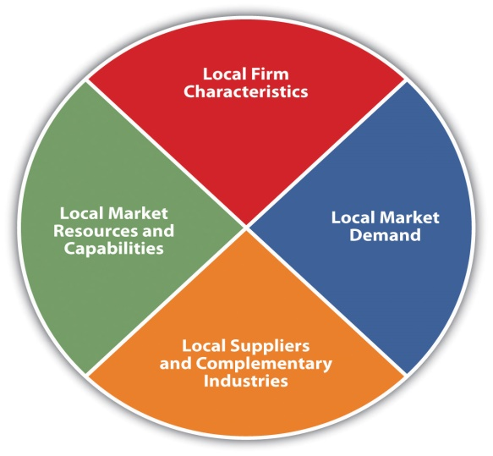

Fig.1.1. Porter’s Diamond

1. **Market Resources and Skills**: Porter appreciated the factor proportions theory, which evaluates a country's resources (e.g., natural resources and labor) when deciding what items to buy or export. Porter described advanced factors as skilled personnel, education, technology, and infrastructural investments. He saw advanced elements as giving a nation a competitive edge.
2. **Local Market Demand:** Porter argues that a smart home market fosters continuous innovation and hence a competitive edge. Companies with skilled, trendsetting, and demanding home markets are constantly developing new goods and technology. Forcing US software businesses to focus on innovation, thereby providing a lasting competitive edge in software goods and services is credited by several sources.
3. **Local Suppliers and Allied Businesses:** Large global enterprises need solid, efficient support and linked sectors to deliver the inputs necessary to stay competitive. Certain sectors are geographically clustered, resulting in efficiency.
4. **Local Company Traits:** A business model, industry structure, and competition are all local firm characteristics. This impacts the competitive edge in the industry

**1.2 Determinants of the Terms of Trade**

There are different factors or conditions that determines the terms of trade. These elements include:

* **Preferences**

According to the law of diminishing marginal return, the more a person consumes a particular product the less he would desire of that product it is called diminishing marginal utility. For instance, if tends to consume some mangos, the ninth mango will bring less satisfaction to him compare to the first mango. A person’s preference determines the level of utility he gets from consuming a product.

* **Unpredictability**

In the case where two traders has not had a taste of each other’s products, One simple way to resolve this uncertainty is for the traders to offer free samples of their products to each other before an exchange is agreed upon.

* **Scarcity**

The terms of trade will be influenced by the relative amounts of the two items available for trade. If Farmer Susan arrived to the market with one hundred mangos and Farmer Lucas arrived with ten apples, the conditions of trade would most likely be different than if the farmers arrived with an equal amount of mangos and apples.

* Dimensions

The size of the apples and mangos is likely to have an impact on the trading terms. If the mangos were the size of kiwifruits and the apples were the size of golf balls, Farmer Susan would undoubtedly obtain more apples for each mango than if the opposite were true.

Goodness

Every trade cost, bargain and even purchase is determined by the quality or how good or bad that product is. If a product is bad it will definitely influence the price of such product, like wise if the product is bad.

Effort

The effort put in to harvest, plant or process are the factors that traders usually consider before any kind of transaction is done. It however, determines the conditions of the transaction. This aspect is, of course, linked to scarcity. The harder it is to manufacture something, the rarer it becomes.

Convincing

The art of persuasion may have a significant impact on the conditions of commerce. Usually traders can lie just to make consumers believe that their products are good enough for purchase. If the trader sounds convincing, then the possibility of a purchase is assured.

Utility Expectations

The utility one expects to get from consuming a good is used to determine how much to trade. For example, if a consumer decided to pay $10 for a cherry berry ice-cream because of the positive reviews he heard from other people and when eventually consume the product he discovers that it was not worth the price $10 paid but rather worth $4 or even $2 Individual may lose money only if the expectations are not met.

## Expectations of a Future Relationship

## Imagine that a trader decides to sell a fake products, she believes that she might not show her face to in that environment ever again, she would use the power of persuasion to obtain her result regardless even though her products are fake.

## Morality

## If two different traders decide to trade, one is moral and the other is not, the one who is not moral is most likely to misrepresent his products in this situation in order to obtain more advantageous trade conditions.

## Censorship

## Coercion impacts the terms of trade. Farmer Lucas may be able to compel a trade that Farmer Susan would never agree to willingly if he threatens Farmer Susan with bodily harm. He may, at the most extreme, demand all of Farmer Susan's mangos in return for no apples. Of fact, once compulsion is included in a transaction, the term "trade" may no longer be appropriate; it would be more proper to refer to it as “stealing.”

* **Government Policies**

Lastly, the policies made by the government can influence the terms of trade. For instance, if tax is paid base on the amount traded by two traders, then this will affect the terms of trade. If a trader is to pay a fine for lying about the efficiency of his product then this will also affect the terms of trade between traders.

**1.3 Regulatory Framework of International Trade**

After the WWII, bilateral treaties were handled by bodies like the GATT and WTO became the main mechanism for regulating worldwide trade. WTO is known as the world trade organization and GATT is known as general agreement on tariff and trade. They regulate multilateral trade agreements between nations. Though GATT deals on goods but agriculture and textiles were not included. The WTO deals with all goods, services, and intellectual property, as well as some investment policies between countries.

The WTO replaced the GATT in 1995. This is an international body tasked with regulating international trade. The WTO deals with almost worldwide trade laws. It is in charge of negotiating and executing new trade agreements, as well as enforcing all WTO agreements signed by the majority of trading states and recognized by their parliaments. The WTO must also monitor global economic policy making to maintain trade policy consistency and transparency.

The WTO is based in Geneva, Switzerland, and has over 150 members representing over 95% of global commerce. In addition to a ministerial conference every two years, it has a general council that executes policy choices and oversees daily operations, and a director-general nominated by the conference.

There are roles which guide the actions of the WTO in ensuring international trade procedures between countries:

* 1. They establish and enforce international trade regulations that help to make transactions between nations easier and faster.
  2. They serve as a platform for discussing and monitoring the expansion of trade liberalization in the future.
  3. They also assist in the resolution of commercial conflicts between member nations.
  4. They serve as a decision-making body for a more transparent trade transactions between nations.
  5. to collaborate with other important international economic management organizations; and
  6. To assist developing nations in reaping the maximum benefits from the global commercial system.

Lastly, to assist in publishing trade regulations and maintaining institutions for a proper review administrative decisions affecting trade between members of the WTO.

Other international trade regulatory framework is the regional agreements such as Mercosur, in South America, NAFTA between the US, Canada, and Mexico, ASEAN in Southeast Asia, and the European Union (EU) between 27 independent states.

Mercosur: The Southern Common Market, or Mercosur, was formed in 1991 by the Treaty of Asunción and the Protocol of Ouro Preto in 1994. Uruguay is a full member as is Argentina. As of December 1, 2016, Venezuela is still a full member. Bolivia, Colombia, Ecuador, Guyana, Peru, Suriname.

Mercosur promotes free commerce and free movement of commodities, people, and money. Mercosur's functions have changed numerous times since its inception; it now consists of a customs union with unfettered intra-zone commerce and a common trade policy among member nations. In 2019, the Mercosur created a nominal GDP of roughly 4.6 trillion dollars, ranking 5th globally. The bloc scores well on the HDI. It has inked FTAs with Israel, Egypt, Japan, and the EU.

Indonesia, Malaysia, the Philippines, Singapore, and Thailand created the ASEAN on August 8, 1967. Cambodia, Laos, and Vietnam have joined. Its goals are to promote economic growth, social progress, cultural development, and regional peace and stability.

NAFTA: The North American Free Trade Agreement (NAFTA), established in 1994, created a free trade relationship between Mexico, Canada, and the United States. The aim is to remove all tariff and non-tariff trade and investment obstacles between the US, Canada, and Mexico. For example, all tariffs and restrictions on US exports to Mexico and Canada were abolished on January 1, 2008. This was only possible because of the regional agreement that exist between them.

EUROPEAN UNION: Consists of 27 member states. The EU was founded on the pre-existing European Economic Community on November 1, 1993, by the Treaty of Maastricht. With nearly 500 million citizens, the EU generates roughly 30% of the nominal gross world product.

The EU has created a single market by harmonizing laws across all member states, allowing free movement of people, goods, services, and capital. Common trade, agri-food, and regional development policies. The Eurozone, a group of 16 countries, has adopted the euro. On the international stage, the EU has a limited role, with representatives at WTO, G8 and UN. That includes the abolition of passport controls between many member states. 21 EU countries are also NATO members, with the exceptions of Austria, Cyprus, Finland, Ireland, Malta, and Sweden. [Europa April,30,2011].

Chapter 1 Conclusions

In this chapter, we discussed mercantilism, absolute advantage, comparative advantage, Heckscher-Ohlin Theory (Factor Proportions Theory), Leontief paradox, contemporary or firm-based trade theories, and Porter's national competitive advantage theory.

We further discussed the determinant of the terms of trade which were as follow, expectation of utility, expectation of a future relationship, coercion, government policies, morality, preferences, uncertainty, scarcity, size, quality, effort, and persuasion. The traditional frameworks responsible for regulating international trade between nations are GATT, and WTO. However, there are other regional authorities that help to regulate trade such as follows NAFTA, ASEAN, NATO, MERCOSUR etc.

**Chapter 2. Analysis of International Trade in the Period of Pandemic**

**2.1 Effects of Covid-19 on International Trade**

The pandemic has caused too many damages to international trade. The world economy is expected to shrink by 5% by 2020. The value of international trade is expected to fall by 8%. Assuming the virus is contained, the global economy and trade are likely to return to 2019 levels next year.

The impact of covid-19 pandemic on international commerce cannot be analyzed without first review the evolution of the pandemic. The number of outlined cases in EMDEs is lower than the predicted number of true cases, particularly in South Asia. New infections of COVID-19 have largely decreased in countries where immunization efforts are moving swiftly. Because most EMDEs have only delivered a small number of doses so far, and low-income nations have just started, they are largely advanced economies.

In emerging market and developing economies (EMDEs), in South Asia, the number of known cases is fewer than the projected number of real cases. Countries where vaccination campaigns are proceeding quickly have generally seen new cases of COVID-19 fall to a low level. These are mostly advanced economies, as most EMDEs have so far administered only a limited number of shots, and low-income countries have scarcely begun. The most affected areas being those most interconnected by commerce and/or tourism. Sub-Saharan Africa (SSA) and the Middle East and North Africa (MENA) would be the least impacted by both scenarios, with a GDP loss of roughly 3%.

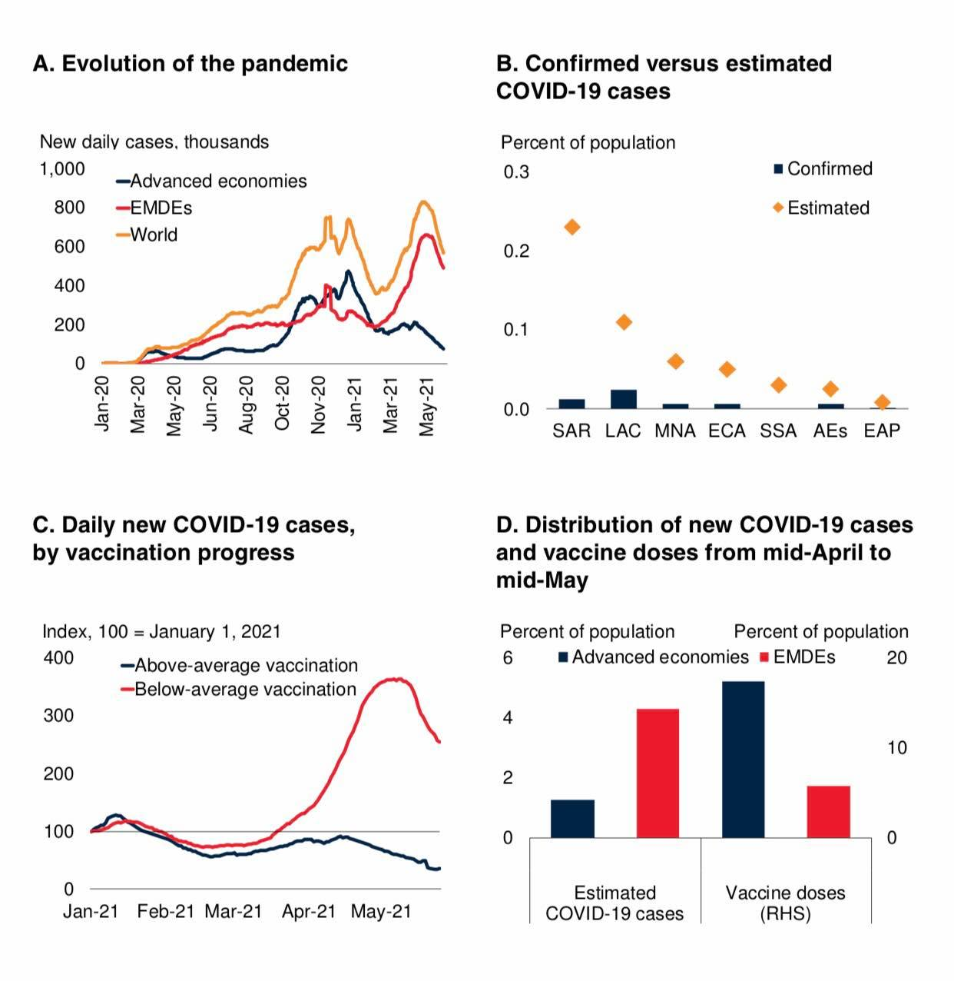

**Figure 2.1. The development of Covid-19 Pandemic**

Sources: Johns Hopkins University (database); Our World in Data (database); World Bank.

Note: AEs = advanced economies; EMDEs = emerging market and developing economies; EAP = East Asia and Pacific, ECA = Europe and Central Asia, LAC = Latin America and the Caribbean, MNA = Middle East and North Africa, SAR = South Asia, SSA = Sub-Saharan Africa.

A. This graph depicts the daily new COVID-19 instances. 36 advanced economies and 147 EMDEs. May 25, 2021

B. The diamonds indicate the COVID-19 cases estimated by the Institute for Health Metrics and Evaluation (IHME). On May 26, 2021. For both verified and estimated cases, last observation taken. 7 EAP, 23 ECA, 26 LAC, 19 MNA, 7 SAR, and 41 SSA economies are included.

c. 36 advanced economies and 147 EMDEs have daily new COVID-19 cases per million persons above and below the worldwide average immunization rate. May 25, 2021

D. The figure depicts the monthly accumulation of COVID-19 cases in AEs and EMDEs from April 17 to May 17, 2021, as predicted by the Institute for Health Metrics and Evaluation (IHME). 36 advanced economies and 120 EMDEs are included.

The epidemic continues to wreak havoc in EMDEs (figure 2.1.A). Since its emergence, COVID-19 has infected over 160 million individuals and killed over 3 million. Every day, dozens of new cases are recorded, with many more undetected, especially in South Asia (figure 2.1.B) Bhattacharyya et al. 2020). Global epidemics of the virus have arrived in waves, each with a larger daily infection rate. Recent epidemics have disproportionately impacted India and other big EMDEs like Brazil. Globally, 9 percent of the population has gotten at least one vaccine shot, with many developed economies and EMDEs ramping up vaccination initiatives. Despite this, huge geographical and economic gaps exist, with the poorest nations having the lowest immunization rates. In countries where vaccination coverage is higher, caseloads are growing much slower than in EMDEs where vaccination coverage is lower (figure 2.1.C-D). However, the COVAX effort and possible temporary waiver of intellectual property rights for COVID-19 vaccinations may make coverage more equal over time.

New variations discovered in Brazil, India, South Africa, and the UK are currently spreading internationally. These new strains may be more easily spread and cause more severe sickness (Davies et al. 2021). Some of the strains seem to be immune to previous illnesses or immunizations (Wang et al. 2021). As long as the virus survives in certain areas and global vaccine coverage is unequal, all countries are at risk (Cakmakli et al.2021). Despite persistent outbreaks, the virus's influence on economic activity seems to be waning in most nations. Firms and consumers have shifted operations to less impacted sectors to reduce interruptions (ECB 2021). Also, lockdown compliance seems to have diminished with time (Goldstein, Yeyati, and Sartorio 2021).

**Global Trade**

A shift in demand toward low-trade-intensity domestic services is expected to hinder the global trade rebound. Supply constraints and localized shipping container shortages are limiting manufacturing trade. Some sectors of the services trade, such telecoms and financial services, are projected to improve, but tourism is predicted to remain sluggish until the virus is contained.

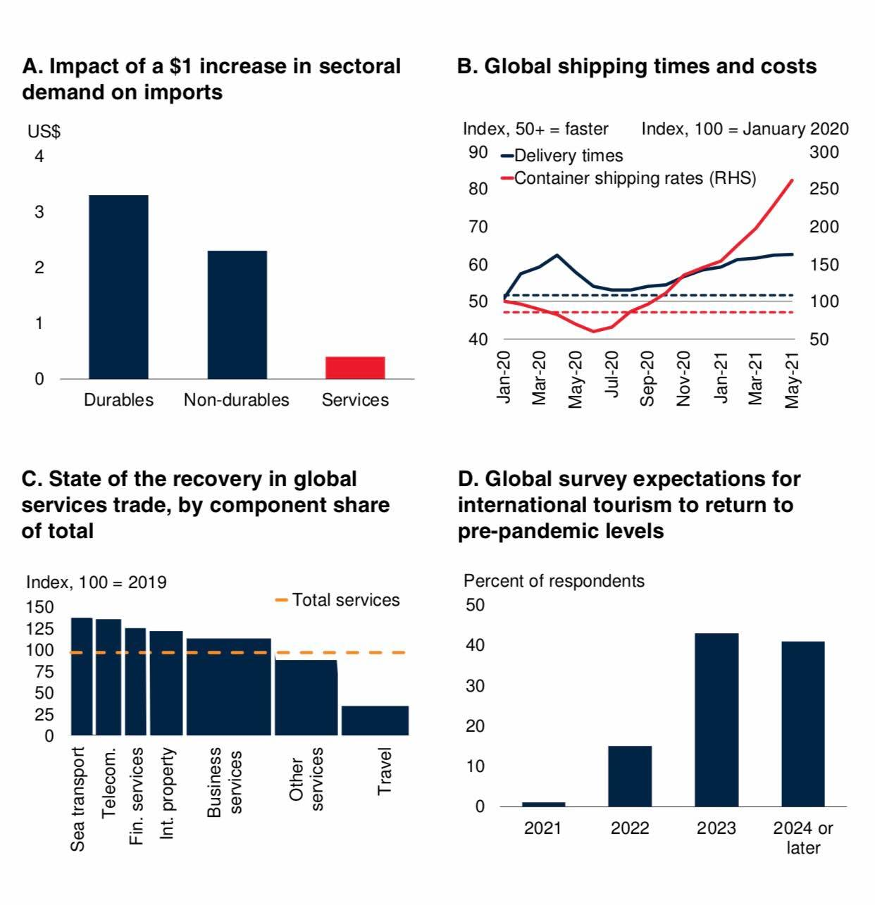

**Figure 2.2 Global Trades**

Sources: Auboin and Borino (2017); Bems, Johnson, and Yi (2010); Harper Petersen & Co. (database); Haver Analytics; United Nations World Tourism Organization; World Bank; World Trade Organization.

A. The figure depicts the effect of a $1 increase in demand from a certain industry on imports (2010). B. The global manufacturing suppliers' delivery times PMI and the Harper Petersen Charter Rates Index (HARPEX) for container shipping rates are shown in Figure. Increasing (decreasing) PMI data indicates quicker (slower) delivery timeframes. Prices in the container ship charter market are reflected in monthly averages of weekly data. Dashed lines show long term averages for delivery timeframes and container shipping charges from January 1998 to December 2019. Last delivery dates are May 2021 and container shipping costs are May 25, 2021. C. The volume of trade is the sum of import and export. 12 AEs and 12 EMDEs in March 2021. A pre-pandemic proportion of each component in total services trade is shown by the width of the bars. Services = telecommunications, computer, and information; Fin. services = financial; Int. property = intellectual property fees. The dotted orange line shows total services trade relative to the 2019 average. D. According to a UNWTO worldwide poll performed in January 2021, international tourism is expected to recover to 2019 levels.

In nations where COVID-19 caseloads are dropping, shifting activities from manufacturing to lower trade-intensity domestic services sector is expected to impede global trade growth. The pandemic's effect on activities requiring face-to-face interaction originally prompted a shift in demand toward purchase of consumer durables, which also have high trade efficiency (figure 2.2.A).

Aside from the Suez Canal closure in March, supply restrictions and global value chain challenges currently impede industrial commerce (Ferrantino et al. 2021). Companies have seen a spike in freight costs and localized container shortages (figure 2.2.B).

To strengthen resilience and eliminate strategic challenges, companies have increased digital technology adoption and supplier diversity (Saurav et al. 2020).

Price pressures from supply shortages will likely ease as global growth slows and shippers build capacity. High-frequency data suggest to a boost in several services trade components including telecommunications and finance (figure 2.1.2.C). Even in places that have not had big epidemics, such tiny island economies, tourism is still down. International travel is predicted to be restricted for some time due to residual mobility issues and aversion to travel until the virus is fully contained (figure 2.1.2.D; UNWTO 2021).

High trade costs, especially in EMDEs, limit trade growth (chapter 3). Protectionist tactics like tariffs on US-China trade and export curbs on food and medical items are likely to have raised trade costs (WTO 2020). Global trade is expected to expand 8.3% this year and 6.3% in 2022, indicating stronger global production and investment, but also a weakening global recovery's trade intensity.

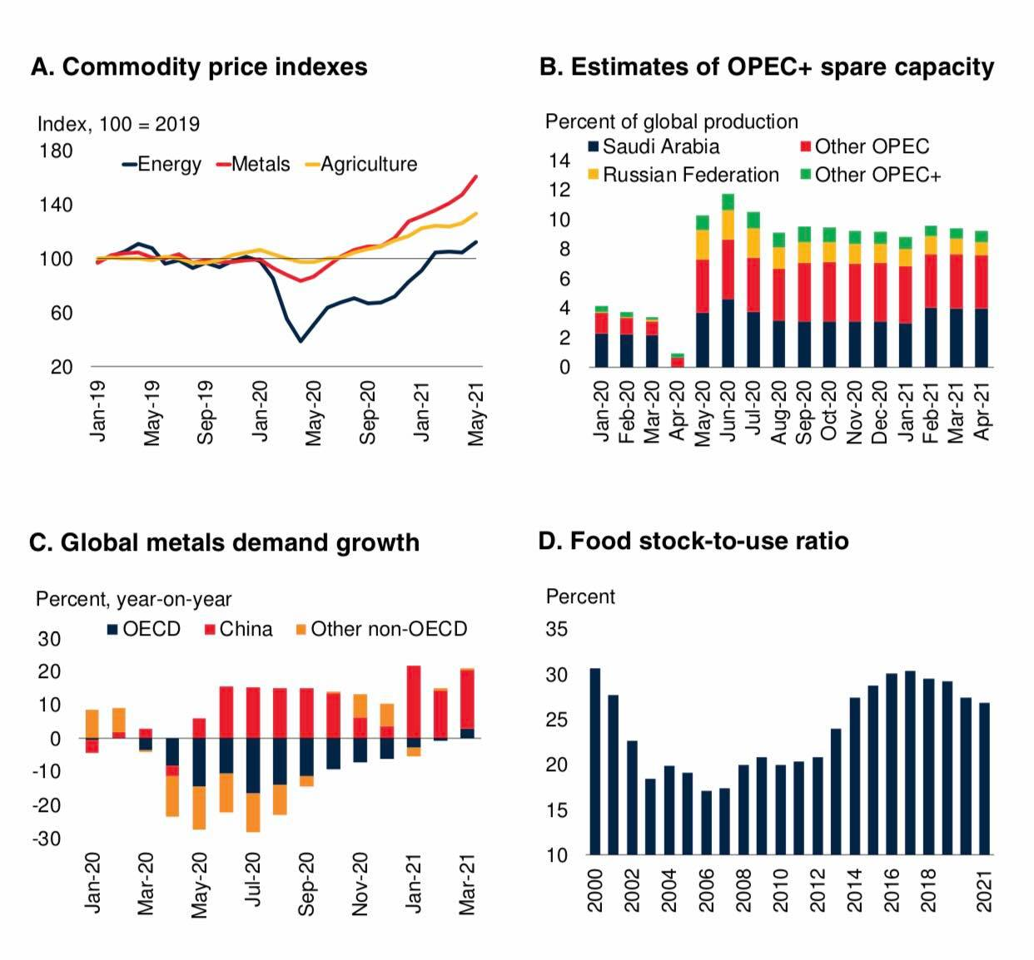

**Figure 2.3 Commodity Markets Condition**

Sources: Bloomberg; International Energy Agency; U.S. Department of Agriculture; World Bank; World Bureau of Metal Statistics.

A. May 2021 is the last date. B. As a percentage of world supply in 2019, spare production capacity is calculated as the gap between current production and maximum output since 2018. Other OPEC comprises all current OPEC members except Iran, Libya, Saudi Arabia, and Venezuela, who are free from output limits. Oman, South Sudan, and Bahrain are also members of OPEC+. C. Expiration March 2021. D. May 12th, 2021. Crop seasons are years (for example, 2019 regards to 2019-20 season of sowing).

Commodity prices soared in 2021, surpassing pre-pandemic levels in several cases (figure 2.3.A; World Bank 2021b). Prices have risen sharply, averaging $60/bbl in 2021. Prices have been underpinned by the rising demand and OPEC+ is continuing production cutbacks, even as the market recovers. Uncertainty over the pandemic's progress and its possible influence on future oil demand has slowed the rise in oil prices. In 2021 and 2022, oil is expected to average $62/bbl. Demand for oil is likely to grow in the second half of 2021, but not reach pre-pandemic levels until following year, due to lower jet fuel usage (IEA 2021). The business now has surplus production capacity of up to 9 million barrels per day, equal to 9% of world demand in 2019. (Figure 2.3.B). A rise in US shale oil drilling activities is also a danger to the oil price projection. Longer term, the forecast for oil and other energy commodities will be determined by the rate of renewable energy transition. Prices of base metals have risen considerably this year, driven by strong Chinese demand and global recovery (figure 2.3.C). Prices are now predicted to be 36% higher in 2021 than last year, before dropping down in 2022 as supply limitations ease. Food insecurity is a challenge in certain nations, particularly those affected by war or poor weather. While most global agricultural commodity markets remain adequately supplied, primary crop output growth has lagged for many years (figure 2.3.D). Prices are predicted to grow by 16% in 2021 before leveling out in 2022.

Various methods have been used to assess the coronavirus's economic effect. UNCTAD (2020) estimates the EU's influence on trade flows at USD 15.6 billion, the US at USD 5.8 billion, and Japan at USD 5.2 billion. This research assumes that supply interruptions are localized to China and that global supply capacity stays unchanged. This model measures the proportion of a country's exports that are sensitive to disruptions in China's intermediate input exports.

A comparable research by Maliszewska et al. (2020) found that a global pandemic reduces GDP by 2%, with undeveloped countries losing 2.5% and industrial ones losing 1.8%. In an accelerated pandemic, the decreases would be doubled. The worldwide GDP reduction in the enhanced global pandemic scenario would be 3.9 percent, with the most affected areas being those most interconnected by commerce and/or tourism. Sub-Saharan Africa (SSA) and the Middle East and North Africa (MENA) would be the least impacted by both scenarios, with a GDP loss of roughly 3%.

The authors achieved these results by assuming four simultaneous supply and demand shocks to trade: (1) a reduction in employment, (2) an increase in the cost of imports, (3) a decline in international tourism and travel-related services, and (4) a shift in demand by households who acquire fewer services requiring close human relation, such as mass transit, domestic tourism, and restaurants. A worldwide epidemic and an enhanced global pandemic In the event of worldwide pandemic, nations are considered to endure just half of the entire China shock. In the case of the worldwide pandemic, the shocks are universal.

Global Financial Market Condition

Borrowing costs have risen for several debt ridden emerging market and developing nations (EMDEs). The latest increase in global rates has been driven by growing U.S. bond yields, but has been much less destabilizing than the 2013 financial crisis. Strong credit spreads in EMDEs have grown moderately, although capital flows have lost impetus. Some EMDEs have seen currencies have depreciated in just this few months.

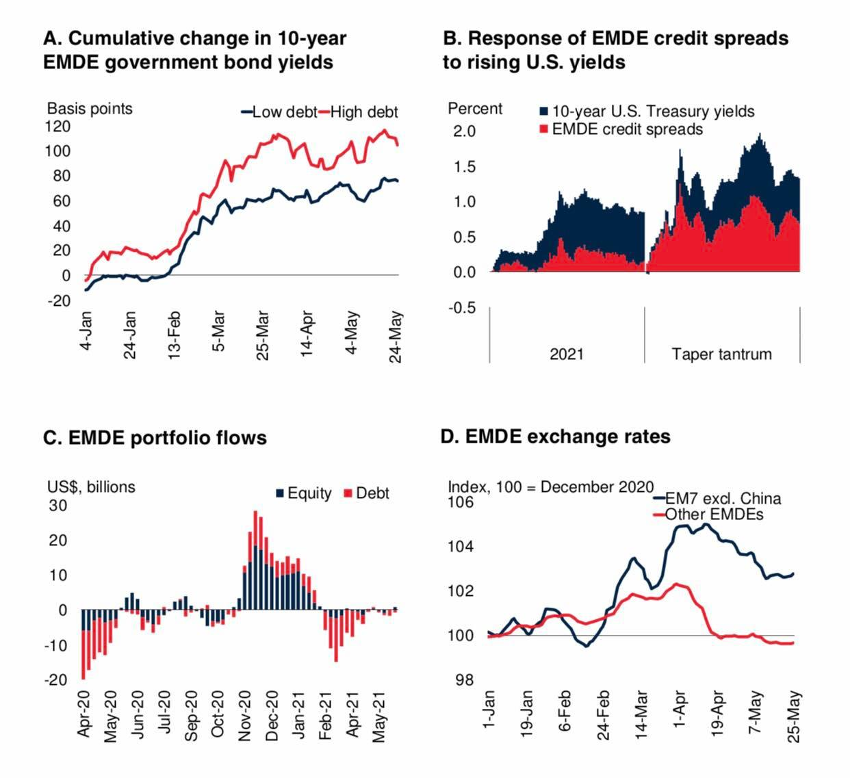

Fig. 2.4. Global Financial Market Condition

Sources: Bloomberg; Haver Analytics; Institute of International Finance; International Monetary Fund; J.P. Morgan; World Bank. Note: EMDEs = emerging market and developing economies.

A. Unweighted averages are used to compute aggregates. In 2020 overall government  debt, EMDEs  scored  an average for the sample (60.5 percent of GDP).    The sample used comprises of 15 EMDEs in sample May 25, 2021.

B. The growing change after the beginning of each occasion, 1 January 2021 for 2021 and May 22, 2013 for taper tantrum. EMDE bond spreads refer to JP Morgan Emerging Markets Bond Index (EMBI) spread. The Last examination was in May 25, 2021.

C. The four weeks of net loan and equity security flows to 18 EMDEs (excluding China). It was last observed by 28 May 2021.

D. The figure depicts the 5-day moving average nominal exchange rates vs the US dollar; an increase means depreciation. Specimen includes 32 EMDEs with floating or free-floating exchange rate;     “EM7 ex China” refers to India, Brazil, Mexico, Russia, Indonesia, and Turkey. The last observation was in May 25, 2021.

The financial climate has tightened but remains favorable. Expectations of faster future growth and greater inflation have driven up long-term rates on government bond.  Though the pandemic has affected the global financial system, it is thus not to be compared to what happened in 2013, where both the global and the EMDE financial were greatly impacted. It caused a great shock to the global financial market.  However, in most locations, the value of equity market are still advancing despite rising global corporate borrowing rates. Despite cheap financing and the continuation of several COVID-19 relief measures, business bankruptcies have increased in some sectors and nations but remain below pre-pandemic levels. The fact that crisis-hit industries represent for a tiny fraction of overall non-financial debt may reduce post-pandemic credit losses (Mojon, Rees, and Schimieder 2021). EMDE national debt rates have grown significantly more than US borrowing costs, resulting in minor spread increases (figure 2.4.A-B). Portfolios to EMDEs have slowed (figure 2.4.C). Some EMDEs have seen their currencies fall, adding to higher inflation (figure 2.4.D). Currency devaluation has caused several EMDE central banks to remove monetary policy accommodation. Large production disparities in many nations may constrain further EMDE policy tightening. Many nations' remittances have held up. Strong activity in the US construction industry has fueled flows to numerous Latin American and Caribbean nations (LAC). As a result of this, the post-pandemic debt losses may be reduced (Mojon, Rees, and Schimieder 2021). Investors' confidence about China’s future and a few significant international acquisitions in India has helped EMDEs attract FDI. Concerns over the pandemic's trajectory and unclear economic prospects keep FDI flows to other EMDEs low.

## The Effect of Covid-19 Pandemic on a country’s Supply Capacity?

An increase in risk premium and an increase in prices of manufacturing are the main supply-side implications of the COVID-19 pandemic.

The present epidemic has caused major disruptions to global commerce and value systems (GVCs). Baldwin and Freeman (2020) claim that shocks to GVCs result in “triple hits” for “modern” economies:

1. Supply disruptions as the disease swiftly spreads from East Asia to other developed countries.

2. The traditional face to face supply chain has experienced a direct shock as manufacturing sectors in less-affected countries has struggled to get critical imported industrial inputs from hard-hit nations, as well as from each other.

3. A supply shock caused of a reduction in employment

4.  An increase in the cost of imports international imports

The Effect of Covid-19 Pandemic on a country’s Demand Capacity?

Surplus worldwide demand for COVID-19-related medical goods, which surpassed existing domestic production levels, resulted in increasing import demand and rising costs. Export limitations by large nations suffering shortages led to price rises of up to 20.5 percent in the case of surgical masks, according to the World Bank.

Pandemics also permanently reduce aggregate demand. According to Correia, Luck, and Verner (2020), the pandemic affects demand by reducing family spending and increasing company uncertainty about future demand, which reduces investment.

The pandemic caused a reduction in global labor productivity which led to the reduction of the demand for capital and also diminished family spending and increased corporate uncertainties for future demand, these has caused a limits on investment. Since enterprises require both labor and capital to generate products and services to survive.

The lack of workers in the economy reduces the requirement for large investment. This may be due to new preventative objectives or just to replenish lost money spent up during the crisis.

McKibbin and Fernando (2020) highlight to altered typical consumption patterns and subsequent market anomalies owing to consumer and company fear when preferences for particular activities shift with the epidemic. McKibbin and Fernando (2020) control the spread by accounting for increasing health spending shocks.

1. Demand interruptions owing to: I macroeconomic declines in aggregate demand (recessions); ii) consumer and firm wait-and-see purchases.

2.The decline in international tourism and travel services.

3.    Reduced demand for services requiring intimate human connection, such as public transportation, domestic tourism, restaurants and leisure activities, despite increasing demand for products and services.

**2.2 Effects of Covid-19 on Ecommerce**

The effect of COVID-19 cannot be overemphasized as its crisis has accelerated an expansion of e-commerce towards new firms, customers and different types of products, likely involving a long-term shift of e-commerce transactions from luxury goods and services to everyday necessities.

**Covid-19 Impact on Consumer Behavior Worldwide**

Covid-19 Pandemic prevented face to face transactions between humans and that has led to a global to shift to online purchase in order to survive through different online shopping platforms. Research had it that 44% of global shoppers are online transactions and online market platforms accounted for 47% of global digital purchases. In response to the epidemic, firms selling online increased in Brazil, Spain, and Japan.

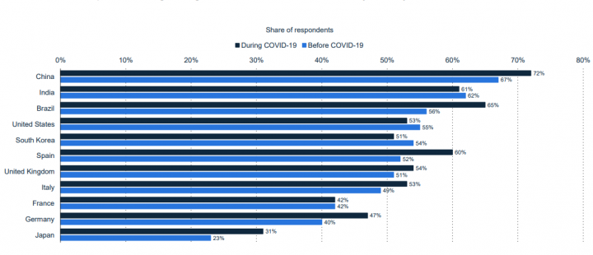

Fig.2.5.Share of B2B Companies Selling Through eCommerce before and during the Pandemic, by Country 2020

The graphic below shows a 19% rise in global trade revenue between pre- and post-COVID-19 periods in 2020. Food and personal care goods are expected to increase the fastest, with a 26% revenue rise due to consumer shift to online business units.

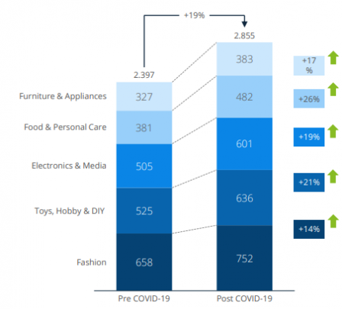

Fig. 2.6. Worldwide eCommerce Revenue Forecast 2020 in Billion USD.

Covid-19 Impact on Small B2B Businesses Worldwide

COVID-related company closures and the underlying financial instability of firms offer a bleak picture for those remaining operational. Or is this merely a hunch based on a dearth of global retail sales are expected to expand by 8% annually between 2019 and 2024, according to the graphic below.

This graph illustrates a growth in digital retail trade due to the COVID outages.

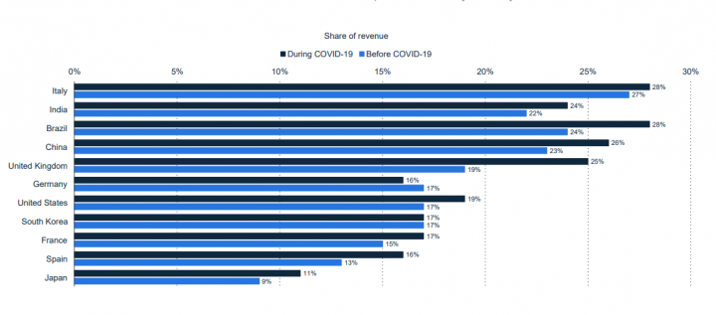

Fig. 2.7. Share of eCommerce Revenue of Small and Medium B2B Companies Before and During the Pandemic in 2020, By Country.

Covid-affiliated Firm closures and financial instability provide a dismal image for those left in business. OR IS THIS JUST A HUNCH?

The graph below shows that worldwide trade sales are predicted to grow by 8% yearly between 2019 and 2024. Due to the COVID, outages, digital retail sales increased.

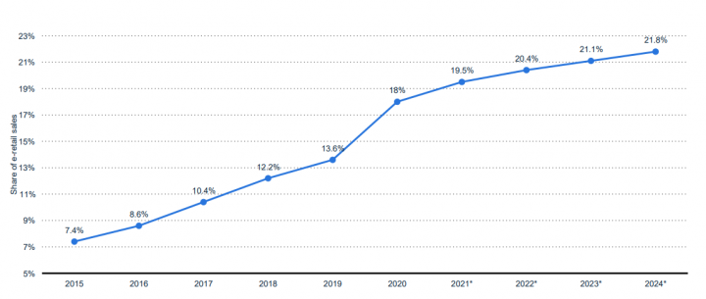

Fig. 2.8. E-Commerce Share of Total Global Retail Sales 2015-2024.

Shift in Demand from Traditional Retail to E-Commerce

The problem caused by the covid-19 pandemic has led to the reduction of physical contacts in several OECD nations. Self-imposed social isolation and severe confinement restrictions established in several OECD nations have temporarily placed a major part of conventional brick-and-mortar retail on hold (OECD, 2020). Between February and April 2020, retail and food service sales fell 7.7% compared to the same period in 2019. However, revenues climbed by 16% for food shops and 14.8% for non-store merchants (mainly e-commerce). Retail sales through mail order houses or the internet grew 30% in April 2020 compared to April 2019, but overall retail sales decreased 17.9%. (E-commerce is set to outpace traditional retail in several nations. For example, although e-percentage commerce's of overall retail grew moderately between 2018 and 2020 (from 9.6% to 11.8%), it soared to 16.1% during the first and second quarters of 2020. In the UK, e-commerce grew from 17.3% to 20.33% between Q1 2018 and Q1 2020, before rising to 31.33% between Q1 and Q2 2020. Other areas, such as China, have seen similar shifts, with online shopping now accounting for 24.6 percent of total retail sales, up from 19.4% in August 2019 and 17.3 percent in August 2018.

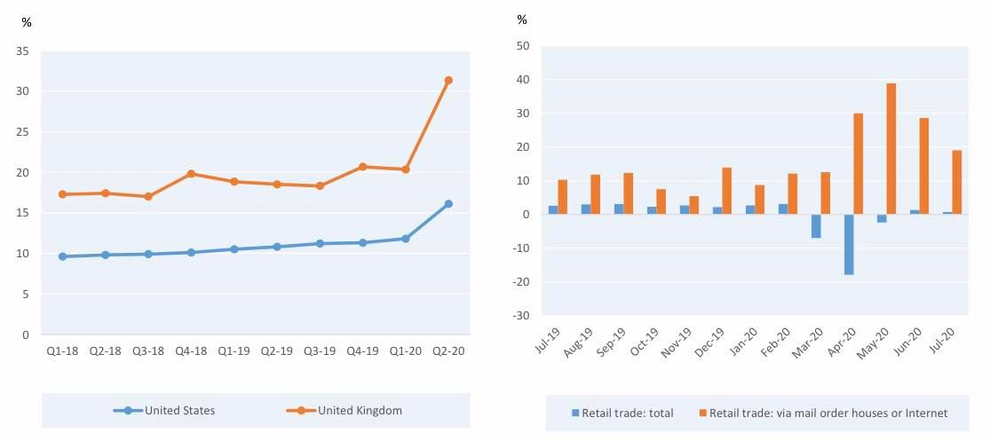

**Figure 2.9. The Covid-19 Crisis has increased the Share of E-commerce in total Retail**

Figure 2.9.a. Share of e-commerce in total retail sales,

Figure 2.9b. Retail turnover, year-on-year change, EU-27 (July 2019-20) United Kingdom and United States (2018-2020)

Note: The Monthly trading and service Survey and official statistics give estimates for e-commerce as a proportion of overall retail sales in the United States. Second quarterly 2020 data are estimates. Data for the UK show Internet sales as a proportion of overall retail sales. Quarterly statistics are simply monthly averages. The statistic shows the percentage change in retail sales from the same time last year for the EU-27. Vehicles and motorbikes are excluded. This covers retail transactions when the customer makes a decision based on adverts, catalogues, website information, models or other advertising and puts an order by mail, phone or Internet. According to the OECD, only the latter qualifies as e-commerce. See (OECD, 2019) for definitions of e-commerce.

Source: OECD analysis of US Census Bureau, UK ONS and Eurostat data.

While official data for most other countries is unavailable, estimations imply that internet orders increased in Europe, North America, and Asia-Pacific in the first half of 2020. (OECD, 2020). Europe and North America followed Europe and North America, notably when numerous OECD nations followed Italy's example and enacted confinement measures within a short period of time.

Inclusive Measures to Help the Rise of Ecommerce amongst the Non-Elite

Rural-urban divisions, wealth inequality, uneven access to education, and an aging population are all factors that restrict e-commerce involvement for some groups of people. Low connection, lack of digital skills, lack of trust (security and privacy issues), and lack of access to online payment systems are all challenges that may be addressed by legislation (OECD, 2019). Targeted information campaigns, trust building activities, adult training, and public-private collaborations may all help.

In Japan, the UK, and the US, governments and companies have announced plans to help the poor and young afford Internet access (OECD, 2020). People with limited digital abilities or access to digital technologies might utilize landline phones and social media to arrange online orders. Customers who are particularly vulnerable (e.g., those in public care homes) or lack the abilities to participate in e-commerce should be considered for community-based delivery initiatives.

In the context of food shopping, a necessary activity with high contact probability, targeted measures may be required. Due to challenges in obtaining a delivery slot or wait periods of several weeks, many seniors with access to digital technology choose not to use these tools for food shopping. Some grocery stores have responded by reserving online grocery delivery slots for the aged and vulnerable or by requesting non-vulnerable customers to buy in-store (e.g. Waitrose, Tesco, Whole Foods). Governments may actively assist. The Citizens Information Board of Ireland advises non-vulnerable persons to purchase in-store or pick up online orders to avoid occupying delivery slots that may be utilized by vulnerable people. Many nations also require retailers to operate during certain times for vulnerable populations, a practice that may be expanded to home delivery. For example, conventional techniques relying on loyalty programs and consumer accounts are generally ad hoc and varied.

Consumers become more financially and psychologically vulnerable during a crisis. Regulators may need to build trust, educate the public about possible scams, and avoid regulatory rollbacks (OECD, 2020). The COVID-19 issue may drive many small local brick-and-mortar establishments out of business, favoring larger retailers with internet sales channels (OECD, 2020).

**2.3. Changes in Trade Agreements and Trade measures**

Bilateral and good trade and investment terms include agreements offers with legally binding guarantees that may help attract investment.. By locking in current policy changes or foreshadowing future policy changes, these agreements help companies adapt to shifting competitive situations. Modern preferential trade agreements frequently include comprehensive investment preservation and liberalization criteria. Intellectual property and services are often incorporated. Due to the current Corona virus epidemic, some governments have changed their trade restrictions.

COVID-19 hampered global trade. Trade reductions vary substantially among bilateral agreements. The average nation fell 14%. 7 When an RTA is added, the decline is about 11%. That is, RTA trade was over 3% more robust than non-RTA trade (Figure 2.10).

The idea that trade is more robust when trading costs are reduced is backed up by RTA types. 8 Deep trade agreements outperform shallow ones. In a low RTA, members traded 6% points less.

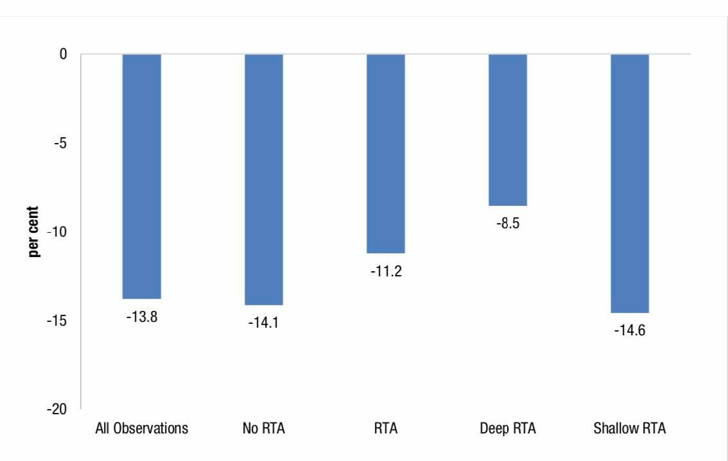

Figure 2.10. Average Growth of Export by RTA (2020)

Source: Authors’ calucations based on UNCTAD Global Trade Update database.

The findings are revealing the possible diverse effects, (and reactions) of the virus may vary across industrialized and poor nations. Figure 2.11 illustrates that trade under RTAs has been more resilient for both developed and developing nations, by 2% points for developing and 3% points for developed. However, these impacts are due to lesser reductions for trade under deep RTAs, with shallow RTAs marginally worse than no RTA.

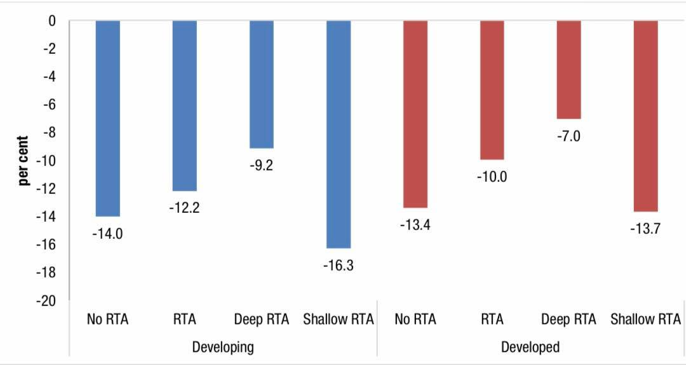

**Figure2.11. Effect of RTA by developed and developing countries (2020)**

Source: Authors’ calculations.

Across-regional comparisons reveal a similar tendency. Figure 2.11 displays the overall and deep RTA premiums (average multilateral export growth of RTA members minus non-RTA members) (average export growth of deep RTA member states minus (-) average export growth of shallow RTA member states).

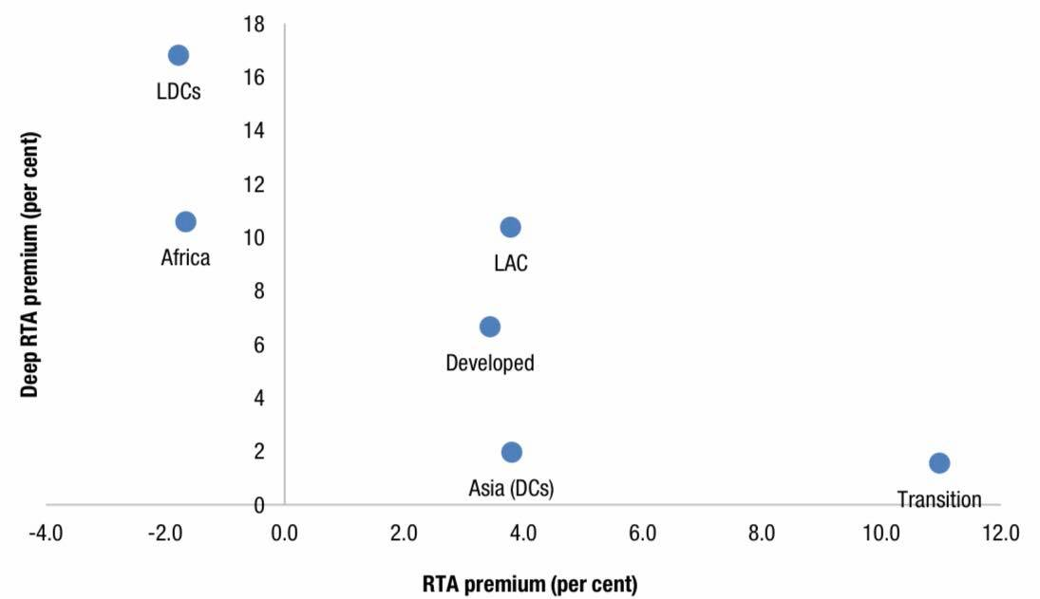

Figure 2.12 RTA and deep RTA premiums by regions (2020)

Source: Authors’ calucations based on UNCTAD Global Trade Update database. Note: Premium is defined as the average bilateral export growth between deep RTA members minus average bilateral export growth of shallow non-RTA member states.

RTAs Evolution, from 1948 to 2021

So far, 350 RTAs have been issued, 568 reports, from WTO members including commodities, services, and accession. The chart below displays all GATT/WTO RTAs (1948-2021), including dormant RTAs, by year of ratification.

The WTO RTA Database has interactive visualizations and data:

ACRs (RTAs), Between October 2020 and May 2021, the WTO received 43 new RTA notices. For the Enabling Clause and GATS V (encompassing goods and services trade), 20 were notified, while 22 were notified under GATT Article XXIV (covering only trade in goods). Thus, 563 notifications in goods, services, and accession bring the total to 348 RTAs (figure2.3.3).

[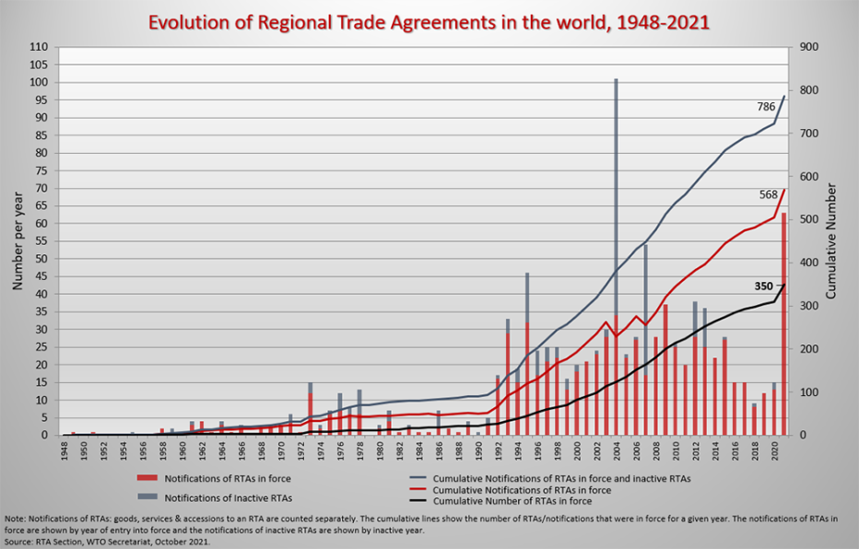](javascript:openImgPopup('/images/img_tratop/evolution_of_rtas_1948_2018.png','links',1010,650,1))

Figure 2.13 RTAs notified to the GATT/WTO (1948 to 2021) by year of entry into force

Source: WTO Secretariat.

Around 80% of the RTAs reported over this time period concerned the UK, which leaves the EU at the end of 2020. Most of these RTAs try to emulate the favorable terms under which the UK traded with its RTA partners as an EU member. The EUUK Trade and Cooperation Agreement replace their prior commercial relationship.

There were eight RTAs notified, including six in Asia-Pacific, three in Africa, one in the Americas, and one in Europe (one each). Four RTAs covered two areas. The CPTPP will be discussed during the CRTA's 100th Session in June 2021. The Agreement contains 11 countries, 7 of whom have ratified it. A number of other plurilateral agreements have been notified, including the USMCA (US-Mexico-Canada Agreement), which will be considered by the CRTA shortly, the RCEP (Regional Comprehensive Economic Partnership) (RCEP) between 15 parties, which has so far been ratified by four, the AFTA (African Continental Free Trade Area) between 54 African economies, which has been implemented since 1 January 2021, and the EU-MERCOSUR.

New developments in RTAs

Many WTO members are still participating in RTA discussions. Most new agreements are bilateral, like the existing ones. Recent developments include new agreements and talks among WTO members. This includes:

1. The Asia-Pacific Region, with the comprehensive and Progressive Trans-Pacific Partnership CPTPP Agreement (signed by 11 countries) coming into effect;

2. Asia, with the signing of the Regional Comprehensive Partnership Agreement (RCEP) between ASEAN and six additional WTO members;

3. Latin America, with the Pacific Alliance including Chile, Colombia, Mexico, and Peru.

4. Africa, with the launch of the African Continental Free Trade Area (AfCFTA) and the Tripartite Agreement discussions between COMESA, the East African Community (EAC) and the Southern African Development Community (SADC). However, since most new plurilateral agreements do not supplant previous bilateral agreements, the number of RTAs has increased.

RTAs notified to the WTO and in force on the 30th of June 2021. Separate notification on goods and services for the same RTA are counted as one.

8 RTAs between the UK and: Canada(S), Mexico (G&S) Serbia (G&S)Albania (G&S), Jordan, (G)Ghana, (G)EU(G&S), SACU(G), and Mozambique(G).

Table 2.1

RTA s notified

|  |  |
| --- | --- |
| **Trade in goods** | **Trade in services** |
| Korea | Central America |
| India | Mauritius |
| PACER Plus | - |
| Namibia | Zimbabwe |
| ASEAN | Hong Kong , china |
| Indonesia | Australia |
| EU | ESA (Accession of Comoros) |
| Ukraine | Israel |
| China | Mauritius |

There were 17 RTAs notified both in trade and in services. The total number of RTAs notified is 350 but if you count separately for both goods and service then it are 568 in total. Changes made to the EU treaty as a result of the brexit were one notification.

Table 2.2

RTAs Considered by the CRTA and the CTO

|  |  |
| --- | --- |
| **Trade in goods** | **Trade in services** |
| EU | Singapore |
| Peru | Australia |
| CPTPP | - |
| Mexico | Paraguay |
| Mexico | Brazil |
| Indonesia | Pakistan |
| EL Salvador | Cuba |
| India | Nepal |

|  |
| --- |
| Note: When the Enabling Clause is used to notify goods (prompting CTD consideration) and the GATS is used to notify services (prompting CTD consideration), a single WTO-notified RTA may be examined twice (prompting a consideration by the CRTA). Rarely is a single RTA examined by both the CRTA and the CTD. |

The total number for both goods and services are 8.

The RTAs considered during the period is 3 at the CRTA and 5 RTA considered at the CTD.

The Transparency Mechanism

The transparency mechanism for RTAs (TM) was established in December 2006 by a decision of the general council. Under the TM, factual presentations (FPs) are prepared by the WTO secretariat under its own responsibility and in full cooperation with the parties (to an RTA). The FPs is presented to the members of the WTO for their consideration.

Committee on Regional Trade Agreement (CRTA)

There were 2 regular session on 22 march and 21 June committee on regional trade agreements considers RTAs notifies under GATT ART XXIV and GATT Art V.

Cease Trade Order (CTO)

There were 2 dedicated session on RTAs on 29 march and 8 June committee on trade and development considers RTAs notified under the enabling clause.

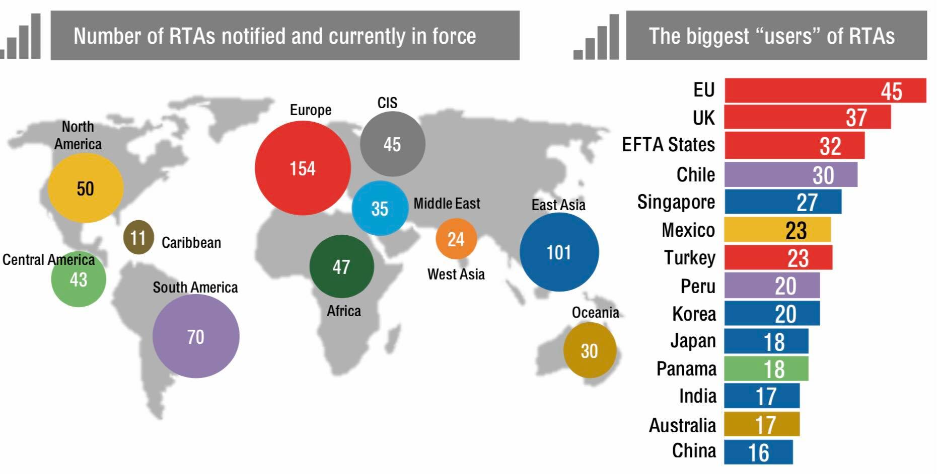

Fig. 2.14. Number of RTAs notified

Source: <https://www.wto.org/english/tratop_e/region_e/rtafactfig_e.pdf>

For more information: Visit the #WTORTAs Database rtais.wto.org

Covid-19 Pandemic: Support measures

The table below lists the support measures taken by WTO members and observers in response to the COVID-19 pandemic. These measures have been submitted by delegations directly to the WTO Trade Monitoring Section in response to the requests by the Director-General in March 2020 and by Deputy Director-General Agah in September 2020. The list only includes measures communicated by members and observers and features measures only in the original language of the submission. The list is an informal situation report and an attempt to provide transparency with respect to support measures taken in the context of the COVID-19 crisis.

Table 2.3.

|  |  |  |  |  |  |
| --- | --- | --- | --- | --- | --- |
| Mem/Obs | Sector | Measure | Source | Date | Status |
| Albania | Financial Service | In response to COVID-19, the Albanian Financial Supervisory Authority (AFSA) issued guidelines for supervised entities with respect to the adoption of preventive measures in the context of the pandemic. These concerned, for example, reporting requirements, liquidity requirements, and the review of insurance contracts in view of current risk exposures. | AFSA Board Decision no. 94 of 29 July 2020 | Wednesday,july 29, 2020 | Official source |
| Australia | All Sector | On 29 March 2020, the Australian Government announced temporary changes to the foreign investment review framework that are designed to safeguard Australia’s national interest during the COVID-19 pandemic crisis. During this period the monetary threshold amounts under the Foreign | Viewed at: <https://firb.gov.au/qa-temporary-changes-foreign-investment-framework>. | Effective from 10:30pm (AEDT) 29 March 2020 Withdrawn as of 1 January 2021 | Verified |

<https://www.wto.org/english/tratop_e/covid19_e/trade_related_support_measures_e.htm>

* [Support measures, as of 22 November 2021](https://www.wto.org/english/tratop_e/covid19_e/trade_related_support_measures_e.htm)

**Conclusions to chapter 2**

A shift in demand toward low-trade-intensity domestic services is expected to hinder the global trade rebound. Supply constraints and localized shipping container shortages are limiting manufacturing trade. Some sectors of the services trade, such telecoms and financial services, are projected to improve, but tourism is predicted to remain sluggish until the virus is contained.

Covid-19 Pandemic prevented face to face transactions between humans and that has led to a global to shift to online purchase in order to survive through different online shopping platforms. Research had it that 44% of global shoppers are online transactions and online market platforms accounted for 47% of global digital purchases. In response to the epidemic, firms selling online increased in Brazil, Spain, and Japan.

Bilateral and good trade and investment terms include agreements offers with legally binding guarantees that may help attract investment.. By locking in current policy changes or foreshadowing future policy changes, these agreements help companies adapt to shifting competitive situations. Modern preferential trade agreements frequently include comprehensive investment preservation and liberalization criteria. Intellectual property and services are often incorporated. Due to the current Corona virus epidemic, some governments have changed their trade restrictions.

**Chapter 3. The prospects of the International trade development**

**3.1 The prospects of the International trade development**

Overall world trade outlook: 2014–2025

The forecast for international trade in terms of the total goods imports at same prices for each country from 2020 to 2025. The IMF Consensus scenario was used to determine this very outlook from October 2020 and because of the steep experienced in 2020, expert’s projects that there will be an economic rebound in 2021.

The IMF is expecting global economic to grow slowly to about 3.5% over time. For this reason, international trade is expected to return to the way it was in 2019 in the second quarter of 2022. Though the rebound at the ending of 2021 created a “V” positive shape scenario, but as it is at the moment, the chances of controlling the pandemic is slim because of the availability of vaccines, and the willingness to be vaccinated. It is possible that even at the end of the fourth quarter of 2021, medical measures may not be fully Implemented (OECD, 2020a). “V” shaped rebound in late 2021.

Figure 3.1 shows the expected trajectory of global merchandise trade under the three cases. Trade grew from 2014 to 2017 before decreasing in 2019 due to growing bilateral trade disputes and slower economic growth (IMF, 2020b). Thus, global merchandise trade fell by 0.1% in total trade in 2019. Both the Agreement and the Optimistic framework expect a 9% fall in goods trade volume in 2020, due to such a recovery in economic activity in the third and fourth quarters of the year. The optimistic scenario anticipates that global commerce will completely recover in 2025, as though the COVID-19 situation had not occurred to disrupt the 2014-2019 flow.

In the pessimistic structure, global commerce declines by 12% in 2020 and does not return to pre-crisis levels until the end of 2023. Unlike the consensus model, where a twofold blow to global trade results in a delayed trend convergence, where trade stays below the 2014 to 2019 trend levels.

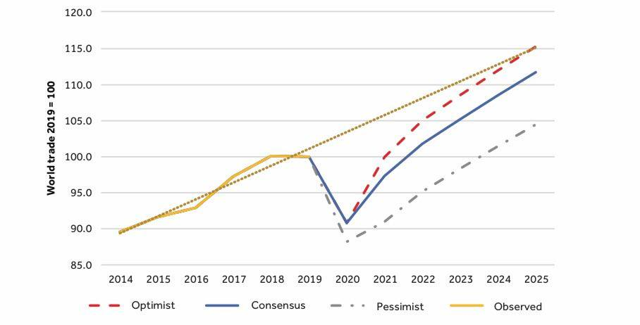

**Figure 3.1. Evolution of world trade, 2014-2025 (goods only, constant price)**

Note: 2014-2019 are actual data, based on WTO data. 202-2025 results are from model simulations

Source: Authors.

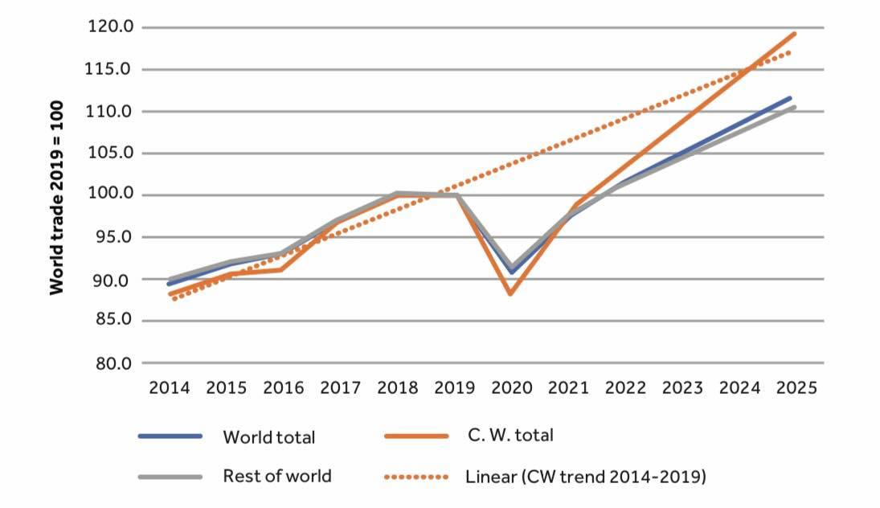

**Figure 3.2 Common wealth and world import 2014-2025 (goods only, constant price)**

The IMF anticipates a sharp decrease in trade for Commonwealth and non-Commonwealth nations in 2020, with the former recovering quicker post-crisis (see Figure 3.2). Commonwealth imports should reach pre-crisis levels by 2021-2022. Imports are predicted to improve and expand steadily until 2024. Our own BACI data models demonstrate that Commonwealth commerce is more in line with global average.

Regional Prospects

There will be a very slow recovery rate in most EMDE regions because of the extent of the damage caused by the pandemic.

Regional production has been projected to remain how it was before the pandemic due to the continuing pandemic and its repercussions, including greater debt burdens and disruption of many of the determinants of potential production. Small, tourism-dependent economies are projected to struggle, as travel restrictions stay in place until the epidemic is contained. Vaccine implementation varies by country, with low-income nations trailing much behind. East Asia and the Pacific are anticipated to recover the fastest, led by China. In South Asia, India has had the greatest epidemic since the pandemic began. In the Middle East, North Africa, and Latin America and the Caribbean, growth in 2021 is likely to be slower than in 2020, while in Sub-Saharan Africa, the slow recovery will do nothing to reverse the pandemic's rise in severe poverty. In most locations, the prognosis is bleak. All areas remain susceptible to COVID-19 outbreaks, which may include variant strains, financial stress exacerbated by high debt levels, pandemic-related scarring that is deeper than predicted, and escalating social unrest prompted by increase in food costs.

Asia-Pacific: The region's growth is expected to rise to 7.7% in 2021, driven by a strong recovery in China. In the area as a whole, production will stay below pre-pandemic levels until 2022. The pandemic is projected to slow economic development in many countries, particularly those most hit by COVID-19 breakouts and the worldwide tourist and commerce collapse. Risks to the prediction include major COVID-19 outbreaks because to delayed vaccines, increased financial stress exacerbated by debt, and more severe and long-lasting pandemic consequences such as reduced investment and human capital. Natural catastrophes are a persistent threat to many nations, particularly island economies. A faster vaccination schedule and larger-than-expected recovery spillovers from the US and other big countries are positive risks.

Europe and Central Asia:The area economy is expected to increase 3.9% in 2021, with stronger foreign demand and higher in industrial commodity prices balancing recent COVID-19 resurgences. Regional growth is expected to stay at 3.9 percent in 2022 as domestic demand recovers. The situation remains unclear, however, due to inconsistent vaccination rollouts and the removal of macroeconomic support measures. Slower than anticipated recovery from pandemic, tighter external financing conditions or increased geopolitical tensions might impair growth. Both the physical and human capital growth will keep declining if covid-19 pandemic is neglected.

Latin America and the Caribbean: After a severe recession in 2020, activity is expected to rise by just 5.2% in 2021. Elimination of movement limitations and improving external economic circumstances will help the resurgence. Income per capital losses will still be high in countries like the Caribbean island in 2022.   Although positive trade and optimism impacted strong growth and greater financial support in the US, there is a snag risk to the very prediction, yet the risks are balanced. Negative market responses from social upheaval or budgetary difficulties; and disruptions linked to social problems or global warming and natural catastrophes are among the key negative risks.

Middle East and North Africa: In 2021, regional production is expected to expand by just 2.4%, half the rate of the worldwide recovery in 2009. Higher oil prices have boosted development hopes for oil exporters, but fresh viral outbreaks and a patchy vaccination implementation have hampered progress. COVID-19 resurgences have harmed oil importers. Regional activity is predicted to be 6% below pre-pandemic forecasts by 2022. The regional picture is mostly negative. The pandemic may re-intensify, new varieties may arise, and movement restrictions may be reinstated. Regional hazards include war, societal unrest, heavy debt in certain countries, and negative commodity price trends. These threats may combine to lower living standards, exacerbate poverty, and raise food insecurity.

Regional Growth

The havoc caused by covid-19 pandemics is projected to really be inadequately reversible in most EMDE locations in 2021. There will be a slight decrease in the Middle East and the North African and Caribbean as well as the Latin America regions while there will be an indifferent moderate rebound in Sub-Saharan Africa (SSA) region because of the pandemic's surge in severe poverty. The worldwide pandemic has left a legacy of increased debt and impaired potential production, which will delay recovery to pre-pandemic levels. The catch-up of developed countries' per capita income is expected to stall or decline in all areas.

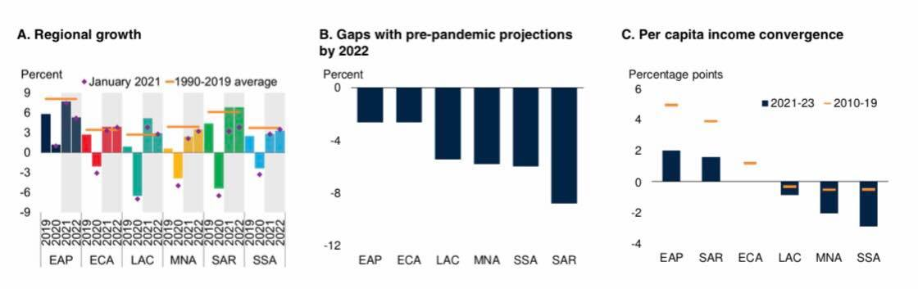

**Fig.3.3. Regional growth of international trade**

Source: World Bank. Note: EAP = East Asia and Pacific, ECA = Europe and Central Asia, LAC = Latin America and the Caribbean, SAR = South Asia, SSA = Sub-Saharan Africa.

A. The bars show In the Global Economic Prospects report for January 2021, diamonds match to the current prediction. Aggregate growth rates derived using constant GDP weights and market exchange rates for 2010-19. Because major economies account for over 50% of GDP in certain areas, weighted averages reflect large economy trends. B. This graph depicts the disparity between current and January 2020 Global Economic Prospects estimates. C. The gap in per capita GDP growth between each area and advanced economies is given in percentage points.

South Asia: The region's output is predicted to climb 6.8% in 2021, matching the preceding decade's average. A big increase of COVID-19 cases has disturbed the year's early pace. Despite steady improvement, 2022 production is expected to be 9% below pre-pandemic levels. The area is predicted to house more than half of the world’s poorest by the end of the year. Vaccination may not occur as rapidly as expected. As regulatory measures implemented during the epidemic are reduced, financial sector balance sheets may deteriorate, limiting lending and investment required to sustain the recovery.

Sub-Saharan Africa: Regional activity is anticipated to grow 2.8% in 2021 and 3.3% in 2012. Improved international regulation of COVID-19 and robust local activity in agricultural commodities exporters are predicted to steadily boost growth. Despite this, the recovery is expected to be difficult due to the pandemic's legacy and the region's sluggish vaccination rate. In an area where COVID-19 is anticipated to have pushed tens of millions more people into severe poverty, growth in per capita income will be modest in 2021-22, recovering just a fraction of last year's loss. The prognosis is bleak, with risks including persisting immunization shortages, increasing food costs, increased internal tensions and conflicts, and longer-than-expected pandemic-related harm.

Perspective Changes in Commodity and Geographical Structure of International Trade

Due to the unthinkable shock produced by the introduction of the covid-19 epidemic, so many changes have occurred, affecting everything from goods to services across borders. Different nations were forced to take dramatic steps and implement emergency policies, which had a negative impact on the geographical structure of global commerce. Developed nations and the East Asian area account for the vast majority of international commerce in products, according to the World Bank. Trade with other emerging areas is substantially less, with certain exceptions, such as trade in primary goods, which is rather significant.

**Table 3.1**

**The trade flows in goods, by importing and exporting regions**

* 1. **Trade in 2019 (billion US$)**

|  |  |  |  |  |  |  |  |  |  |  |  |  |  |  |
| --- | --- | --- | --- | --- | --- | --- | --- | --- | --- | --- | --- | --- | --- | --- |
| **Agriculture**  **Imp / Exp** | **Developed** | | **East Asia** | | **Transition Economies** | | **Latin America** | | **West Asia**  **and North Africa** | | **South Asia** | | **Sub-Saharan Africa** | |
| Developed | 6350  522 | 825  5003 | 2264  58 | 124  2082 | 327  184 | 29  114 | 687  74 | 144  469 | 426  220 | 22  183 | 203  13 | 17  173 | 137  49 | 26  62 |
| East Asia | 1605  180 | 166  1258 | 2318  191 | 115  2012 | 126  86 | 15  25 | 221  98 | 70  53 | 326  270 | 5  52 | 88  22 | 10  56 | 100  66 | 8  27 |
| Transition Economies | 240  10 | 26  204 | 122  1 | 6  115 | 116  31 | 22  64 | 11  1 | 8  3 | 23  2 | 4  17 | 10  1 | 2  8 | 3  1 | 1  1 |
| Latin America | 560  92 | 86  382 | 304  3 | 22  278 | 11  2 | 2  8 | 162  25 | 43  95 | 15  5 | 2  8 | 18  1 | 2  15 | 6  3 | 1  2 |
| West Asia and North Africa | 404  28 | 55  322 | 217  3 | 12  202 | 56  9 | 27  20 | 34  5 | 20  10 | 176  41 | 28  107 | 73  15 | 12  46 | 22  1 | 4  17 |
| South Asia | 164  22 | 11  131 | 241  21 | 14  206 | 17  6 | 6  5 | 27  12 | 8  8 | 145  95 | 4  46 | 39  8 | 8  22 | 36  23 | 3  11 |
| Sub-Saharan Africa | 114  15 | 22  78 | 90  4 | 12  73 | 5  1 | 2  2 | 8  1 | 4  2 | 37  19 | 4  14 | 25  5 | 3  16 | 57  17 | 12  29 |

* 1. **Change 2018-2019 (per cent)**

|  |  |  |  |  |  |  |  |  |  |  |  |  |  |  |
| --- | --- | --- | --- | --- | --- | --- | --- | --- | --- | --- | --- | --- | --- | --- |
| **Natural Resources**  **Imp / Exp** | **Developed** | | **East Asia** | | **Transition Economies** | | **Latin America** | | **West Asia and North Africa** | | **South Asia** | | **Sub-Saharan Africa** | |
| Developed | -2  -6 | -1  -2 | -3  -14 | -2  -3 | -7  -12 | -1 | -2  -21 | 1  2 | -9  -16 | -1 | -4  -44 | 137  49 | -4  -10 | -5  3 |
| East Asia | -6  -2 | 11  -9 | -4  -7 | 3  -4 | -3  -4 | 48  -16 | 3  7 | 9  -10 | -8  -8 | 112  -12 | -18  -40 | 100  66 | -16  -5 | -18  -35 |
| Transition Economies | 2  -18 | -2  4 | 8  26 | 7  8 | 2  -12 | 9  7 | -3  21 | -3  -7 | 8  -1 | -9  14 | 8  -18 | 3  1 | -10  -3 | -17  -4 |
| Latin America | -5  -10 | 17  -7 | -1  -29 | 25  -2 | -11  -44 | -17  2 | -11  -23 | 5  -13 | -9  -17 | 19  -7 | 2  242 | 6  3 | -22  -20 | -21  -27 |
| West Asia and North Africa | -9  -16 | 3  -11 | -2  47 | -3  -3 | -6  -23 | 2  -8 | -8  -8 | 2  -22 | 3  4 | 5  2 | 6  34 | 22  1 | -21  -41 | 6  -25 |
| South Asia | -7  -5 | 3  -8 | -5  -5 | -7  -5 | 1  46 | -6  -20 | -13  -23 | -1  -7 | -1  -4 | 4  7 | -23  -55 | 36  23 | -9  -7 | -16  -11 |
| Sub-Saharan Africa | -5  -21 | 5  -3 | -10  -12 | -17  -8 | -18  -37 | -30  7 | -15  -3 | -8  -26 | -4  -5 | -1  -3 | 10  49 | 57  17 | -5  -13 | 3  -4 |

* 1. **Trade in 2005 (billion US$)**

|  |  |  |  |  |  |  |  |  |  |  |  |  |  |  |
| --- | --- | --- | --- | --- | --- | --- | --- | --- | --- | --- | --- | --- | --- | --- |
| **Manufacturing**  **Imp / Exp** | **Developed** | | **East Asia** | | **Transition Economies** | | **Latin America** | | **West Asia and North Africa** | | **South Asia** | | **Sub-Saharan Africa** | |
| Developed | 4490  382 | 361  3637 | 1206  56 | 45  1089 | 201  129 | 6  65 | 436  114 | 67  244 | 327  232 | 10  83 | 100  25 | 6  68 | 127  69 | 15  42 |
| East Asia | 786  32 | 36  711 | 948  83 | 27  834 | 34  11 | 2  22 | 47  13 | 13  21 | 134  120 | 0  13 | 44  23 | 2  19 | 27  17 | 1  9 |
| Transition Economies | 119  3 | 12  103 | 25  0 | 2  22 | 66  23 | 7  31 | 6  0 | 5  1 | 7  0 | 1  5 | 3  0 | 1  2 | 1  0 | 1  0 |
| Latin America | 305  20 | 22  261 | 76  1 | 1  72 | 7  4 | 0  3 | 103  23 | 14  65 | 7  6 | 0  1 | 4  1 | 0  3 | 7  6 | 0  1 |
| West Asia and North Africa | 233  8 | 18  205 | 61  1 | 3  57 | 27  8 | 2  13 | 12  1 | 7  4 | 53  15 | 7  30 | 25  4 | 3  16 | 5  1 | 1  3 |
| South Asia | 85  4 | 3  73 | 50  4 | 4  42 | 7  1 | 0  6 | 4  0 | 3  1 | 28  11 | 1  17 | 11  2 | 2  6 | 5 | 1  4 |
| Sub-Saharan Africa | 75  3 | 7  59 | 29  1 | 3  24 | 1  0 | 0  1 | 6  1 | 2  2 | 12  8 | 1  4 | 8  3 | 1  4 | 24  9 | 3  11 |

Source: UNCTAD secretariat calculations based on COMTRADE data.

The top left number in each cell represents total trade, the top right figure represents total l trades in agricultural, the bottom left natural resources, and the bottom right manufactures. Exporting areas are on the left. Uncategorized trading causes discrepancies.

Imports and exports of emerging nations are increasingly related to global commerce. After the 2008 crisis, South–South commerce quickly recovered to pre-crisis levels, and grew to about $5 trillion in 2014. After two years of decrease in 2015 and 2016, South-South trade improved in 2018, but fell again in 2019. Most developing nation areas' relative importance of intraregional and other South-South (interregional) trade flows remained constant in 2019. In 2019, however, interregional commerce grew in West Asia and Northern Africa, offsetting a fall in intraregional trade. The number given in the top left of each cell shows the overall trade, the upper right figure in each cell depicts the overall traded value in agriculture, the bottom left is natural resources and bottom right, manufactures. Importing regions are on the left and exporting on top of the tables. Discrepancies are due to uncategorized trade.

International trade in goods is increasingly linked to imports and exports of developing countries. After the 2008 crisis, South–South trade rebounded promptly to pre-crisis levels, and continued to grow to reach close to US$ 5 trillion in 2014. After 2 years of decline in 2015 and 2016, South-South trade recovered to surpass that level in 2018 but it declined again in 2019. The relative significance of intraregional and other South-South (interregional) trade flows remained quite stable in 2019 compared to 2018 for most developing country regions. However, for West Asia and Northern Africa, the share of interregional trade increased in 2019 compensated by a relative decline in intraregional trade.

South-South Trade

Intraregional

with China Other South-South

Percentage over total trade

0 20 40 60 80

2005

China 2018

2019

2005

East Asia (excl. China) 2018

2019

2005

Latin America 2018

2019

2005

South Asia 2018

2019

2005

Sub-saharan Africa 2018

2019

2005

Transition Ec. 2018

2019

2005

W. Asia & N. Africa 2018

2019



Distribution of World Trade Developed-Developing Countries

North-North

South-North

North-South

South-South

20

15

10

5

0

2005 2006 2007 2008 2009 2010 2011 2012 2013 2014 2015 2016 2017 2018 2019

1. (b)

**3.4. Trade in goods/within developed and developing countries**

Source: UNCTAD secretariat calculations based on COMTRADE data.

The increase in world trade during the last decade was largely driven by the rise of trade between developing countries (South–South) (Figure 3.3a). By 2014, the value of South–South trade had reached almost US$ 5 trillion, a magnitude close to that of trade between developed countries (North–North). The substantial decline in trade of 2015 and 2016 hit developing countries relatively more than developed countries. In 2017 and 2018 South-South trade saw a stronger rebound than other types of trade. Figure 4b highlights the contribution of South–South trade to total trade and further decomposes it among intraregional flows, those related to China and other South–South trade. The significance of South–South trade flows for developing countries is evident when considering that in recent years, they represented more than half the trade of developing country regions (imports and exports). South–South trade share varies by region, from about 40 per cent in Latin America to over 60 per cent in South Asia and East Asia. Although a certain proportion of South–South trade encompasses intraregional flows, an important part involves trade with China. Since 2005, China has become an increasingly important partner for all other developing country regions

The uneven performance of the largest bilateral flows in 2019 reflects the tumultuous nature of trade during this year. While agricultural trade flows experienced some large percentage increases, in particular exports from the European Union to China and the United States of America to China and Mexico, some manufacturing flows decreased significantly, in particular exports from China to the United States of America. Exports of natural resources to China also experienced significant increases, while flows to other destinations, particularly the European Union, decreased.

**Table 3.2**

**Changes in the value of the largest bilateral trade flows between 2018 and 2019, by product group**

|  |  |  |  |
| --- | --- | --- | --- |
| Agriculture  Exporter | Importer | Change 2018 vs 2019 (%) | Value in 2019 (US$ Billion) |
| European Union | European Union | -3% | 500 |
| European Union | United States of America | 12% | 68 |
| Canada | United States of America | -4% | 49 |
| Mexico | United States of America | 7% | 41 |
| United States of America | Mexico | 19% | 33 |
| Brazil | China | -12% | 29 |
| United States of America | Canada | % | 28 |
| European Union | China | 92% | 28 |
| United States of America | European Union | -1% | 20 |
| United States of America | China | 21% | 19 |
| Natural Resources  Exporter | Importer | Change 2018 vs 2019 (%) | Value in 2019 (US$ Billion) |
| European Union | European Union | -12% | 203 |
| Russian Federation | European Union | -13% | 114 |
| Canada | United States of America | 1% | 92 |
| Australia | China | 5% | 80 |
| Norway | European Union | -22% | 43 |
| Russian Federation | China | -1% | 43 |
| Brazil | China | 18% | 42 |
| Saudi Arabia | China | 30% | 42 |
| Australia | Japan | 1% | 38 |
| United States of America | Mexico | -15% | 36 |
| Manufacturing  Exporter | Importer | Change 2018 vs 2019 (%) | Value in 2019 (US$ Billion) |
| European Union | European Union | -4% | 2712 |
| China | European Union | 1% | 496 |
| China | United States of America | -16% | 457 |
| European Union | United States of America | 5% | 437 |
| Mexico | United States of America | 4% | 306 |
| United States of America | European Union | 3% | 305 |
| China | Hong Kong (Chinas) | -6% | 249 |
| European Union | China | -7% | 230 |
| Canada | United States of America | 1% | 186 |
| United States of America | Canada | -2% | 174 |

Source: UNCTAD secretariat calculations based on COMTRADE data.

The table reports the percentage changes between 2018 and 2019, and the value in 2019, of the 10 largest bilateral flows in each of the three product groupings.

Intermediate products represent almost half of world trade in goods (close to US$ 8 trillion in 2019), with consumer products amounting to about a quarter (US$ 4.8 trillion in 2019). While the amount of trade in each category has grown substantially since 2005, the relative importance of goods at different stages of processing remained relatively stable. In 2019, trade in all categories except consumer products decreased, with the strongest fall in primary products. Differentiated by broad category, world trade in goods is largely comprised of manufacturing products (about US$ 14.1 trillion in 2019

1. (b)

Trade in Goods by stage of processing

2005

2018

2019

15

10

5

0

**Agriculture**

**Natural Resources Manufacturing**

Trade in Goods by stage of processing

2005

2018

2019

8

6

4

2

0

**Primary** **Intermediate** **Consumer**

**Capital**

US$ Trillion

US$ Trillion

**Figure 3.5 Values of world trade in goods by stage of processing and abroad category**

Source: UNCTAD secretariat calculations based on COMTRADE data.

Depending on the intended usage throughout the manufacturing cycle, items may be traded internationally at various stages of processing. Primary, intermediate, consumer, and capital products are so categorized (the ending includes machineries used for the production of other types of goods). Categories such as natural resources, agriculture, and industry may also be used to distinguish goods. By processing stage, intermediate items continued to dominate global commerce in 2019. (Figure 3.5a). A significant portion of global commerce involves consumer items. For the year 2019, the overall value of commerce increased across all categories, but their relative proportions remained stable. Primary product trade was heavily impacted by the 2015 trade slump, and although it rebounded in 2018, it moderated in 2019. Agricultural trade grew extremely slowly in 2019, as did resource and industrial trade (Figure 3.5b).

In terms of imports, trading with industrialized nations remains vital. Each emerging region's participation in global commerce varies widely. This includes commerce in intermediates and consumer goods, which BRICS nations dominate. Other developing countries' import and export involvement in global commerce is restricted). BRICS stands for Brazil, Russia, India, China, and South Africa, the five largest developing economies.

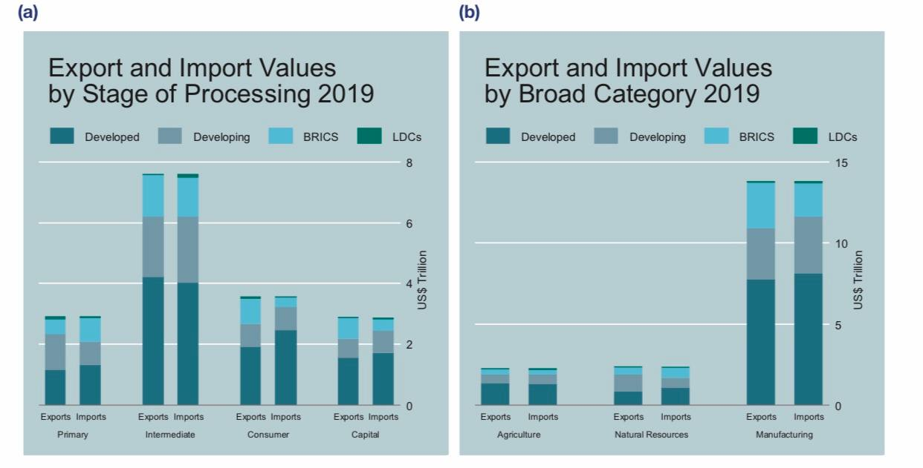

Source: UNCTAD secretariat calculations based on COMTRADE data.

**Figure 3.6. Value of world Trade in Goods by Region, Stage of Processing and Broad Category**

Developed nations contribute for the majority of international commerce, both in terms of items differentiated by stage of processing and broad category (Figure 3.6, b) (Figure 3.6, b). Besides other emerging nation areas, a large amount of commerce is related to BRICS, notably in connection to the trade of intermediates and manufacturing. They also tend to import less consumer items while exporting a reasonably big amount. Developing nations tend to export more natural resources than they buy, unlike developed countries. LDCs only represent a tiny percentage in all categories of commodities, with a bigger participation in the exports of raw items and the imports of intermediate goods.

Chemicals trade for almost US$2 trillion, a significant part of global goods commerce. Other important areas include machinery and automobiles, communications, and energy. In 2019, global trade fell in most industries, including oil, coal, gas, and petroleum products. In the previous decade, export market shares have shifted in favor of emerging nations in all sectors, but especially in communications, non-metallic resources, and manufacturing.

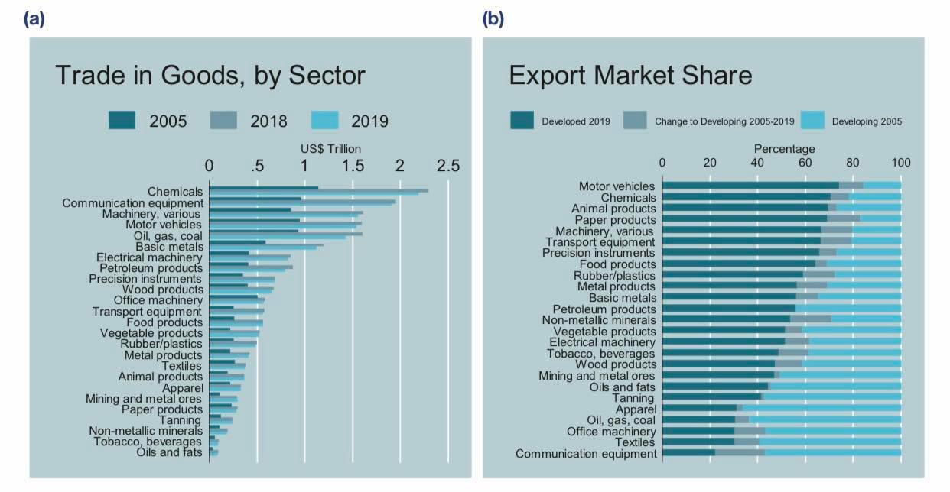

**Figure 3.7.** **Values of world trade in goods by sectors**

Source: UNCTAD secretariat calculations based on COMTRADE data.

Figure 3.7 shows the value of global commerce in 25 categories. In terms of value, a lot of global commerce is about energy (oil, gas, coal, and petroleum products), chemicals, machinery, cars, and communications. Light manufacturing, such as textiles, clothes, and tanning, contributes substantially less to global commerce. Agriculture, which includes food, vegetable and animal goods, oils and fats, tobacco and drinks, accounted for less than 10% of global trade in 2019. Except for mining and metal ores, trade value stagnated or decreased in 2019. In the recent decade, emerging nations' position on global markets has risen dramatically. (Figure 3.7 b) In non-metallic minerals and communications equipment, their export market share has grown.

Transportation system has dominated the world exports services industry. All service sectors like trade in services rose drastically over the previous decade. Transport, construction, and insurance had declines in 2019. Telecommunications and IT services grew significantly in 2019. Although developing nations have expanded their share of services trade in the previous decade, developed countries remain the leading exporters in all industries except construction. Developing nations are becoming key providers of insurance and professional services.

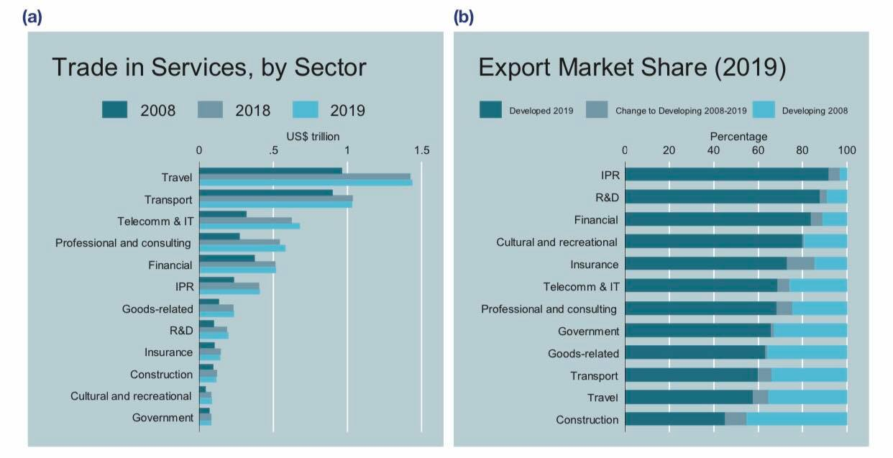

**Figure 3.8** **Market shares of trade in services of developing and developed countries by sector**

Source: UNCTAD secretariat calculations based on COMTRADE data.

With regard to services, trade in travel services at almost US$ 1.5 trillion represents the largest sector, followed by transport, amounting to about US$1 trillion in 2019 (Figure 3.8). Other important sectors include telecommunications and IT, professional services and financial services. Since 2008, the value of trade has increased in all sectors. Trade grew to some extent in 2019 in most categories, except for transportation, construction and insurance. Figure 3.8b depicts the share of global exports of different service categories pertaining to developed and developing countries, and their change between 2008 and 2019. Although developed countries still account for the largest part of exports of services, the export market share has been shifting to the advantage of developing countries in all sectors (Figure 3.8 b). The exceptions have been government and goods-related services for which market shares have not changed significantly.

**3.2 Trends of Changes in International Trade Regulation**

The COVID-19 outbreak of 2020 shook the global economy. The anticipation for world's GDP is that it will reduce by 5% in 2020.  The value of global commerce is predicted to shrink by 8%. Assuming the epidemic is contained, the world economy and commerce are expected to revive to 2019 levels next year. COVID-19's impact on global commerce confirms the decade's unpredictable trend.

The measure by the global trade in goods and services has become less reliant on trade in the last decade (a popularly used measure ascertain the trend in global economy). In 2008, it topped 30%. International trade to world production has been trending downward since then, with a 2020 target of about 25%. A rise in this percentage is possible for the years 2021 and beyond. With COVID-19 disrupting global value chains and unresolved trade concerns among several key economies, the size of a recovery is questionable.

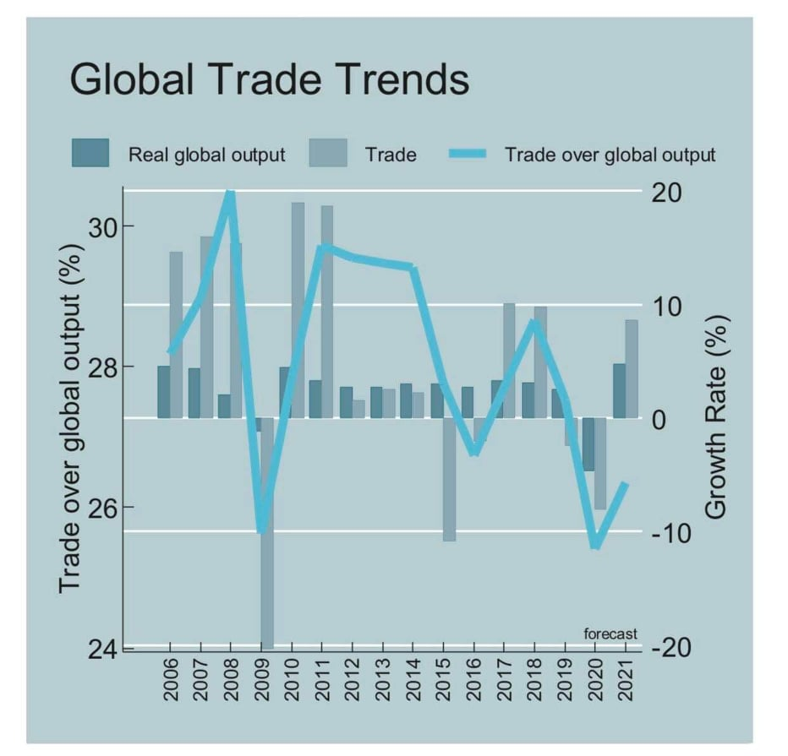

**Figure 3.9 World Trade Trend**

Global Trade in 2020 COVID-19 immediately impacted global commerce. In January, most major economies saw negative trade trends, signaling the start of the trade crisis. Still, global merchandise trade fell more than 20% in the second half of 2020, compared to the same time in 2019.  There was a negative trade trend experienced in the third quarter of the year but it was far better than the second quarter of the year.  Over the course of 2020, the global trade deficit shrank sharply, notably in exports. South-South trade has been more resilient than total trade, with a fall of about 17% in Q2 and a decrease of 5% in the third quarter.

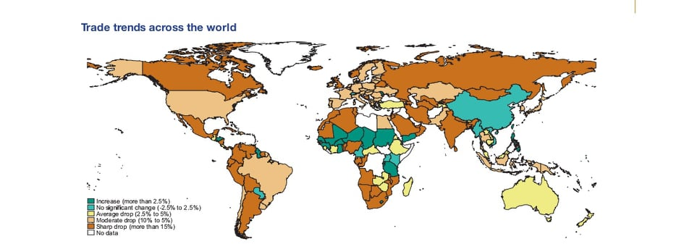

**Figure 3.10 World Trade Trend**

The recovery process has lagged in many of the other major economies, some of which still recorded double digit drops in September 2020. For example, imports and exports have remained substantially below 2019 levels for Brazil, India, Japan, and the Russian Federation. On the other hand, signs of a tepid recovery are found in the statistics of the European Union, Republic of Korea, and South Africa.

Trends in International Trade

Physical products gradually dominate the international commerce. Despite growth, services trade remains small. World commerce in products was near to US$19 trillion in 2019, while trade in services was close to US$6 trillion. After the global financial crisis, both commodities and services in trade quickly recovered to pre-crisis levels by 2011. The value of global commodities trade fell dramatically between 2015 and 2016. While growth in 2017 and 2018 more than made up for the loss, trade in goods fell again in 2019 to a level comparable to 2014. Services trade has been more robust.

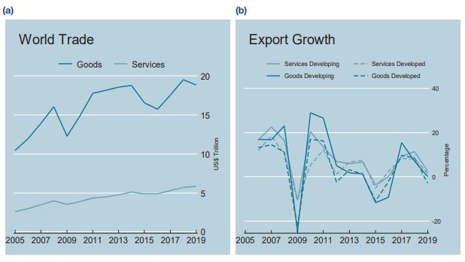

**Figure 3.11.Values and Growth rates of world Trade in Goods and Services**

International trade may be divided into two categories: products and services. The vast majority of global commerce is in products, with services coming in second. World goods trade has risen rapidly over the previous decade, from over $10 trillion in 2005 to over $18.5 trillion in 2014, before falling in 2016 and increasing again in 2019. Between 2005 and 2019, services trade expanded from roughly $2.5 trillion to over $6 trillion. Both goods and services exports fell sharply in 2015 and 2016, then rose in 2017 and 2018, before leveling off (services) or falling (goods) in 2019. Export growth rates (in current dollars) fell in 2015 and 2016 after a significant resurgence in 2010 and 2011. Imports from emerging nations showed a substantial rebound in 2017, but remained below pre-crisis levels. In 2019, both goods and services export growth rates slowed, with developed country export growth rates declining.

Since 2005, global commodities trade has expanded considerably. However, growth has slowed dramatically in recent years, almost ceasing in 2015-2016. A rebound between 2017 and 2018 slowed in 2019. Imports and exports improved strongly in major economies in 2017, but they remained stable in 2019.

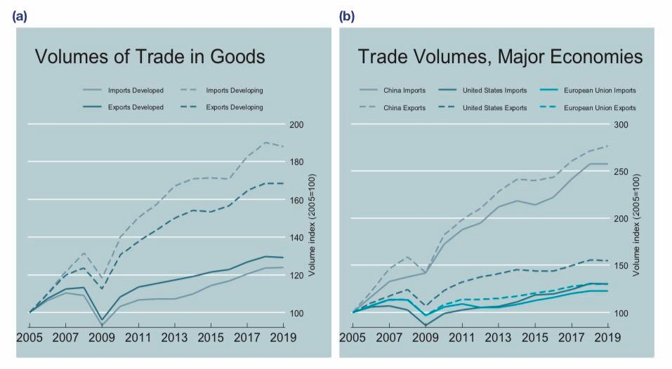

**Figure 3.12 Volumes of Global Trade in Goods**

Source: UNCTAD secretariat calculations based on UNCTADStat data.

The amount of global goods trade has expanded considerably in the recent decade (Figure 3.12a). Despite the 2009 financial crisis, developing nations have almost quadrupled their goods trade volume since 2009. While imports have grown faster than exports in developing countries, the reverse has occurred in rich nations. The significantly bigger growth in imports is explained by rising consumer demand in emerging markets. Trade volume growth has slowed in recent years, notably for developing nations, before rising up again in 2017, when import and export volumes climbed at the fastest pace since 2011. In 2015 and 2016, volume growth for imports and exports was modest or negative in the three major economies (Figure 3.12 b). Import and export volumes grew dramatically in 2017, and continued to expand in 2018. In 2019, most major economies' import and export growth rates were near to zero, or even negative in the case of the USA. Except for China, whose exports climbed over 2% in 2019. It is approximately equally split between developing and developed nations. However, in 2019, developed nations accounted for around two-thirds of service trade. BRICS1 trade in products and services is significant. LDCs continue to have a modest percentage of global commerce.

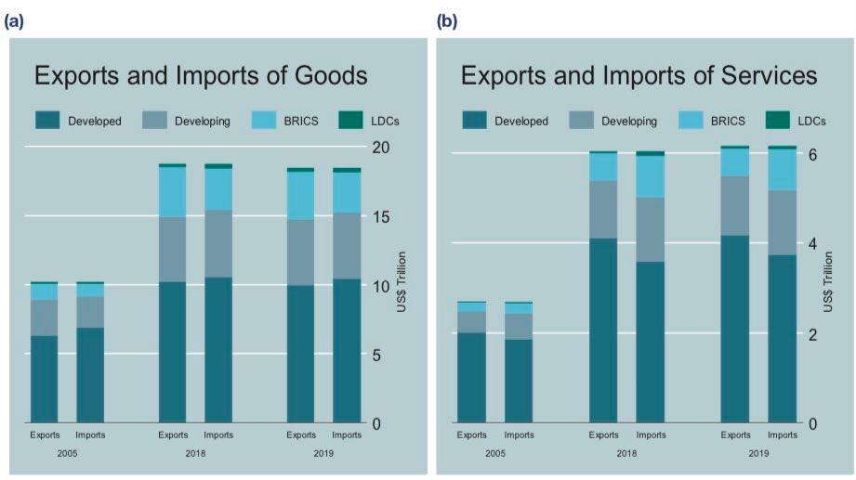

**Figure 3.13. Values of Trade in Goods and Services by Region**

Source: UNCTAD secretariat calculations based on COMTRADE and UNCTADStat data.

The relevance of industrialized nations as suppliers is dwindling. Nonetheless, they account for almost half of the value of products and services exported. In 2019, developed nations exported commodities worth over $10.5 trillion and services worth around $4.1 trillion (Figure 3.13 a) (Figure 3.14 b). In 2019, developing nations exported about US$8.5 trillion in products and nearly US$2 trillion in services. BRICS exported US$3.5 trillion in products and US$600 billion in services. The contribution of LDCs to global commerce remains limited, notwithstanding recent increases in exports and imports.

Trade flows between industrialized nations and East Asia make up the bulk of global goods trade. Except for trade in basic goods, commerce between emerging areas is significantly smaller.

**Conclusion to chapter 3**

The forecast for international trade in terms of the total goods imports at same prices for each country from 2020 to 2025. The IMF Consensus scenario was used to determine this very outlook from October 2020 and because of the steep experienced in 2020, expert’s projects that there will be an economic rebound in 2021.

Due to the unthinkable shock produced by the introduction of the covid-19 epidemic, so many changes have occurred, affecting everything from goods to services across borders. Different nations were forced to take dramatic steps and implement emergency policies, which had a negative impact on the geographical structure of global commerce.

International trade may be divided into two categories: products and services. The vast majority of global commerce is in products, with services coming in second. World goods trade has risen rapidly over the previous decade, from over $10 trillion in 2005 to over $18.5 trillion in 2014, before falling in 2016 and increasing again in 2019. Between 2005 and 2019, services trade expanded from roughly $2.5 trillion to over $6 trillion.

**CONCLUSIONS**

1. It were discussed mercantilism, absolute advantage, comparative advantage, Heckscher-Ohlin Theory (Factor Proportions Theory), Leontief paradox, contemporary or firm-based trade theories, and Porter's national competitive advantage theory.

2. We further discussed the determinant of the terms of trade which were as follow, expectation of utility, expectation of a future relationship, coercion, government policies, morality, preferences, uncertainty, scarcity, size, quality, effort, and persuasion. The traditional frameworks responsible for regulating international trade between nations are GATT, and WTO. However, there are other regional authorities that help to regulate trade such as follows NAFTA, ASEAN, NATO, MERCOSUR etc.

3. A shift in demand toward low-trade-intensity domestic services is expected to hinder the global trade rebound. Supply constraints and localized shipping container shortages are limiting manufacturing trade. Some sectors of the services trade, such telecoms and financial services, are projected to improve, but tourism is predicted to remain sluggish until the virus is contained.

Covid-19 Pandemic prevented face to face transactions between humans and that has led to a global to shift to online purchase in order to survive through different online shopping platforms. Research had it that 44% of global shoppers are online transactions and online market platforms accounted for 47% of global digital purchases. In response to the epidemic, firms selling online increased in Brazil, Spain, and Japan.

4. Bilateral and good trade and investment terms include agreements offers with legally binding guarantees that may help attract investment.. By locking in current policy changes or foreshadowing future policy changes, these agreements help companies adapt to shifting competitive situations. Modern preferential trade agreements frequently include comprehensive investment preservation and liberalization criteria. Intellectual property and services are often incorporated. Due to the current Corona virus epidemic, some governments have changed their trade restrictions.

5. In 2019, developed countries exported goods worth over $10.5 trillion and services worth $4.1 trillion. In 2019, developing countries exported over $8.5 trillion in goods and services. BRICS exports totaled $3.5 trillion in goods and services. Despite recent growth in exports and imports, LDCs' contribution to global trade remains low. The global economy is anticipated to contract by 5% in 2020 and 6% in 2021.

The South Asian region's output is predicted to climb by 6.8% in 2021, matching the preceding decade's average. The Sub-Saharan African regional activity is anticipated to grow by 2.8% in 2021 and 3.3% in 2022. Europe and Central Asia, The area economy is expected to increase 3.9% in 2021. Latin America and the Caribbean,after a severe recession in 2020, activity is expected to rise by just 5.2% in 2021. Middle East and North Africa,in 2021, regional production is expected to expand by just 2.4%, half the rate of the worldwide recovery in 2009.

6. The Covid-19 Pandemic banned human-to-human interactions, leading to a worldwide move to online purchases to survive. Online market platforms accounted for 44% of worldwide digital purchases, according to research.

WTO members have issued 350 RTAs, 568 reports, covering commodities, services, and accession. During the COVID era, regional trade members implemented various actions. The IMF expects global economic growth to decline to 3.5% over time. As a result, in the second quarter of 2022, foreign commerce should return to normal.

7. A decade ago, the measure of global commerce in commodities and services was based on trade (a popularly used measure ascertain the trend in global economy). In 2008, it hit 30%. Since then, the ratio of international commerce to global output has fallen to about 25%. This proportion may climb by 2021 and beyond.

8. The forecast for international trade in terms of the total goods imports at same prices for each country from 2020 to 2025. The IMF Consensus scenario was used to determine this very outlook from October 2020 and because of the steep experienced in 2020, expert’s projects that there will be an economic rebound in 2021.

9. Due to the unthinkable shock produced by the introduction of the covid-19 epidemic, so many changes have occurred, affecting everything from goods to services across borders. Different nations were forced to take dramatic steps and implement emergency policies, which had a negative impact on the geographical structure of global commerce.

International trade may be divided into two categories: products and services. The vast majority of global commerce is in products, with services coming in second. World goods trade has risen rapidly over the previous decade, from over $10 trillion in 2005 to over $18.5 trillion in 2014, before falling in 2016 and increasing again in 2019. Between 2005 and 2019, services trade expanded from roughly $2.5 trillion to over $6 trillion.

**References**

1. Akresh, R., D. Halim, and M. Kleemans. 2021. “LongTerm and Intergenerational Effects of Education: Evidence from School Construction in Indonesia.” Policy Research Working Paper 9559, World Bank, Washington, DC.
2. Albanesi, S., and J. Kim. 2021. “The Gendered Impact of the COVID-19 Recession on the US Labor Market.” NBER Working Paper 28505, National Bureau of Economic Research, Cambridge, MA.
3. Alkire, S., R. Nogales, N. N. Quinn, and N. Suppa. 2020. “On Track or Not? Projecting the Global Multidimensional Poverty Index.” OPHI Research Paper 58a, University of Oxford.
4. Alonso Gispert, T., E. Feyen, T. Kliatskova, D. S. Mare, and M. Poser. 2020. “COVID-19 Pandemic: A Database of Policy Responses Related to the Financial Sector” (database). World Bank, Washington, DC.
5. Alonso Gispert, T., E. Feyen, T. Kliatskova, D. S. Mare, and M. Poser. 2020. “COVID-19 Pandemic: A Database of Policy Responses Related to the Financial Sector” (database). World Bank, Washington, DC.
6. Al-Samarrai, S., P. Cerdan-Infantes, A. Bigarinova, J. Bodmer, M. J. Vital, M. Antoninis, B. F. Barakat, and Y. Murakami. 2021. “Education Finance Watch 2021.” World Bank, Washington, DC.
7. Alvaro Espitia, Nadia Rocha, Michele Ruta: Trade in Critical COVID-19 Products, World Bank Trade and COVID-19 Guidance Note, 27 March 2020
8. Ambec, S., M. A. Cohen, S. Elgie, and P. Lanoie. 2011. “The Porter Hypothesis at 20: Can Environmental Regulation Enhance Innovation and Competitiveness?” Resources for the Future
9. Anderson JE and Yotov YV (2016). Terms of trade and global efficiency effects of free trade agreements, 1990–2002. Journal of International Economics. 99(C):279–298.
10. Apedo-Amah, M. C., B. Avdiu, X. Cirera, M. Cruz, E. Davies, A. Grover, L. Iacovone, et al. 2020. “Unmasking the Impact of COVID-19 on Businesses: Firm Level Evidence from Across the World.” Policy Research Working Paper 9434, World Bank, Washington, DC.
11. Auboin, M., and F. Borino. 2017. “The Falling Elasticity of Global Trade to Economic Activity: Testing the Demand Channel.” WTO Staff Working Paper ERSD-2017-09, World Trade Organization, Geneva.
12. Baker, P. (2020). The Impact of COVID-19: Reflections on the Transport and Logistics Sector. International Economics’ Insights.
13. Barnes, S., E. Casey, and E. Jordan-Doak. 2021. “Managing Government Debt at High Altitude: Velocity, Instability and Headwinds.” IFAC Working Paper 15, Irish Fiscal Advisory Council, Dublin.
14. Beck, T., E. Carletti, and B. Bruno. 2021. “Unwinding COVID Support Measures for Banks.” VoxEU.org, CEPR Policy Portal, March 17, https://voxeu.org/ article/unwinding-covid-support-measures-banks.
15. Bems, R., R. C. Johnson, and K. Yi. 2010. “Demand Spillovers and the Collapse of Trade in Global Recession.” IMF Working Paper 10/142, International Monetary Fund, Washington, DC.
16. Bernhofen, Daniel M. and John C. Brown (2004), “A Direct Test of the Theory of Comparative Advantage: the Case of Japan”, Journal of Political Economy, 112, 48-67.
17. Bernhofen, Daniel M. and John C. Brown (2004), “A Direct Test of the Theory of Comparative Advantage: the Case of Japan”, Journal of Political Economy, 112, 48-67.
18. Blanchard, O. J., J. Felman, and A. Subramanian. 2021. “Does the New Fiscal Consensus in Advanced Economies Travel to Emerging Markets?” PIIE Policy Brief 21-7, Peterson Institute for International Economics, Washington, DC.
19. Bloom, N., P. Bunn, P. Mizen, P. Smietanka, and G. Thwaites. 2021. “The Impact of Covid-19 on Productivity.” VoxEU.org, CEPR Policy Portal, January 18, https://voxeu.org/article/impact-covid-19- productivity.
20. Bolt, J., R. Inklaar, H. de Jong, and J. L. van Zanden. 2018. “Rebasing ‘Maddison’: New Income Comparisons and the Shape of Long-Run Economic Development.” GGDC Research Memorandum 174, University of Groningen, Groningen.
21. Boot, A., E. Carletti, H-H. Kotz, J. P. Krahnen, L. Pelizzon, and M. Subrahmanyam. 2021. “Coronavirus and Banking: Evaluating Policy Options for Avoiding a Financial Crisis.” VoxEU.org, CEPR Policy Portal, January 25, URL: <https://voxeu.org/article/coronavirus-andbanking-evaluating-policy-options-avoiding-financialcrisis>.
22. Bundervoet, T., M. E. Davalos, and N. Garcia. 2021. “The Short-Term Impacts of COVID-19 on Households in Developing Countries: An Overview Based on a Harmonized Data Set of High-Frequency Surveys.” Policy Research Working Paper 9582, World Bank, Washington, DC.
23. Burns, M., M. Santally, Y. Rajabalee, R. Halkhoree, and R. Sungkur. 2019. “Information and Communications Technologies in Secondary Education in SubSaharan Africa: Policies, Practices, Trends and Recommendations.” Mastercard Foundation, Toronto.
24. Çakmaklı, C., S. Demiralp, S. Kalemli-Özcan, S. Yeşiltaş, and M. A. Yıldırım. 2021. “The Economic Case for Global Vaccinations: An Epidemiological Model with International Production Networks?” NBER Working Paper 28395, National Bureau of Economic Research, Cambridge, MA.
25. Comunale M, Dainauskas J and Lastauskas P (2021). Supply chains and trade flows volatility in the face of shocks. VOX, CEPR Policy Portal. Available at <https://voxeu.org/article/supplychains-and-trade-flows-volatility-face-global-shocks>.
26. Das, S., and P. Wingender. 2021. “Slow-Healing Scars: The Pandemic’s Legacy.” IMF Blog. March 31, 2021. URL: <https://blogs.imf.org/2021/03/31/slow-healing-scarsthe-pandemics-legacy/>.
27. Davis, Donald R. and David E. Weinstein (2002), “An Account of Global Factor Trade”, American Economic Review, 91, 1423-53. Deardorff, Alan V. (1984), “The General Validity of the Law of Comparative Advantage”, Journal of Political Economy, 88, 941-57.
28. Diez, F. J., R. A. Duval, J. Fan, J. Garrido, S. KalemliOzcan, C. Maggi, M. S. Martinez Peria, and N. Pierri. 2021. “Insolvency Prospects Among Small and Medium Enterprises in Advanced Economies: Assessment and Policy Options.” IMF Staff Discussion Note 21/02, International Monetary Fund, Washington, DC.
29. Discussion Paper 11-01, SSRN Electronic Journal. URL: https:// papers.ssrn.com/sol3/papers.cfm?abstract_id=1754674.
30. ECB (European Central Bank). 2021. “The Impact of Containment Measures across Sectors and Countries during the COVID-19 Pandemic.” ECB Economic Bulletin 2/2021, European Central Bank, Frankfurt.
31. Espitia A, Mattoo A, Rocha N, Ruta M and D Winkler (2021). Pandemic trade: COVID-19, Remote Work and Global Value Chains. Policy Research Working Paper no. WPS 9508. World Bank.
32. Furceri, D., P. Loungani, J. D. Ostry, and P. Pizzuto. 2020. “Will Covid-19 Affect Inequality? Evidence from Past Pandemics.” Covid Economics: Vetted and RealTime Papers 12 (May): 138-157.
33. Group of Mirty. 2021. Sovereign Debt and Financing for Recovery After the COVID-19 Shock: Next Steps to Build a Better Architecture. Washington, DC: Group of Mirty.
34. Guénette, J.-D., and T. Yamazaki. 2021. “Projecting the Economic Consequences of the COVID-19 Pandemic.” Policy Research Working Paper 9589, World Bank, Washington, DC.
35. Ha, J., M. Stocker, and H. Yilmazkuday. 2019. “Inflation and Exchange Rate Pass-Mrough.” Policy Research Working Paper 8780, World Bank, Washington, DC.
36. IEC (2020). COVID-19 and African businesses: Focus on Mauritius. International Economics’ Insights.
37. IMF (International Monetary Fund). 2021b. Global Financial Stability Report: Preempting a Legacy of Vulnerabilities. April. Washington, DC: International Monetary Fund.
38. Kilic Celik, S., M. A. Kose, and F. Ohnsorge. 2020“Subdued Potential Growth: Sources and Remedies.” In Growth in a Time of Change: Global and Country Perspectives on a New Agenda, edited by H.-W. Kim and Z. Qureshi. Washington, DC: Brookings Institution.
39. Klein, A., and E. Smith. 2021. “Explaining the Economic Impact of COVID-19: Core Industries and the Hispanic Workforce.” Brookings Institution, Washington, DC. https://www.brookings.edu/research/ explaining-the-economic-impact-of-covid-19-coreindustries-and-the-hispanic-workforce/.
40. Kolinets, L. B. (2018). Novyi svitovyi finansovyi poriadok [The new world financial order]. *Ternopil: TNEU [in Ukrainian]*.
41. Kolinets, L., & Tokar, V. (2019). Status quo of gender equality in eu rural business management. *Management theory and studies for rural business and infrastructure development= Vadybos mokslas ir studijos-kaimo verslų ir jų infrastruktūros plėtrai: mokslo darbai, 2019, vol. 41, no. 3, p. 400-408*.
42. Kose, M. A., and F. Ohnsorge. 2021. “The 2020s: Roaring or Disappointing?” Voices (blog), March 29, 2021. https://blogs.worldbank.org/voices/2020sroaring-or-disappointing.
43. Kose, M. A., N. Sugawara, and M. E. Terrones. 2020. “Global Recessions.” CEPR Discussion Paper 14397, Center for Economic Policy Research, London.
44. Kose, M. A., P. Nagle, F. Ohnsorge, and N. Sugawara. 2021. Global Waves of Debt: Causes and Consequences. Washington, DC: World Bank.
45. Kose, M. A., S. Kurlat, F. Ohnsorge, and N. Sugawara. 2017. “A Cross-Country Database of Fiscal Space.” Policy Research Working Paper 8157, World Bank, Washington, DC. Kose, M. A., C. Lakatos, F. L. Ohnsorge, and M. Stocker. 2017. “The Global Role of the U.S. Economy: Linkages, Policies and Spillovers.” Policy Research Working Paper 7962, World Bank, Washington, DC.
46. Liu X, Ornelas E and Shi H (2021). The Trade Impact of the COVID-19 Pandemic. CESifo Working Paper No. 9109. CESifo.
47. Maggi G (2014). Chapter 6 - International Trade Agreements. In: Gopinath G, Helpman E and Rogoff K, eds. Handbook of International Economics, Volume 4. Elsevier: 317–390.
48. Mathai, K., C. Duenwald, A. Guscina, A. R. Al-Farah, H. Bukhari, A. Chaudry, M. El-Said, F. Fareed, et al. 2020. “Social Spending for Inclusive Growth in the Middle East and Central Asia.” IMF Departmental Paper 20/12, International Monetary Fund, Washington, DC.
49. Morgan, R.E. and Katsikeas, C.S., 1997. Theories of international trade, foreign direct investment and firm internationalization: a critique. Management decision.
50. Morgan, R.E. and Katsikeas, C.S., 1997. Theories of international trade, foreign direct investment and firm internationalization: a critique. Management decision.
51. OECD (2020), “Connecting businesses and consumers during COVID-19: trade in parcels”*, OECD Policy Responses to Coronavirus (COVID-19)*, URL: <http://www.oecd.org/coronavirus/policy-responses/connecting-businesses-and-consumers-during-covid-19-trade-in-parcels-d18de131/>.
52. OECD (2020), “Coronavirus (COVID-19): SME Policy Responses”*, OECD Policy Responses to Coronavirus (COVID-19)*, URL: <https://read.oecd-ilibrary.org/view/?ref=119_119680-di6h3qgi4x&title=Covid-19_SME_Policy_Responses>.
53. OECD (2020), “COVID-19 and the retail sector: impact and policy responses”*, OECD Policy Responses to Coronavirus (COVID-19)*, OECD Paris, URL: <http://www.oecd.org/coronavirus/policy-responses/covid-19-and-the-retail-sector-impact-and-policy-responses-371d7599/>.
54. OECD (2020), *Protecting online consumers during the COVID-19 crisis*, URL: <https://www.oecd.org/coronavirus/policy-responses/protecting-online-consumers-during-the-covid-19-crisis-2ce7353c/>.
55. Òscar Jordà, Sanjay R. Singh and Alan M. Taylor: Longer-run economic consequences of pandemics, Covid Economics, Issue 1, 3 April 2020
56. Oxford Economics. 2019. “Global Economic Model.” July. Oxford Economics, Oxford, U.K.
57. Reinhart, C., and V. Reinhart. 2020. "The Pandemic Depression: The Global Economy Will Never Be the Same." Foreign Affairs, September/October. https:// www.foreignaffairs.com/articles/united-states/2020-08- 06/coronavirus-depression-global-economy
58. Richard Baldwin and Rebecca Freeman: Supply chain contagion waves: Thinking ahead on manufacturing ‘contagion and reinfection’ from the COVID concussion, 1 April 2020, found at [*https://voxeu.org/article/covid-concussion-and-supply-chain-contagion-waves*](https://voxeu.org/article/covid-concussion-and-supply-chain-contagion-waves)
59. Sedik, T. S., and J. Yoo. 2021. “Pandemics and Automation: Will the Lost Jobs Come Back?” IMF Working Paper 2021/11, International Monetary Fund, Washington, DC.
60. Stiglitz, J. E. 2020. “The Pandemic Economic Crisis, Precautionary Behavior, and Mobility Constraints: An Application of the Dynamic Disequilibrium Model with Randomness.” NBER Working Paper 27992, National Bureau of Economic Research, Cambridge, MA.
61. Stocker, M., J. Baffes, Y. Some, D. Vorisek, and C. M. Wheeler. 2018. “The 2014-16 Oil Price Collapse in Retrospect: Sources and Implications.” Policy Research Working Paper 8419, World Bank, Washington, DC.
62. Strand, J., and M. Toman. 2010. “‘Green Stimulus,’ Economic Recovery, and Long-Term Sustainable Development.” Policy Research Working Paper 5163, World Bank, Washington, DC.
63. Stukalo, N. V., Lytvyn, M. V., Golovko, L. S., Kolinets, L. B., & Pylypenko, Y. (2020). ENSURING SUSTAINABLE DEVELOPMENT IN THE COUNTRIES OF THE WORLD BASED ON ENVIRONMENTAL MARKETING. *Scientific Bulletin of National Mining University*, (3).
64. Stukalo, N. V., Lytvyn, M. V., Petrushenko, Y. M., Pylypenko, Y. I., & Kolinets, L. B. (2021). THE CONCEPT OF SUSTAINABLE DEVELOPMENT OF UKRAINE IN THE CONTEXT OF GLOBAL THREATS. *Natsional'nyi Hirnychyi Universytet. Naukovyi Visnyk*, (3), 178-183
65. Tandrayen-Ragoobur, V., Seetanah, B. & de Melo, J. (2020). Monitoring COVID-19 in Tourist Islands. International Economics’ Insights.
66. UNCTAD (2020): Global trade impact of the Coronavirus (COVID-19) Epidemic, document UNCTAD/DITC/INF/2020/1, 4 March 2020
67. UNCTAD (United Nations Conference on Trade and Development). 2021. Investment Trends Monitor. Issue 38. Geneva: UNCTAD.
68. UNDP (United Nations Development Programme) and OPHI (Oxford Poverty and Human Development Initiative). 2020. Global Multidimensional Poverty Index 2020—Charting Pathways out of Multidimensional Poverty: Achieving the SDGs. New York: UNDP; Oxford, UK: OPHI.
69. United Nations Economic and Social Commission for Asia and the Pacific (database). “ESCAP-World Bank Trade Cost Database.” Accessed May 25, 2021. https:// www.unescap.org/resources/escap-world-bank-tradecost-database.
70. UNWTO (United Nations World Tourism Organization). 2021. “2020: Worst Year in Tourism History With 1 Billion Fewer International Arrivals.” UNWTO News, January 28, 2021.
71. WFP (World Food Program) and FAO (Food and Agriculture Organization of the United Nations). 2021. “Hunger Hotspots. FAO-WFP Early Warnings on Acute Food Insecurity.” March to July 2021 outlook. Rome:
72. WFP and FAO. Wheeler, C. M., J. Baffes, A. Kabundi, G. KindbergHanlon, P. S. Nagle, and F. Ohnsorge. 2020. “Adding Fuel to the Fire: Cheap Oil during the COVID-19 Pandemic.” Policy Research Working Paper 9320, World Bank, Washington, DC.
73. Wilson, D. J. 2020. “The COVID-19 Fiscal Multiplier: Lessons from the Great Recession.” Federal Reserve Bank San Francisco Economic Letter. May 26. URL: https://www.frbsf.org/economic-research/publications/ economic-letter/2020/may/covid-19-fiscal-multiplierlessons-from-great-recession/. World Bank. 2016. World Development Report 2016: Digital Dividends. Washington, DC:
74. World Bank. 2019. Africa's Pulse: An Analysis of Issues Shaping Africa’s Economic Future. Volume 19. Washington, DC: World Bank.
75. World Bank. 2020a. Global Economic Prospects. June. Washington, DC: World Bank. World Bank. 2020b. Poverty and Shared Prosperity Report 2020: Reversing Reversals of Fortune. Washington, DC: World Bank.
76. World Bank. 2020c. “COVID-19: Debt Service Suspension Initiative.” Brief. Updated on September 15, 2020. World Bank, Washington, DC. World Bank. 2020d. Global Economic Prospects: Slow Growth, Policy Challenges. January. Washington, DC: World Bank. World Bank. 2020e.
77. World Bank. 2021d. “From COVID-19 Crisis Response to Resilient Recovery—Saving Lives and Livelihoods while Supporting Green, Resilient and Inclusive Development (GRID).” World Bank, Washington.
78. World Bank. 2021e. “Food Security and COVID-19.” World Bank Brief. May 7. https://www.worldbank.org/ en/topic/agriculture/brief/food-security-and-covid-19. World Bank. 2021f. East Asia and Pacific Economic Update: Uneven Recovery. March. Washington, DC: World Bank.
79. World Bank. World Bank. 2017. Global Economic Prospects: Weak Investment in Uncertain Times. June. Washington, DC: World Bank. World Bank. 2018a. Global Economic Prospects: BroadBased Upturn, but for How Long? January. Washington, DC:
80. World Bank. World Bank. 2018b. World Development Report 2018: Learning to Realize Education’s Promise. Washington, DC: World Bank.
81. World Development Report. Trading for Development in the Age of Global Value Chains. Washington, DC: World Bank.
82. Wouters, O. J., K. C. Shadlen, M. Salcher-Konrad, A. J. Pollard, H. J. Larson, Y. Teerawattananon, and M. Jit. 2021. “Challenges in Ensuring Global Access to COVID-19 Vaccines: Production, Affordability, Allocation, and Deployment.” Me Lancet 397 (10278): 1023-1034.
83. WTO (World Trade Organization). 2020. “Exports Restrictions and Prohibitions.” Information Note. World Trade Organization, Geneva. URL: https:// www.wto.org/english/tratop_e/covid19_e/ export_prohibitions_report_e.pdf.
84. Yoshino, N., J. Dong, N. S. Hendriyetty, and P. J. Morgan. 2020. “Coordinated and Comprehensive Fiscal and Monetary Stimulus for Tackling the Covid19 Crisis.” Policy Brief, G20 Insights. URL: https://www.g 20-insights.org/wp-content/uploads/2020/11/T20_TF 11_PB9.pdf.